**IOS PRACTICALS**

**PRACTICAL 10**

**10)Aim: Introduction to Xcode, Swift, and the iOS SDK and App Design**

Xcode is used to build apps for iPhone and iPad, as well as apps for Mac, Apple Watch and Apple TV. These tutorials are based on Xcode 8.1, released on October 27, 2016. Xcode 8.1 is the latest version of Apple’s integrated development environment (IDE) and is completely free. If you want to code along with the tutorials, you can download Xcode from <https://developer.apple.com/download/>or directly from the [Mac App Store](https://itunes.apple.com/us/app/xcode/id497799835?ls=1&mt=12). You can use Xcode not only to build apps for iPhone and iPads, but you can use it to build apps for Mac, Apple Watch and Apple TV as well.

**Swift** is a [general-purpose](https://en.wikipedia.org/wiki/General-purpose_programming_language), [multi-paradigm](https://en.wikipedia.org/wiki/Multi-paradigm_programming_language), [compiled](https://en.wikipedia.org/wiki/Compiled_language) [programming language](https://en.wikipedia.org/wiki/Programming_language) developed by [Apple Inc.](https://en.wikipedia.org/wiki/Apple_Inc.) for [iOS](https://en.wikipedia.org/wiki/IOS), [macOS](https://en.wikipedia.org/wiki/MacOS), [watchOS](https://en.wikipedia.org/wiki/WatchOS), [tvOS](https://en.wikipedia.org/wiki/TvOS), and [Linux](https://en.wikipedia.org/wiki/Linux). Swift is designed to work with Apple's [Cocoa](https://en.wikipedia.org/wiki/Cocoa_(API)) and [Cocoa Touch](https://en.wikipedia.org/wiki/Cocoa_Touch) [frameworks](https://en.wikipedia.org/wiki/Application_framework) and the large body of existing [Objective-C](https://en.wikipedia.org/wiki/Objective-C) code written for Apple products. It is built with the open source [LLVM](https://en.wikipedia.org/wiki/LLVM) [compiler](https://en.wikipedia.org/wiki/Compiler) framework and has been included in [Xcode](https://en.wikipedia.org/wiki/Xcode) since version 6. On platforms other than Linux,[[10]](https://en.wikipedia.org/wiki/Swift_(programming_language)#cite_note-10) it uses the Objective-C [runtime library](https://en.wikipedia.org/wiki/Runtime_library) which allows [C](https://en.wikipedia.org/wiki/C_(programming_language)), Objective-C, [C++](https://en.wikipedia.org/wiki/C%2B%2B) and Swift code to run within one program.

Apple intended Swift to support many core concepts associated with Objective-C, notably [dynamic dispatch](https://en.wikipedia.org/wiki/Dynamic_dispatch), widespread [late binding](https://en.wikipedia.org/wiki/Late_binding), [extensible programming](https://en.wikipedia.org/wiki/Extensible_programming) and similar features, but in a "safer" way, making it easier to catch [software bugs](https://en.wikipedia.org/wiki/Software_bugs); Swift has features addressing some common [programming errors](https://en.wikipedia.org/wiki/Programming_error) like [null pointer](https://en.wikipedia.org/wiki/Null_pointer) dereferencing and provides [syntactic sugar](https://en.wikipedia.org/wiki/Syntactic_sugar) to help avoid the [pyramid of doom](https://en.wikipedia.org/wiki/Pyramid_of_doom_(programming)). Swift supports the concept of [protocol](https://en.wikipedia.org/wiki/Protocol_(object-oriented_programming)) extensibility, an extensibility system that can be applied to types, [structs](https://en.wikipedia.org/wiki/Record_(computer_science)) and [classes](https://en.wikipedia.org/wiki/Class_(computer_programming)), which Apple promotes as a real change in programming paradigms they term "protocol-oriented programming"[[12]](https://en.wikipedia.org/wiki/Swift_(programming_language)#cite_note-12) (similar to [traits](https://en.wikipedia.org/wiki/Trait_(computer_programming))).[[13]](https://en.wikipedia.org/wiki/Swift_(programming_language)#cite_note-13)

Swift was introduced at Apple's [2014 Worldwide Developers Conference](https://en.wikipedia.org/wiki/Apple_Worldwide_Developers_Conference#2010s) (WWDC). It underwent an upgrade to version 1.2 during 2014 and a more major upgrade to Swift 2 at WWDC 2015. Initially a [proprietary language](https://en.wikipedia.org/wiki/Proprietary_programming_language), version 2.2 was made [open-source software](https://en.wikipedia.org/wiki/Open-source_software) under the [Apache License](https://en.wikipedia.org/wiki/Apache_License) 2.0 on December 3, 2015, for Apple's platforms and [Linux](https://en.wikipedia.org/wiki/Linux).[[15]](https://en.wikipedia.org/wiki/Swift_(programming_language)#cite_note-15)[[16]](https://en.wikipedia.org/wiki/Swift_(programming_language)#cite_note-16)

In March 2017, Swift made the top 10 in the monthly [TIOBE index](https://en.wikipedia.org/wiki/TIOBE_index) ranking of popular programming languages,[[17]](https://en.wikipedia.org/wiki/Swift_(programming_language)#cite_note-17) and was ranked 11th at the end of 2017.[[18]](https://en.wikipedia.org/wiki/Swift_(programming_language)#cite_note-18) By October 2017, however, Swift had begun to lose momentum in the TIOBE index as mobile development moved toward [Xamarin](https://en.wikipedia.org/wiki/Xamarin) and [C#](https://en.wikipedia.org/wiki/C_Sharp_programming_language), as well as similar tools for [JavaScript](https://en.wikipedia.org/wiki/JavaScript).[[19]](https://en.wikipedia.org/wiki/Swift_(programming_language)#cite_note-19) As of April 2018, Swift ranked No. 15 at 1.53% share, losing 0.75% from its 2.28% share just one year earlier.[[20]](https://en.wikipedia.org/wiki/Swift_(programming_language)#cite_note-20)

Different major versions have been released at an annual schedule with incompatible syntax and library invocations each, requiring significant source code rewrites. For larger code bases this has caused many developers to dismiss Swift until a more stable version becomes available.

The **iOS SDK (Software Development Kit)** (formerly **iPhone SDK**) is a [software development kit](https://en.wikipedia.org/wiki/Software_development_kit) developed by [Apple Inc.](https://en.wikipedia.org/wiki/Apple_Inc.) The kit allows for the development of [mobile apps](https://en.wikipedia.org/wiki/Mobile_app) on Apple's [iOS](https://en.wikipedia.org/wiki/IOS) operating system.

While originally developing [iPhone](https://en.wikipedia.org/wiki/IPhone) prior to its unveiling in 2007, Apple's then-[CEO](https://en.wikipedia.org/wiki/CEO) [Steve Jobs](https://en.wikipedia.org/wiki/Steve_Jobs) did not intend to let third-party developers build native apps for iOS, instead directing them to make [web applications](https://en.wikipedia.org/wiki/Web_application) for the [Safari web browser](https://en.wikipedia.org/wiki/Safari_(web_browser)). However, backlash from developers prompted the company to reconsider, with Jobs announcing in October 2007 that Apple would have a software development kit available for developers by February 2008. The SDK was released on March 6, 2008.

The SDK is a free download for users of [Mac](https://en.wikipedia.org/wiki/Macintosh) personal computers. It is not available for [Microsoft Windows](https://en.wikipedia.org/wiki/Microsoft_Windows) PCs. The SDK contains sets giving developers access to various functions and services of iOS devices, such as hardware and software attributes. It also contains an iPhone [simulator](https://en.wikipedia.org/wiki/Simulator)to mimic the look and feel of the device on the computer while developing. New versions of the SDK accompany new versions of iOS. In order to test applications, get technical support, and distribute apps through [App Store](https://en.wikipedia.org/wiki/App_Store_(iOS)), developers are required to subscribe to the Apple Developer Program.

Combined with [Xcode](https://en.wikipedia.org/wiki/Xcode), the iOS SDK helps developers write iOS apps using officially supported programming languages, including [Swift](https://en.wikipedia.org/wiki/Swift_(programming_language)) and [Objective-C](https://en.wikipedia.org/wiki/Objective-C). Other companies have also created tools that allow for the development of native iOS apps using their respective programming languages.

**PRACTICAL 11**

**11) Aim:GoodAsOldPhones I& LoveTweet mplementation using swift**

* ***GoodAsOldPhone***

**ProductViewController.shift**

import UIKit

class ProductViewController: UIViewController {

  @IBOutlet var productImageView: UIImageView!

  @IBOutlet var productNameLabel: UILabel!

  var product: Product?

  override func viewDidLoad() {

    super.viewDidLoad()

    productNameLabel.text = product?.name

    if let imageName = product?.fullscreenImageName {

      productImageView.image = UIImage(named: imageName)

    }

  }

  @IBAction func addToCartButtonDidTap(_ sender: AnyObject) {

    print("Add to cart successfully")

  }

}

**ContactViewController.shift**

import UIKit

class ContactViewController: UIViewController {

  @IBOutlet weak var scrollView: UIScrollView!

  override func viewDidLoad() {

    super.viewDidLoad()

    view.addSubview(scrollView)

  }

  override func viewDidLayoutSubviews() {

    super.viewDidLayoutSubviews()

    if #available(iOS 11.0, *) {

      scrollView.frame = CGRect(x: 0, y: view.safeAreaInsets.top, width: view.frame.width, height: view.frame.height - view.safeAreaInsets.bottom - view.safeAreaInsets.top)

    } else {

      scrollView.frame = CGRect(x: 0, y: topLayoutGuide.length, width: view.frame.width, height: view.frame.height - topLayoutGuide.length - bottomLayoutGuide.length)

    }

    scrollView.contentSize = CGSize(width: self.view.frame.width, height: 800)

  }

}

**ProductsTableViewController.swift**

import UIKit

class ProductsTableViewController: UITableViewController {

  fileprivate var products: [Product]?

  fileprivate let identifer = "productCell"

  override func viewDidLoad() {

    super.viewDidLoad()

    products = [

      Product(name: "1907 Wall Set", cellImageName: "image-cell1", fullscreenImageName: "phone-fullscreen1"),

      Product(name: "1921 Dial Phone", cellImageName: "image-cell2", fullscreenImageName: "phone-fullscreen2"),

      Product(name: "1937 Desk Set", cellImageName: "image-cell3", fullscreenImageName: "phone-fullscreen3"),

      Product(name: "1984 Moto Portable", cellImageName: "image-cell4", fullscreenImageName: "phone-fullscreen4")

    ]

  }

  // MARK: - UITableViewDataSource

  override func tableView(_ tableView: UITableView, numberOfRowsInSection section: Int) -> Int {

    return products?.count ?? 0

  }

  override func tableView(_ tableView: UITableView, cellForRowAt indexPath: IndexPath) -> UITableViewCell {

    let cell = tableView.dequeueReusableCell(withIdentifier: identifer, for: indexPath)

    guard let products = products else { return cell }

    cell.textLabel?.text = products[(indexPath as NSIndexPath).row].name

    if let imageName = products[(indexPath as NSIndexPath).row].cellImageName {

      cell.imageView?.image = UIImage(named: imageName)

    }

    return cell;

  }

    // MARK: - View Transfer

  override func prepare(for segue: UIStoryboardSegue, sender: Any?) {

    if segue.identifier == "showProduct" {

      if let cell = sender as? UITableViewCell,

        let indexPath = tableView.indexPath(for: cell),

        let productVC = segue.destination as? ProductViewController {

        productVC.product = products?[(indexPath as NSIndexPath).row]

      }

    }

  }

}

**Product.swift**

import Foundation

class Product {

  var name: String?

  var cellImageName: String?

  var fullscreenImageName: String?

  init(name: String, cellImageName: String, fullscreenImageName: String) {

    self.name = name

    self.cellImageName = cellImageName

    self.fullscreenImageName = fullscreenImageName

  }

}

**Output:**

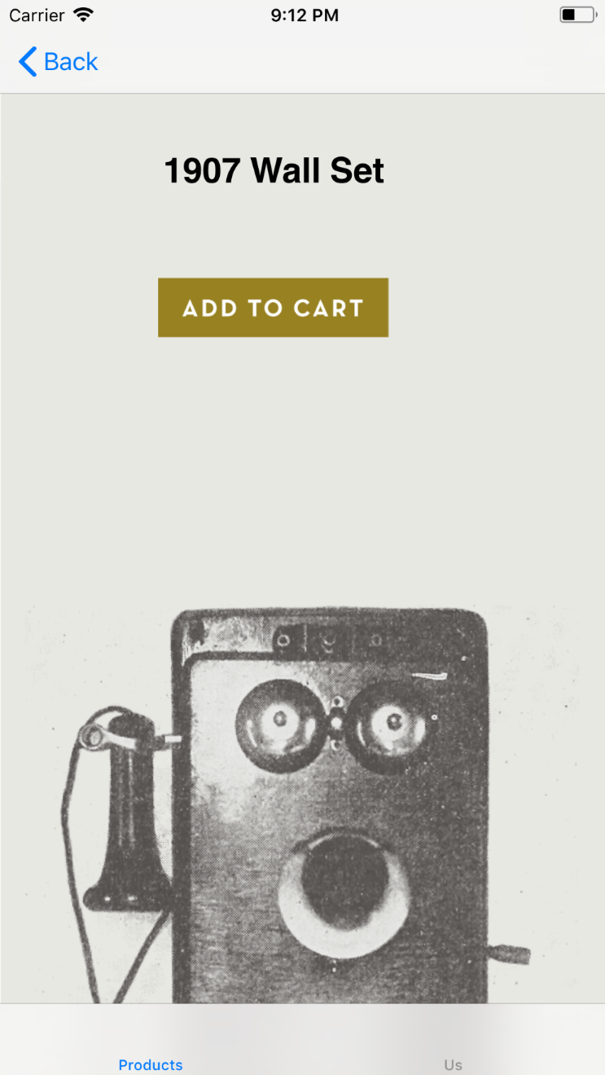 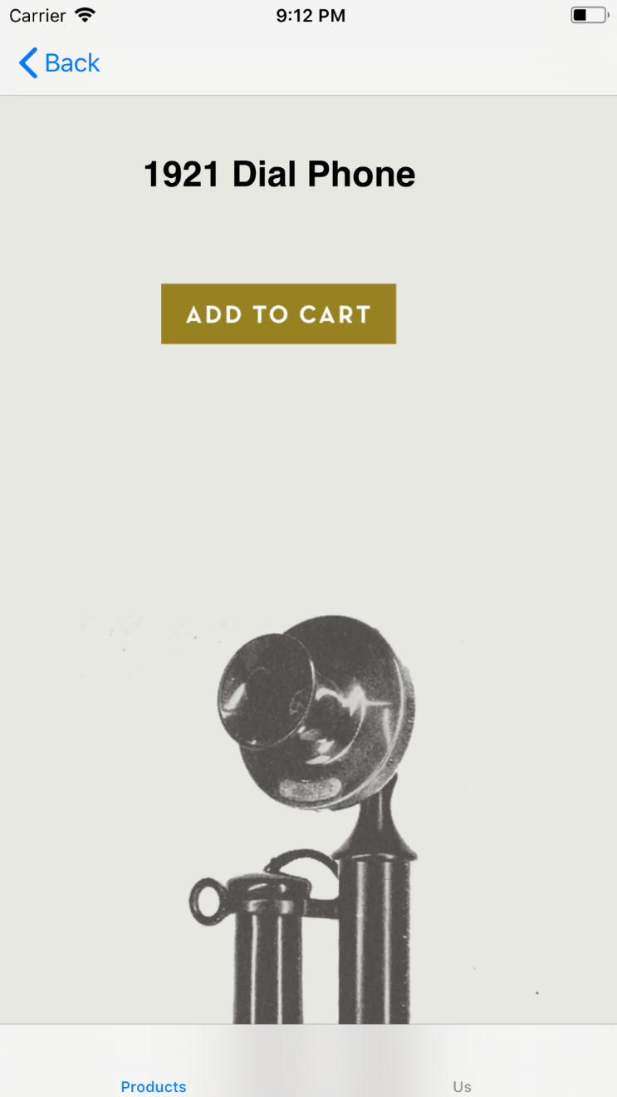

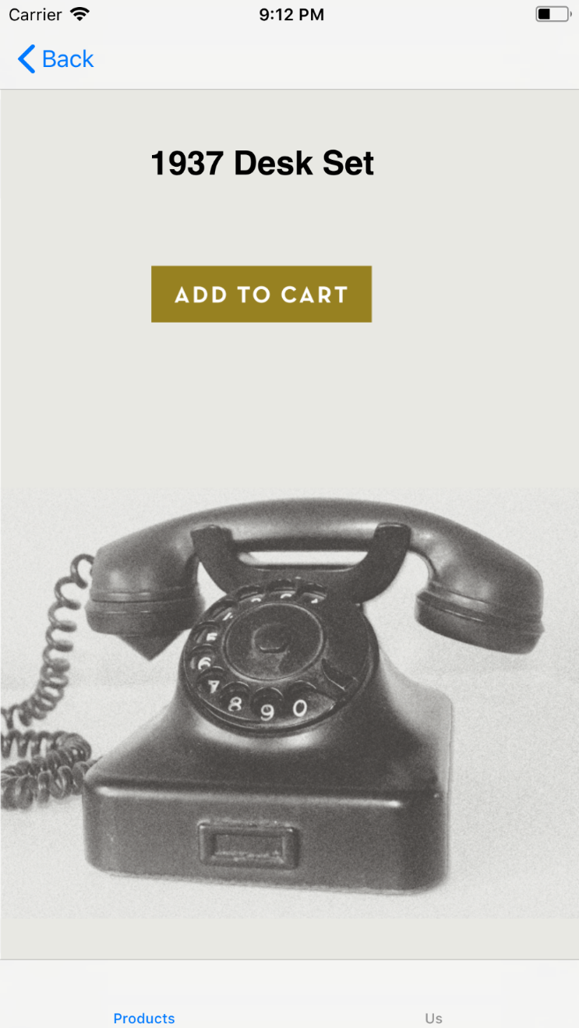 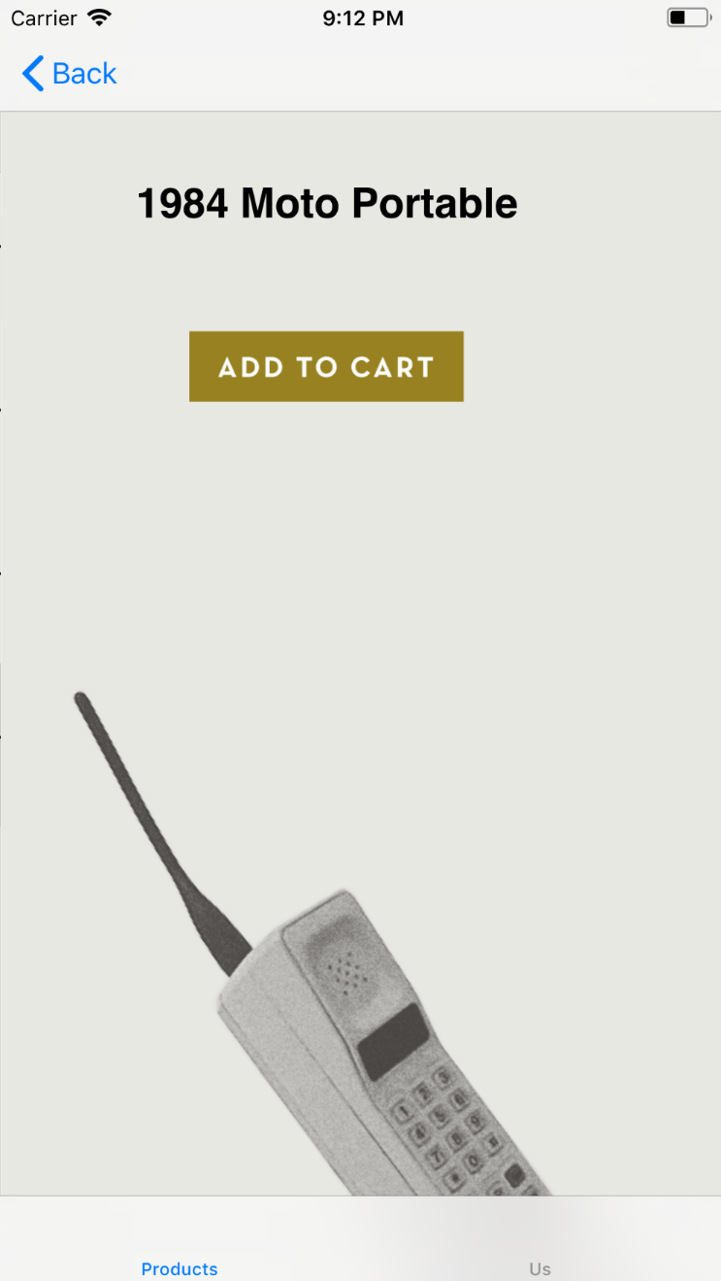

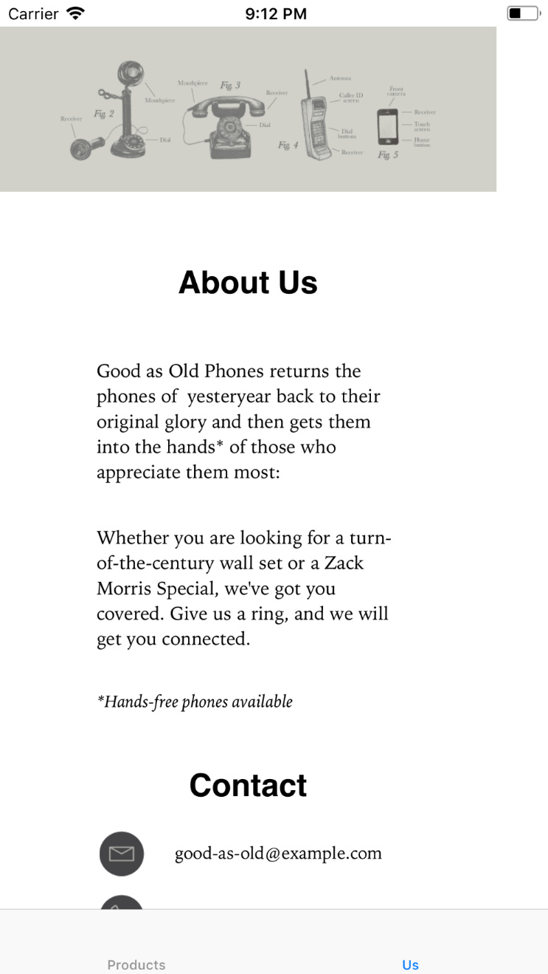 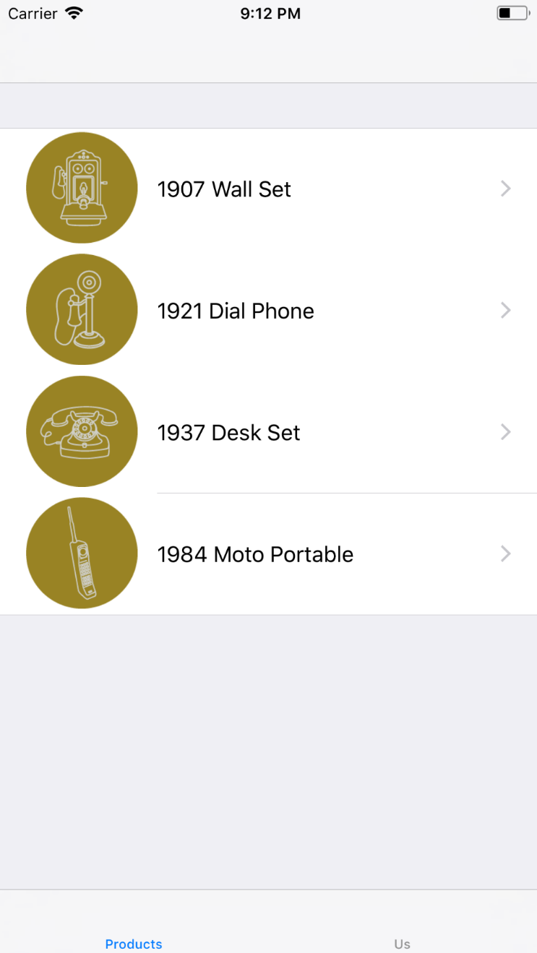

* ***Lovetweet***

**AppDelegate.swift**

import UIKit

@UIApplicationMain

class AppDelegate: UIResponder, UIApplicationDelegate, CAAnimationDelegate {

  var window: UIWindow?

  var mask: CALayer?

  var imageView: UIImageView?

  func application(_ application: UIApplication, didFinishLaunchingWithOptions launchOptions: [UIApplicationLaunchOptionsKey: Any]?) -> Bool {

    window = UIWindow(frame: UIScreen.main.bounds)

    if let window = window {

      // add background imageView

      imageView = UIImageView(frame: window.frame)

      imageView!.image = UIImage(named: "twitterScreen")

      window.addSubview(imageView!)

      // set up mask

      mask = CALayer()

      mask?.contents = UIImage(named: "twitterBird")?.cgImage

      mask?.position = window.center

      mask?.bounds = CGRect(x: 0, y: 0, width: 100, height: 80)

      imageView!.layer.mask = mask

      animateMask()

      // make window visible

      window.rootViewController = UIViewController()

      window.backgroundColor = UIColor(red: 70/255, green: 154/255, blue: 233/255, alpha: 1)

      window.makeKeyAndVisible()

    }

    UIApplication.shared.isStatusBarHidden = true

    return true

  }

  func animateMask() {

    // init key frame animation

    let keyFrameAnimation = CAKeyframeAnimation(keyPath: "bounds")

    keyFrameAnimation.delegate = self

    keyFrameAnimation.duration = 1

    keyFrameAnimation.beginTime = CACurrentMediaTime() + 1

    let initalBounds = NSValue(cgRect: mask!.bounds)

    let secondBounds = NSValue(cgRect: CGRect(x: 0, y: 0, width: 80, height: 64))

    let finalBounds = NSValue(cgRect: CGRect(x: 0, y: 0, width: 2000, height: 2000))

    keyFrameAnimation.values = [initalBounds, secondBounds, finalBounds]

    // set up time interals

    keyFrameAnimation.keyTimes = [0, 0.3, 1]

    // add animation to current view

    keyFrameAnimation.timingFunctions = [CAMediaTimingFunction(name: kCAMediaTimingFunctionEaseInEaseOut), CAMediaTimingFunction(name: kCAMediaTimingFunctionEaseOut)]

    mask!.add(keyFrameAnimation, forKey: "bounds")

  }

  func animationDidStop(_ anim: CAAnimation, finished flag: Bool) {

    imageView?.layer.mask = nil

  }

}

**Output:**

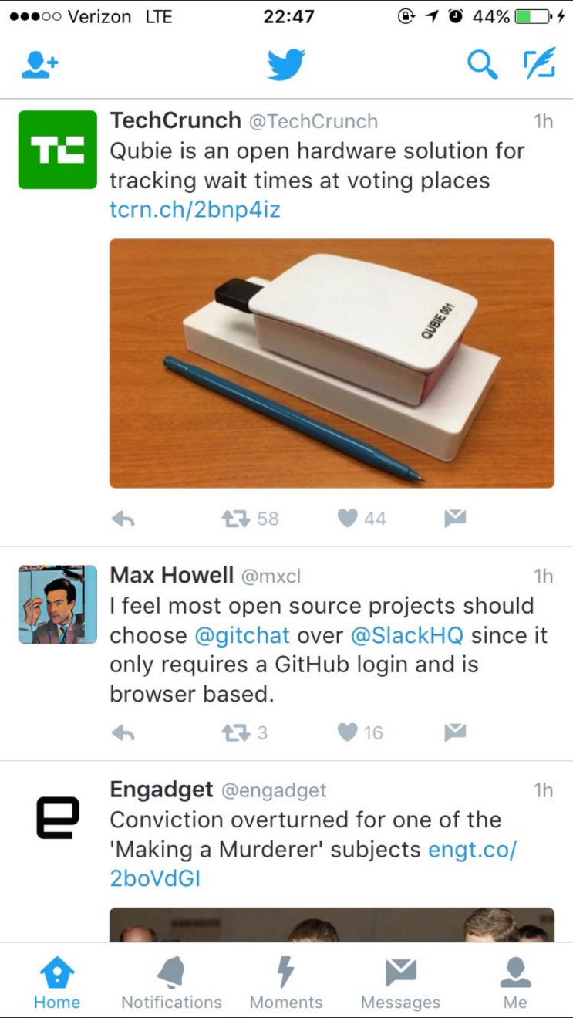

**PRACTICAL 12**

**12)Aim:Implementation of Stopwatch, To Do List & CandySearch in IoS**

* ***Stopwatch***

**ViewController.swift**

import UIKit

class ViewController: UIViewController, UITableViewDelegate {

    // MARK: - Variables

    fileprivate let mainStopwatch: Stopwatch = Stopwatch()

    fileprivate let lapStopwatch: Stopwatch = Stopwatch()

    fileprivate var isPlay: Bool = false

    fileprivate var laps: [String] = []

    // MARK: - UI components

    @IBOutlet weak var timerLabel: UILabel!

    @IBOutlet weak var lapTimerLabel: UILabel!

    @IBOutlet weak var playPauseButton: UIButton!

    @IBOutlet weak var lapRestButton: UIButton!

    @IBOutlet weak var lapsTableView: UITableView!

    // MARK: - Life Cycle

    override func viewDidLoad() {

        super.viewDidLoad()

        let initCircleButton: (UIButton) -> Void = { button in

            button.layer.cornerRadius = 0.5 * button.bounds.size.width

            button.backgroundColor = UIColor.white

        }

        initCircleButton(playPauseButton)

        initCircleButton(lapRestButton)

        lapRestButton.isEnabled = false

        lapsTableView.delegate = self;

        lapsTableView.dataSource = self;

    }

    // MARK: - UI Settings

    override var shouldAutorotate : Bool {

        return false

    }

    override var preferredStatusBarStyle : UIStatusBarStyle {

        return UIStatusBarStyle.lightContent

    }

    override var supportedInterfaceOrientations : UIInterfaceOrientationMask {

        return UIInterfaceOrientationMask.portrait

    }

    // MARK: - Actions

    @IBAction func playPauseTimer(_ sender: AnyObject) {

        lapRestButton.isEnabled = true

        changeButton(lapRestButton, title: "Lap", titleColor: UIColor.black)

        if !isPlay {

            unowned let weakSelf = self

            mainStopwatch.timer = Timer.scheduledTimer(timeInterval: 0.035, target: weakSelf, selector: Selector.updateMainTimer, userInfo: nil, repeats: true)

            lapStopwatch.timer = Timer.scheduledTimer(timeInterval: 0.035, target: weakSelf, selector: Selector.updateLapTimer, userInfo: nil, repeats: true)

            RunLoop.current.add(mainStopwatch.timer, forMode: .commonModes)

            RunLoop.current.add(lapStopwatch.timer, forMode: .commonModes)

            isPlay = true

            changeButton(playPauseButton, title: "Stop", titleColor: UIColor.red)

        } else {

            mainStopwatch.timer.invalidate()

            lapStopwatch.timer.invalidate()

            isPlay = false

            changeButton(playPauseButton, title: "Start", titleColor: UIColor.green)

            changeButton(lapRestButton, title: "Reset", titleColor: UIColor.black)

        }

    }

    @IBAction func lapResetTimer(_ sender: AnyObject) {

        if !isPlay {

            resetMainTimer()

            resetLapTimer()

            changeButton(lapRestButton, title: "Lap", titleColor: UIColor.lightGray)

            lapRestButton.isEnabled = false

        } else {

            if let timerLabelText = timerLabel.text {

                laps.append(timerLabelText)

            }

            lapsTableView.reloadData()

            resetLapTimer()

            unowned let weakSelf = self

            lapStopwatch.timer = Timer.scheduledTimer(timeInterval: 0.035, target: weakSelf, selector: Selector.updateLapTimer, userInfo: nil, repeats: true)

            RunLoop.current.add(lapStopwatch.timer, forMode: .commonModes)

        }

    }

    // MARK: - Private Helpers

    fileprivate func changeButton(_ button: UIButton, title: String, titleColor: UIColor) {

        button.setTitle(title, for: UIControlState())

        button.setTitleColor(titleColor, for: UIControlState())

    }

    fileprivate func resetMainTimer() {

        resetTimer(mainStopwatch, label: timerLabel)

        laps.removeAll()

        lapsTableView.reloadData()

    }

    fileprivate func resetLapTimer() {

        resetTimer(lapStopwatch, label: lapTimerLabel)

    }

    fileprivate func resetTimer(_ stopwatch: Stopwatch, label: UILabel) {

        stopwatch.timer.invalidate()

        stopwatch.counter = 0.0

        label.text = "00:00:00"

    }

    @objc func updateMainTimer() {

        updateTimer(mainStopwatch, label: timerLabel)

    }

    @objc func updateLapTimer() {

        updateTimer(lapStopwatch, label: lapTimerLabel)

    }

    func updateTimer(_ stopwatch: Stopwatch, label: UILabel) {

        stopwatch.counter = stopwatch.counter + 0.035

        var minutes: String = "\((Int)(stopwatch.counter / 60))"

        if (Int)(stopwatch.counter / 60) < 10 {

            minutes = "0\((Int)(stopwatch.counter / 60))"

        }

        var seconds: String = String(format: "%.2f", (stopwatch.counter.truncatingRemainder(dividingBy: 60)))

        if stopwatch.counter.truncatingRemainder(dividingBy: 60) < 10 {

            seconds = "0" + seconds

        }

        label.text = minutes + ":" + seconds

    }

}

// MARK: - UITableViewDataSource

extension ViewController: UITableViewDataSource {

    func tableView(_ tableView: UITableView, numberOfRowsInSection section: Int) -> Int {

        return laps.count

    }

    func tableView(_ tableView: UITableView, cellForRowAt indexPath: IndexPath) -> UITableViewCell {

        let identifier: String = "lapCell"

        let cell: UITableViewCell = tableView.dequeueReusableCell(withIdentifier: identifier, for: indexPath)

        if let labelNum = cell.viewWithTag(11) as? UILabel {

            labelNum.text = "Lap \(laps.count - (indexPath as NSIndexPath).row)"

        }

        if let labelTimer = cell.viewWithTag(12) as? UILabel {

            labelTimer.text = laps[laps.count - (indexPath as NSIndexPath).row - 1]

        }

        return cell

    }

}

// MARK: - Extension

fileprivate extension Selector {

    static let updateMainTimer = #selector(ViewController.updateMainTimer)

    static let updateLapTimer = #selector(ViewController.updateLapTimer)

}

**Stopwatch.swift**

import Foundation

class Stopwatch: NSObject {

  var counter: Double

  var timer: Timer

  override init() {

    counter = 0.0

    timer = Timer()

  }

}

**Output:**

 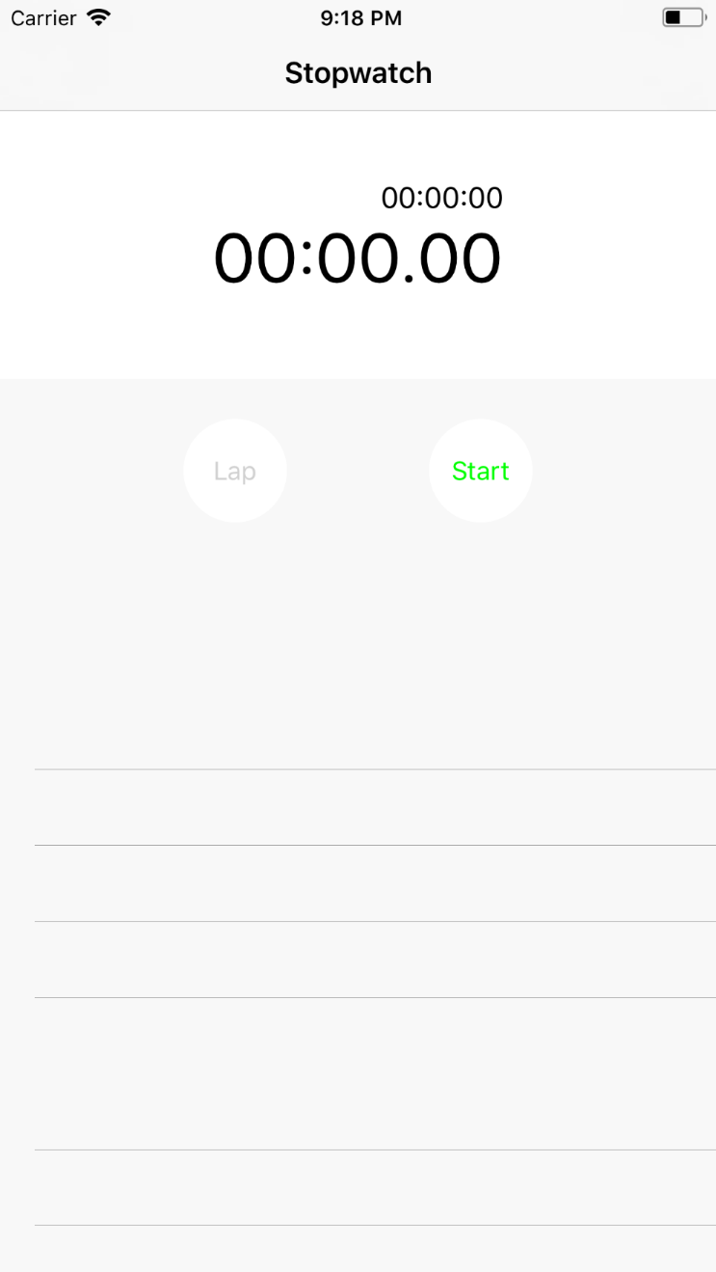

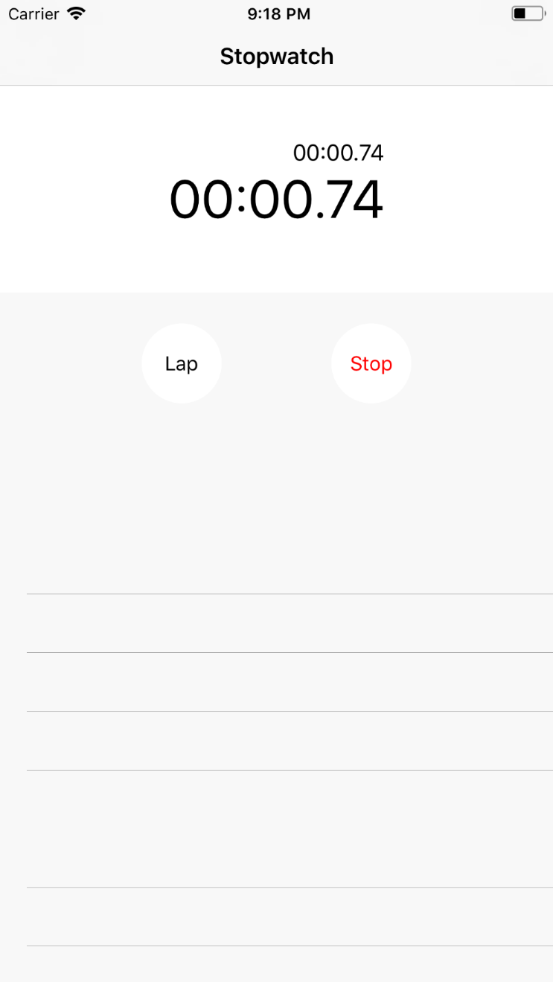 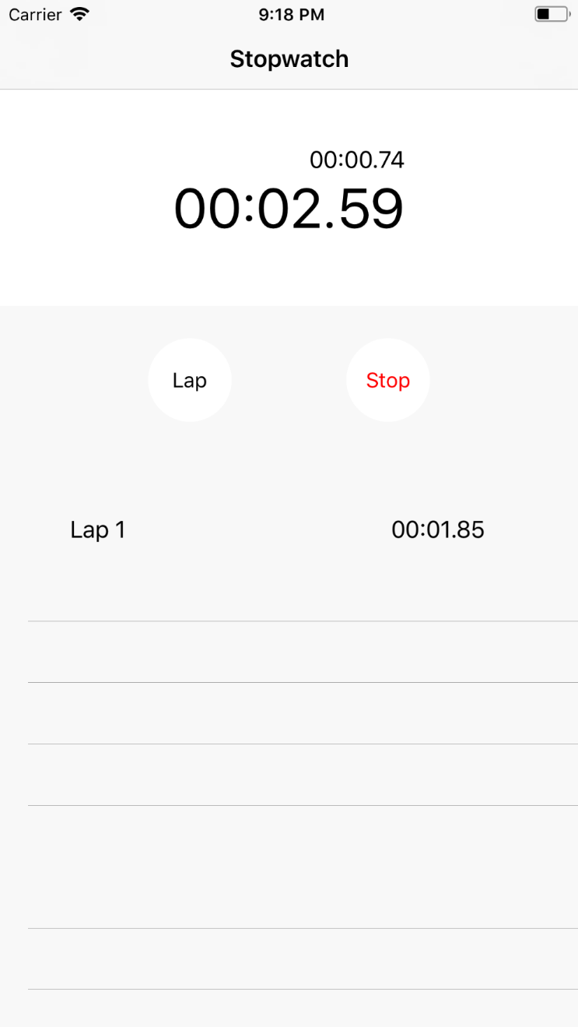

* ***To do***

**Utils.swift**

import Foundation

func dateFromString(_ date: String) -> Date? {

  let dateFormatter = DateFormatter()

  dateFormatter.dateFormat = "yyyy-MM-dd"

  return dateFormatter.date(from: date)

}

func stringFromDate(_ date: Date) -> String {

  let dateFormatter = DateFormatter()

  dateFormatter.dateFormat = "yyyy-MM-dd"

  return dateFormatter.string(from: date)

}

**ToDoItem.swift**

import Foundation

class ToDoItem: NSObject {

  var id: String

  var image: String

  var title: String

  var date: Date

  init(id: String, image: String, title: String, date: Date) {

    self.id = id

    self.image = image

    self.title = title

    self.date = date

  }

}

**ViewController.swift**

import UIKit

var todos: [ToDoItem] = []

class ViewController: UIViewController {

  @IBOutlet weak var todoTableView: UITableView!

  override func viewDidLoad() {

    super.viewDidLoad()

    navigationItem.leftBarButtonItem = editButtonItem

    todos = [ToDoItem(id: "1", image: "child-selected", title: "Go to Disney", date: dateFromString("2014-10-20")!),

             ToDoItem(id: "2", image: "shopping-cart-selected", title: "Cicso Shopping", date: dateFromString("2014-10-28")!),

             ToDoItem(id: "3", image: "phone-selected", title: "Phone to Jobs", date: dateFromString("2014-10-30")!),

             ToDoItem(id: "4", image: "travel-selected", title: "Plan to Europe", date: dateFromString("2014-10-31")!)]

  }

  override func viewWillAppear(_ animated: Bool) {

    super.viewWillAppear(animated)

    todoTableView.reloadData()

  }

  func setMessageLabel(_ messageLabel: UILabel, frame: CGRect, text: String, textColor: UIColor, numberOfLines: Int, textAlignment: NSTextAlignment, font: UIFont) {

    messageLabel.frame = frame

    messageLabel.text = text

    messageLabel.textColor = textColor

    messageLabel.numberOfLines = numberOfLines

    messageLabel.textAlignment = textAlignment

    messageLabel.font = font

    messageLabel.sizeToFit()

  }

  func setCellWithTodoItem(_ cell: UITableViewCell, todo: ToDoItem) {

    let imageView: UIImageView = cell.viewWithTag(11) as! UIImageView

    let titleLabel: UILabel = cell.viewWithTag(12) as! UILabel

    let dateLabel: UILabel = cell.viewWithTag(13) as! UILabel

    imageView.image = UIImage(named: todo.image)

    titleLabel.text = todo.title

    dateLabel.text = stringFromDate(todo.date)

  }

  override func prepare(for segue: UIStoryboardSegue, sender: Any?) {

    if segue.identifier == "editTodo" {

      let vc = segue.destination as! DetailViewController

      let indexPath = todoTableView.indexPathForSelectedRow

      if let indexPath = indexPath {

        vc.todo = todos[(indexPath as NSIndexPath).row]

      }

    }

  }

}

extension ViewController: UITableViewDataSource {

  func tableView(_ tableView: UITableView, numberOfRowsInSection section: Int) -> Int {

    if todos.count != 0 {

      return todos.count

    } else {

      let messageLabel: UILabel = UILabel()

      setMessageLabel(messageLabel, frame: CGRect(x: 0, y: 0, width: self.view.bounds.size.width, height: self.view.bounds.size.height), text: "No data is currently available.", textColor: UIColor.black, numberOfLines: 0, textAlignment: NSTextAlignment.center, font: UIFont(name:"Palatino-Italic", size: 20)!)

      self.todoTableView.backgroundView = messageLabel

      self.todoTableView.separatorStyle = UITableViewCellSeparatorStyle.none

      return 0

    }

  }

  func tableView(_ tableView: UITableView, cellForRowAt indexPath: IndexPath) -> UITableViewCell {

    let cellIdentifier: String = "todoCell"

    let cell = tableView.dequeueReusableCell(withIdentifier: cellIdentifier, for: indexPath)

    setCellWithTodoItem(cell, todo: todos[(indexPath as NSIndexPath).row])

    return cell

  }

}

extension ViewController: UITableViewDelegate {

  // Edit mode

  override func setEditing(_ editing: Bool, animated: Bool) {

    super.setEditing(editing, animated: animated)

    todoTableView.setEditing(editing, animated: true)

  }

  func tableView(_ tableView: UITableView, commit editingStyle: UITableViewCellEditingStyle, forRowAt indexPath: IndexPath) {

    if editingStyle == UITableViewCellEditingStyle.delete {

      todos.remove(at: (indexPath as NSIndexPath).row)

      todoTableView.deleteRows(at: [indexPath], with: UITableViewRowAnimation.automatic)

    }

  }

  // Move the cell

  func tableView(_ tableView: UITableView, canMoveRowAt indexPath: IndexPath) -> Bool {

    return self.isEditing

  }

  func tableView(_ tableView: UITableView, moveRowAt sourceIndexPath: IndexPath, to destinationIndexPath: IndexPath) {

    let todo = todos.remove(at: (sourceIndexPath as NSIndexPath).row)

    todos.insert(todo, at: (destinationIndexPath as NSIndexPath).row)

  }

}

**DetailViewController.swift**

import UIKit

class DetailViewController: UIViewController {

  @IBOutlet weak var childButton: UIButton!

  @IBOutlet weak var phoneButton: UIButton!

  @IBOutlet weak var shoppingCartButton: UIButton!

  @IBOutlet weak var travelButton: UIButton!

  @IBOutlet weak var todoTitleLabel: UITextField!

  @IBOutlet weak var todoDatePicker: UIDatePicker!

  var todo: ToDoItem?

  override func viewDidLoad() {

    super.viewDidLoad()

    if let todo = todo {

      self.title = "Edit Todo"

      if todo.image == "child-selected"{

        childButton.isSelected = true

      }

      else if todo.image == "phone-selected"{

        phoneButton.isSelected = true

      }

      else if todo.image == "shopping-cart-selected"{

        shoppingCartButton.isSelected = true

      }

      else if todo.image == "travel-selected"{

        travelButton.isSelected = true

      }

      todoTitleLabel.text = todo.title

      todoDatePicker.setDate(todo.date, animated: false)

    } else {

      title = "New Todo"

      childButton.isSelected = true

    }

  }

  // MARK: type select

  @IBAction func selectChild(_ sender: AnyObject) {

    resetButtons()

    childButton.isSelected = true

  }

  @IBAction func selectPhone(_ sender: AnyObject) {

    resetButtons()

    phoneButton.isSelected = true

  }

  @IBAction func selectShoppingCart(_ sender: AnyObject) {

    resetButtons()

    shoppingCartButton.isSelected = true

  }

  @IBAction func selectTravel(_ sender: AnyObject) {

    resetButtons()

    travelButton.isSelected = true

  }

  func resetButtons() {

    childButton.isSelected = false

    phoneButton.isSelected = false

    shoppingCartButton.isSelected = false

    travelButton.isSelected = false

  }

    @IBAction func tapDone(_ sender: AnyObject) {

    var image = ""

    if childButton.isSelected {

      image = "child-selected"

    }

    else if phoneButton.isSelected {

      image = "phone-selected"

    }

    else if shoppingCartButton.isSelected {

      image = "shopping-cart-selected"

    }

    else if travelButton.isSelected {

      image = "travel-selected"

    }

    if let todo = todo {

      todo.image = image

      todo.title = todoTitleLabel.text!

      todo.date = todoDatePicker.date

    } else {

      let uuid = UUID().uuidString

      todo = ToDoItem(id: uuid, image: image, title: todoTitleLabel.text!, date: todoDatePicker.date)

      todos.append(todo!)

    }

    let _ = navigationController?.popToRootViewController(animated: true)

  }

  override func touchesBegan(_ touches: Set<UITouch>, with event: UIEvent?) {

    super.touchesBegan(touches, with: event)

    view.endEditing(true)

  }

}

**Output:**

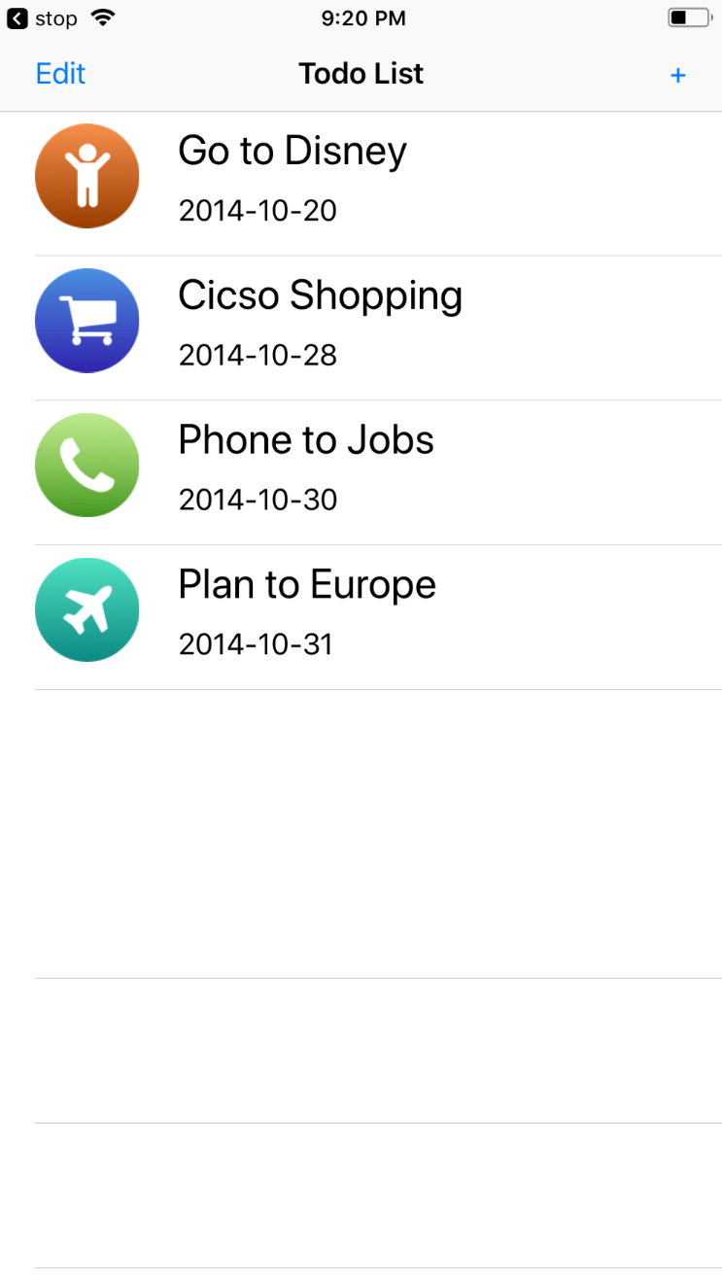 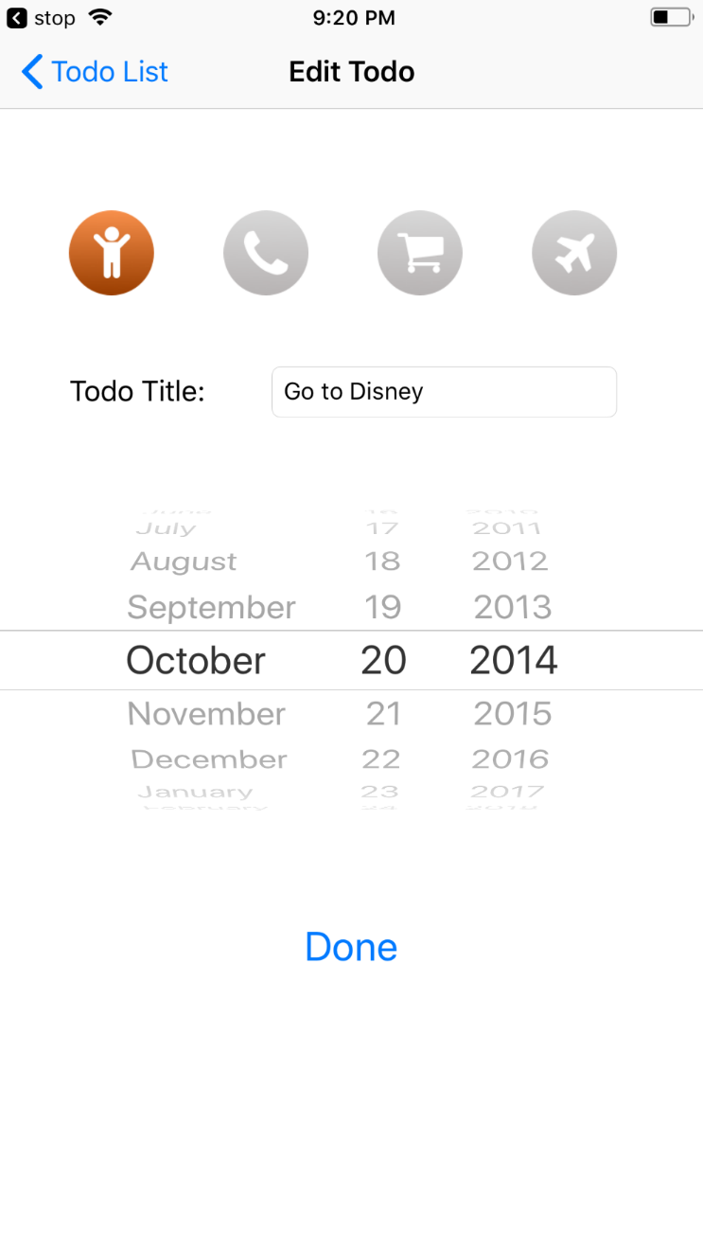

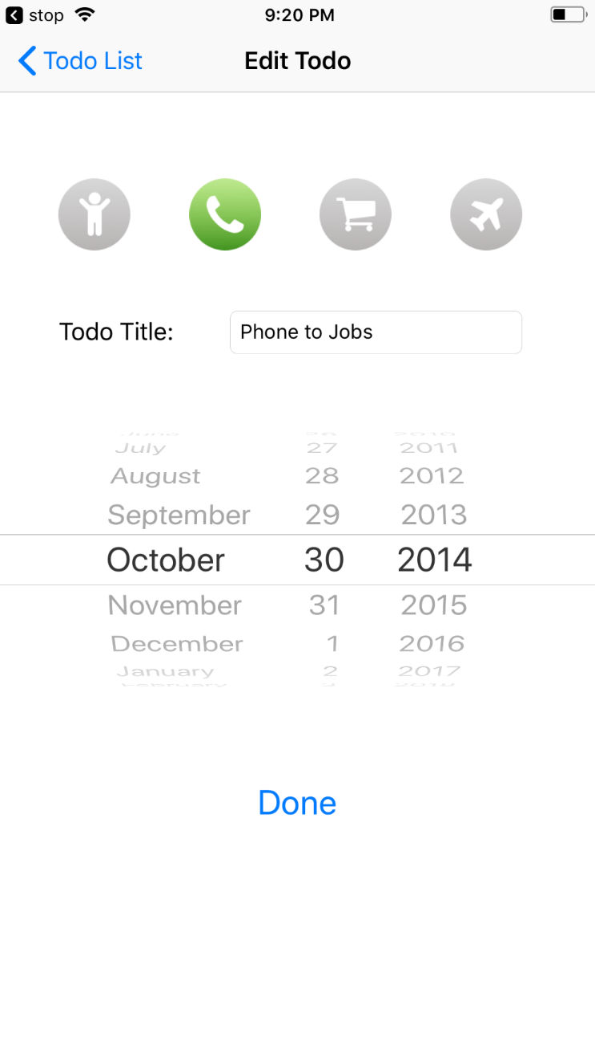

* ***CandySearch***

**MasterViewController.shift**

import UIKit

class MasterViewController: UITableViewController {

  // MARK: - Properties

  var detailViewController: DetailViewController? = nil

  var candies = [Candy]()

  var filteredCandies = [Candy]()

  let searchController = UISearchController(searchResultsController: nil)

  // MARK: - View Setup

  override func viewDidLoad() {

    super.viewDidLoad()

    candies = [

        Candy(category:"Chocolate", name:"Chocolate Bar"),

        Candy(category:"Chocolate", name:"Chocolate Chip"),

        Candy(category:"Chocolate", name:"Dark Chocolate"),

        Candy(category:"Hard", name:"Lollipop"),

        Candy(category:"Hard", name:"Candy Cane"),

        Candy(category:"Hard", name:"Jaw Breaker"),

        Candy(category:"Other", name:"Caramel"),

        Candy(category:"Other", name:"Sour Chew"),

        Candy(category:"Other", name:"Gummi Bear")

    ]

    setupSearchController()

    if let splitViewController = splitViewController {

      let controllers = splitViewController.viewControllers

      detailViewController = (controllers[controllers.count - 1] as! UINavigationController).topViewController as? DetailViewController

    }

  }

  // MARK: - Search Controller Setup

  func setupSearchController () {

    searchController.searchResultsUpdater = self

    searchController.dimsBackgroundDuringPresentation = false

    definesPresentationContext = true

    searchController.searchBar.scopeButtonTitles = ["All", "Chocolate", "Hard", "Other"]

    searchController.searchBar.delegate = self

    if #available(iOS 11, *) {

        self.navigationItem.searchController = searchController

        self.navigationItem.searchController?.isActive = true

        self.navigationItem.hidesSearchBarWhenScrolling = false

    } else {

        tableView.tableHeaderView = searchController.searchBar

    }

  }

  func filterContentForSearchText(_ searchText: String, scope: String = "All") {

        filteredCandies = candies.filter { candy in

            if !(candy.category == scope) && scope != "All" {

                return false

            }

            return candy.name.lowercased().contains(searchText.lowercased()) || searchText == ""

        }

        tableView.reloadData()

  }

  override func viewWillAppear(_ animated: Bool) {

    clearsSelectionOnViewWillAppear = splitViewController!.isCollapsed

    super.viewWillAppear(animated)

  }

  override func didReceiveMemoryWarning() {

    super.didReceiveMemoryWarning()

  }

  // MARK: - Table View

  override func numberOfSections(in tableView: UITableView) -> Int {

    return 1

  }

  override func tableView(_ tableView: UITableView, numberOfRowsInSection section: Int) -> Int {

    if searchController.isActive {

      return filteredCandies.count

    }

    return candies.count

  }

  override func tableView(_ tableView: UITableView, cellForRowAt indexPath: IndexPath) -> UITableViewCell {

    let cell = tableView.dequeueReusableCell(withIdentifier: "Cell", for: indexPath)

    let candy: Candy

    if searchController.isActive {

      candy = filteredCandies[(indexPath as NSIndexPath).row]

    } else {

      candy = candies[(indexPath as NSIndexPath).row]

    }

    cell.textLabel!.text = candy.name

    cell.detailTextLabel!.text = candy.category

    return cell

  }

  // MARK: - Segues

  override func prepare(for segue: UIStoryboardSegue, sender: Any?) {

    if segue.identifier == "showDetail" {

      if let indexPath = tableView.indexPathForSelectedRow {

        let candy: Candy

        if searchController.isActive {

          candy = filteredCandies[(indexPath as NSIndexPath).row]

        } else {

          candy = candies[(indexPath as NSIndexPath).row]

        }

        let controller = (segue.destination as! UINavigationController).topViewController as! DetailViewController

        controller.detailCandy = candy

        controller.navigationItem.leftBarButtonItem = splitViewController?.displayModeButtonItem

        controller.navigationItem.leftItemsSupplementBackButton = true

      }

    }

  }

}

extension MasterViewController: UISearchResultsUpdating {

  func updateSearchResults(for searchController: UISearchController) {

    let searchBar = searchController.searchBar

    let scope = searchBar.scopeButtonTitles![searchBar.selectedScopeButtonIndex]

    filterContentForSearchText(searchController.searchBar.text!, scope: scope)

  }

}

extension MasterViewController: UISearchBarDelegate {

  func searchBar(_ searchBar: UISearchBar, selectedScopeButtonIndexDidChange selectedScope: Int) {

    filterContentForSearchText(searchBar.text!, scope: searchBar.scopeButtonTitles![selectedScope])

  }

}

**DetailViewController.shift**

import UIKit

class DetailViewController: UIViewController {

  @IBOutlet weak var detailDescriptionLabel: UILabel!

  @IBOutlet weak var candyImageView: UIImageView!

  var detailCandy: Candy? {

    didSet {

      configureView()

    }

  }

  func configureView() {

    if let detailCandy = detailCandy {

      if let detailDescriptionLabel = detailDescriptionLabel, let candyImageView = candyImageView {

        detailDescriptionLabel.text = detailCandy.name

        candyImageView.image = UIImage(named: detailCandy.name)

        title = detailCandy.category

      }

    }

  }

  override func viewDidLoad() {

    super.viewDidLoad()

    configureView()

  }

  override func didReceiveMemoryWarning() {

    super.didReceiveMemoryWarning()

  }

}

**Candy.shift**

import Foundation

class Candy {

  var category : String

  var name : String

  init(category: String, name: String) {

    self.category = category

    self.name = name

  }

}

**Output:**

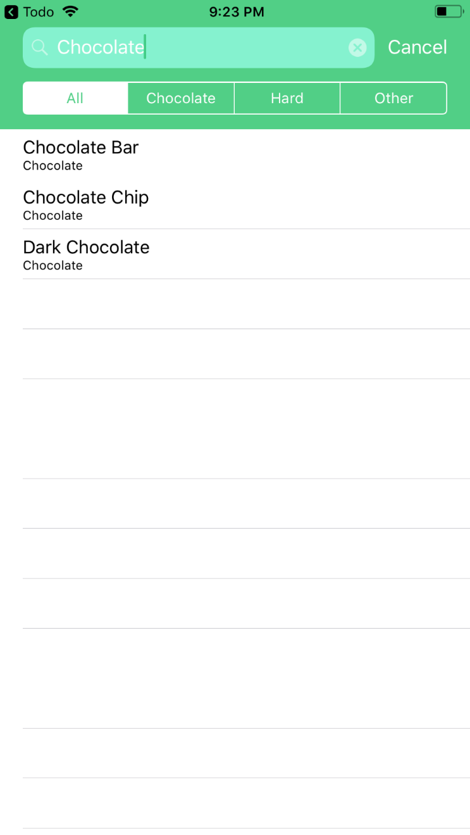 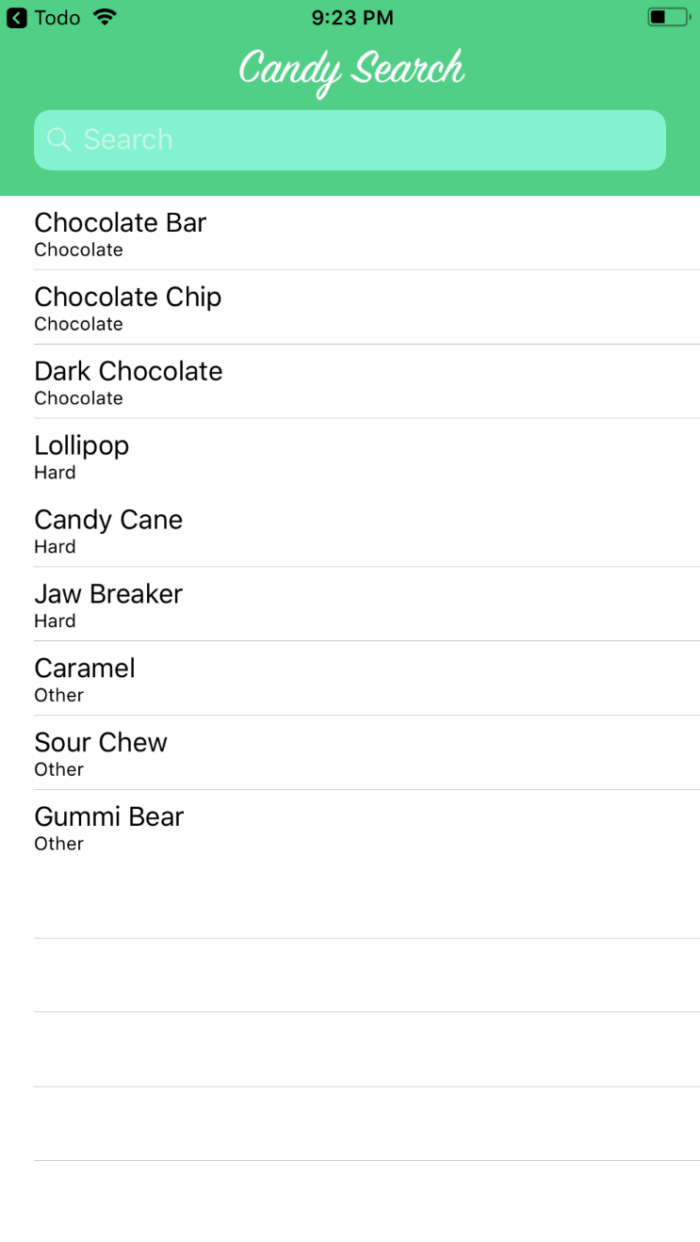

**PRACTICAL 13**

**13) Aim:Implementation of PokedexGo, Simple RSS Reader,FacebookMe, Interests, Photoscroll & Animation in iOS**

* ***PokedexGo***

**MasterViewControllerTableViewController.swift**

import UIKit

import RxSwift

import RxCocoa

protocol PokemonSelectionDelegate: class {

  func pokemonSelected(_ newPokemon: Pokemon)

}

class MasterViewController: UITableViewController {

  var pokemons = LibraryAPI.sharedInstance.getPokemons()

  var filteredPokemons = [Pokemon]()

  weak var delegate: PokemonSelectionDelegate?

  fileprivate let disposeBag = DisposeBag()

  @IBOutlet weak var searchBar: UISearchBar!

  override func viewDidLoad() {

    super.viewDidLoad()

    setupUI()

    filteredPokemons = pokemons

  }

  fileprivate func setupUI() {

    self.title = "精灵列表"

    definesPresentationContext = true

    searchBar

      .rx.text

      .throttle(0.5, scheduler: MainScheduler.instance)

      .subscribe(

        onNext: { [unowned self] query in

          if query?.characters.count == 0 {

            self.filteredPokemons = self.pokemons

          } else {

            self.filteredPokemons = self.pokemons.filter{ $0.name.hasPrefix(query!) }

          }

          self.tableView.reloadData()

        })

      .addDisposableTo(disposeBag)

  }

  func dismissKeyboard() {

    view.endEditing(true)

  }

  // MARK: - UITableViewDelegate

  override func tableView(_ tableView: UITableView, heightForRowAt indexPath: IndexPath) -> CGFloat {

    return 140

  }

  override func tableView(_ tableView: UITableView, didSelectRowAt indexPath: IndexPath) {

    let pokemon = self.filteredPokemons[(indexPath as NSIndexPath).row]

    delegate?.pokemonSelected(pokemon)

    if let detailViewController = self.delegate as? DetailViewController {

      splitViewController?.showDetailViewController(detailViewController.navigationController!, sender: nil)

    }

  }

  // MARK: - UITableViewDataSource

  override func numberOfSections(in tableView: UITableView) -> Int {

    return 1

  }

  override func tableView(_ tableView: UITableView, numberOfRowsInSection section: Int) -> Int {

    return filteredPokemons.count

  }

  override func tableView(_ tableView: UITableView, cellForRowAt indexPath: IndexPath) -> UITableViewCell {

    let identifier = "Cell"

    let cell = tableView.dequeueReusableCell(withIdentifier: identifier, for: indexPath) as! MasterTableViewCell

    let pokemon = filteredPokemons[(indexPath as NSIndexPath).row]

    cell.awakeFromNib(pokemon.id, name: pokemon.name, pokeImageUrl: pokemon.pokeImgUrl)

    return cell

  }

}

**LibraryAPI.swift**

import UIKit

class LibraryAPI: NSObject {

  static let sharedInstance = LibraryAPI()

  let persistencyManager = PersistencyManager()

  fileprivate override init() {

    super.init()

    NotificationCenter.default.addObserver(self, selector:#selector(LibraryAPI.downloadImage(_:)), name: NSNotification.Name(rawValue: downloadImageNotification), object: nil)

  }

  deinit {

    NotificationCenter.default.removeObserver(self)

  }

    func getPokemons() -> [Pokemon] {

    return pokemons

  }

  func downloadImg(_ url: String) -> (UIImage) {

    let aUrl = URL(string: url)

    let data = try? Data(contentsOf: aUrl!)

    let image = UIImage(data: data!)

    return image!

  }

  func downloadImage(_ notification: Notification) {

    // retrieve info from notification

    let userInfo = (notification as NSNotification).userInfo as! [String: AnyObject]

    let pokeImageView = userInfo["pokeImageView"] as! UIImageView?

    let pokeImageUrl = userInfo["pokeImageUrl"] as! String

    if let imageViewUnWrapped = pokeImageView {

      imageViewUnWrapped.image = persistencyManager.getImage(URL(string: pokeImageUrl)!.lastPathComponent)

      if imageViewUnWrapped.image == nil {

        DispatchQueue.global().async {

          let downloadedImage = self.downloadImg(pokeImageUrl as String)

          DispatchQueue.main.async {

            imageViewUnWrapped.image = downloadedImage

            self.persistencyManager.saveImage(downloadedImage, filename: URL(string: pokeImageUrl)!.lastPathComponent)

          }

        }

      }

    }

  }

}

**PersistencyManager.swift**

import UIKit

class PersistencyManager: NSObject {

  func saveImage(_ image: UIImage, filename: String) {

    let path = NSHomeDirectory() + "/Documents/\(filename)"

    let data = UIImagePNGRepresentation(image)

    try? data!.write(to: URL(fileURLWithPath: path), options: [.atomic])

  }

  func getImage(_ filename: String) -> UIImage? {

    let path = NSHomeDirectory() + "/Documents/\(filename)"

    do {

      let data = try Data(contentsOf: URL(fileURLWithPath: path), options: .uncachedRead)

      return UIImage(data: data)

    } catch {

      return nil

    }

  }

}

**MasterViewControllerTableViewController.swift**

import UIKit

import RxSwift

import RxCocoa

protocol PokemonSelectionDelegate: class {

  func pokemonSelected(_ newPokemon: Pokemon)

}

class MasterViewController: UITableViewController {

  var pokemons = LibraryAPI.sharedInstance.getPokemons()

  var filteredPokemons = [Pokemon]()

  weak var delegate: PokemonSelectionDelegate?

  fileprivate let disposeBag = DisposeBag()

  @IBOutlet weak var searchBar: UISearchBar!

  override func viewDidLoad() {

    super.viewDidLoad()

    setupUI()

    filteredPokemons = pokemons

  }

  fileprivate func setupUI() {

    self.title = "精灵列表"

    definesPresentationContext = true

    searchBar

      .rx.text

      .throttle(0.5, scheduler: MainScheduler.instance)

      .subscribe(

        onNext: { [unowned self] query in

          if query?.characters.count == 0 {

            self.filteredPokemons = self.pokemons

          } else {

            self.filteredPokemons = self.pokemons.filter{ $0.name.hasPrefix(query!) }

          }

          self.tableView.reloadData()

        })

      .addDisposableTo(disposeBag)

  }

  func dismissKeyboard() {

    view.endEditing(true)

  }

  // MARK: - UITableViewDelegate

  override func tableView(_ tableView: UITableView, heightForRowAt indexPath: IndexPath) -> CGFloat {

    return 140

  }

  override func tableView(_ tableView: UITableView, didSelectRowAt indexPath: IndexPath) {

    let pokemon = self.filteredPokemons[(indexPath as NSIndexPath).row]

    delegate?.pokemonSelected(pokemon)

    if let detailViewController = self.delegate as? DetailViewController {

      splitViewController?.showDetailViewController(detailViewController.navigationController!, sender: nil)

    }

  }

  // MARK: - UITableViewDataSource

  override func numberOfSections(in tableView: UITableView) -> Int {

    return 1

  }

  override func tableView(_ tableView: UITableView, numberOfRowsInSection section: Int) -> Int {

    return filteredPokemons.count

  }

  override func tableView(_ tableView: UITableView, cellForRowAt indexPath: IndexPath) -> UITableViewCell {

    let identifier = "Cell"

    let cell = tableView.dequeueReusableCell(withIdentifier: identifier, for: indexPath) as! MasterTableViewCell

    let pokemon = filteredPokemons[(indexPath as NSIndexPath).row]

    cell.awakeFromNib(pokemon.id, name: pokemon.name, pokeImageUrl: pokemon.pokeImgUrl)

    return cell

  }

}

**DetailViewController.swift**

import UIKit

class DetailViewController: UIViewController {

  // MARK: - IBOutlets

  @IBOutlet weak var nameIDLabel: UILabel!

  @IBOutlet weak var pokeImageView: UIImageView!

  @IBOutlet weak var pokeInfoLabel: UILabel!

  var pokemon: Pokemon! {

    didSet (newPokemon) {

      self.refreshUI()

    }

  }

  override func viewDidLoad() {

    refreshUI()

    super.viewDidLoad()

      }

  func refreshUI() {

    nameIDLabel?.text = pokemon.name + (pokemon.id < 10 ? " #00\(pokemon.id)" : pokemon.id < 100 ? " #0\(pokemon.id)" : " #\(pokemon.id)")

    pokeImageView?.image = LibraryAPI.sharedInstance.downloadImg(pokemon.pokeImgUrl)

    pokeInfoLabel?.text = pokemon.detailInfo

    self.title = pokemon.name

  }

}

extension DetailViewController: PokemonSelectionDelegate {

  func pokemonSelected(_ newPokemon: Pokemon) {

    pokemon = newPokemon

  }

}

**Pokemon.swift**

import UIKit

enum PokeType {

  case normal

  case fire

  case water

  case electric

  case grass

  case ice

  case fighting

  case poison

  case ground

  case flying

  case psychic

  case bug

  case rock

  case ghost

  case dragon

  case dark

  case steel

  case fairy

}

class Pokemon: NSObject {

  let name: String

  let id: Int

  let detailInfo: String

  let type: [PokeType]

  let weak: [PokeType]

  let pokeImgUrl: String

  init(name: String, id: Int, detailInfo: String, type: [PokeType], weak: [PokeType], pokeImgUrl: String) {

    self.name = name

    self.id = id

    self.detailInfo = detailInfo

    self.type = type

    self.weak = weak

    self.pokeImgUrl = pokeImgUrl

  }

}

**MasterTableViewCell.swift**

import UIKit

class MasterTableViewCell: UITableViewCell {

  @IBOutlet weak var idLabel: UILabel!

  @IBOutlet weak var nameLabel: UILabel!

  @IBOutlet weak var pokeImageView: UIImageView!

  fileprivate var indicator: UIActivityIndicatorView!

  func awakeFromNib(_ id: Int, name: String, pokeImageUrl: String) {

    super.awakeFromNib()

    setupUI(id, name: name)

    setupNotification(pokeImageUrl)

  }

    deinit {

    pokeImageView.removeObserver(self, forKeyPath: "image")

  }

  override func setSelected(_ selected: Bool, animated: Bool) {

    super.setSelected(selected, animated: animated)

  }

  fileprivate func setupUI(_ id: Int, name: String) {

    idLabel.text = NSString(format: "#%03d", id) as String

    nameLabel.text = name

    pokeImageView.image = UIImage(named: "default_img")

    indicator = UIActivityIndicatorView()

    indicator.center = CGPoint(x: pokeImageView.bounds.midX, y: pokeImageView.bounds.midY)

    indicator.activityIndicatorViewStyle = .whiteLarge

    indicator.startAnimating()

    pokeImageView.addSubview(indicator)

    pokeImageView.addObserver(self, forKeyPath: "image", options: [], context: nil)

  }

  fileprivate func setupNotification(_ pokeImageUrl: String) {

    NotificationCenter.default.post(name: Notification.Name(rawValue: downloadImageNotification), object: self, userInfo: ["pokeImageView":pokeImageView, "pokeImageUrl" : pokeImageUrl])

  }

  override func observeValue(forKeyPath keyPath: String?, of object: Any?, change: [NSKeyValueChangeKey : Any]?, context: UnsafeMutableRawPointer?) {

    if keyPath == "image" {

      indicator.stopAnimating()

    }

  }

}

**PokemonConstants.swift**

import Foundation

let pokemons = [

  Pokemon(name: "妙蛙种子", id: 1,

    detailInfo: "妙蛙种子经常在阳光下酣睡。它背上有个种子，通过吸收阳光渐渐长大。",

    type: [PokeType.grass, PokeType.poison],

    weak: [PokeType.fire, PokeType.flying, PokeType.ice, PokeType.psychic],

    pokeImgUrl: "http://assets.pokemon.com/assets/cms2/img/pokedex/full/001.png"),

  Pokemon(name: "妙蛙草", id: 2,

    detailInfo: "在它的背上有一个花苞。妙蛙草的四肢非常粗壮，这样才能支撑它的体重。如果它开始经常晒太阳，表明它将要开花了。",

    type: [PokeType.grass, PokeType.poison],

    weak: [PokeType.fire, PokeType.flying, PokeType.ice, PokeType.psychic],

    pokeImgUrl: "http://assets.pokemon.com/assets/cms2/img/pokedex/full/002.png"),

  Pokemon(name: "妙蛙花", id: 3,

    detailInfo: "妙蛙花的背上有一朵巨大的鲜花。如果它吸收养分、晒太阳，花的颜色就会变得非常鲜艳。花的香气还可以抚慰伤感的人。",

    type: [PokeType.grass, PokeType.poison],

    weak: [PokeType.fire, PokeType.flying, PokeType.ice, PokeType.psychic],

    pokeImgUrl: "http://assets.pokemon.com/assets/cms2/img/pokedex/full/003.png"),

  Pokemon(name: "小火龙", id: 4,

    detailInfo: "它尾巴上的火焰能够表现出它的情绪。当它开心时，火焰会摇曳。如果它被激怒，火焰就会猛烈地燃烧。",

    type: [PokeType.fire],

    weak: [PokeType.ground, PokeType.rock, PokeType.water],

    pokeImgUrl: "http://assets.pokemon.com/assets/cms2/img/pokedex/full/004.png"),

  Pokemon(name: "火恐龙", id: 5,

    detailInfo: "火恐龙会用它锋利的爪子残忍地撕裂敌人。如果它的敌人十分强壮，它就会变得好斗。在这种情况下，它尾巴上的火焰会变成带点蓝色的亮白。",

    type: [PokeType.fire],

    weak: [PokeType.ground, PokeType.rock, PokeType.water],

    pokeImgUrl: "http://assets.pokemon.com/assets/cms2/img/pokedex/full/005.png"),

  Pokemon(name: "喷火龙", id: 6,

    detailInfo: "喷火龙在空中飞行，寻找强大的对手。它吐出的火焰温度极高，可以融化一切物体。然而，它从来不攻击任何比它弱小的对手。",

    type: [PokeType.fire, PokeType.flying],

    weak: [PokeType.ground, PokeType.electric, PokeType.water],

    pokeImgUrl: "http://assets.pokemon.com/assets/cms2/img/pokedex/full/006.png"),

  Pokemon(name: "杰尼龟", id: 7,

    detailInfo: "杰尼龟的壳不仅仅用来保护自己。它圆形的壳和表明的沟壑减小了它在水中的阻力，让这只神奇宝贝能高速游泳。",

    type: [PokeType.water],

    weak: [PokeType.electric, PokeType.grass],

    pokeImgUrl: "http://assets.pokemon.com/assets/cms2/img/pokedex/full/007.png"),

  Pokemon(name: "卡咪龟", id: 8,

    detailInfo: "蓬松的毛覆盖的大大的尾巴的颜色会随着年龄的增长而变深。背甲上的伤痕是强者的证明。",

    type: [PokeType.water],

    weak: [PokeType.electric, PokeType.grass],

    pokeImgUrl: "http://assets.pokemon.com/assets/cms2/img/pokedex/full/008.png"),

  Pokemon(name: "水箭龟", id: 9,

    detailInfo: "水箭龟背甲上伸出喷射口，可以精确瞄准，水弹可以击中50米外的空罐子。",

    type: [PokeType.water],

    weak: [PokeType.electric, PokeType.grass],

    pokeImgUrl: "http://assets.pokemon.com/assets/cms2/img/pokedex/full/009.png"),

  Pokemon(name: "绿毛虫", id: 10,

    detailInfo: "有着很好的食欲，可以瞬间吃掉比身体还大的叶子。触角会释放出强烈的臭味。",

    type: [PokeType.bug],

    weak: [PokeType.fire, PokeType.flying, PokeType.rock],

    pokeImgUrl: "http://assets.pokemon.com/assets/cms2/img/pokedex/full/010.png"),

  Pokemon(name: "铁甲蛹", id: 11,

    detailInfo: "身体外面的壳有铁板那么硬。不怎么移动是因为里面柔软的身体正在准备进化。",

    type: [PokeType.bug],

    weak: [PokeType.fire, PokeType.flying, PokeType.rock],

    pokeImgUrl: "http://assets.pokemon.com/assets/cms2/img/pokedex/full/011.png"),

  Pokemon(name: "巴大蝶", id: 12,

    detailInfo: "寻找美味花蜜的能力非常好，离家10公里外开花的花蜜也可以找到并运回来。",

    type: [PokeType.bug, PokeType.flying],

    weak: [PokeType.fire, PokeType.flying, PokeType.rock, PokeType.electric, PokeType.ice],

    pokeImgUrl: "http://assets.pokemon.com/assets/cms2/img/pokedex/full/012.png"),

  Pokemon(name: "独角虫", id: 13,

    detailInfo: "嗅觉非常灵敏，可以用大大的红鼻子从讨厌的叶子中嗅出自己喜欢的叶子的味道。",

    type: [PokeType.bug, PokeType.poison],

    weak: [PokeType.fire, PokeType.flying, PokeType.rock, PokeType.psychic],

    pokeImgUrl: "http://assets.pokemon.com/assets/cms2/img/pokedex/full/013.png"),

  Pokemon(name: "铁壳蛹", id: 14,

    detailInfo: "挂在树上几乎一动不动是为了进化忙碌地准备着，证据是身体在逐渐变热。",

    type: [PokeType.bug, PokeType.poison],

    weak: [PokeType.fire, PokeType.flying, PokeType.rock, PokeType.psychic],

    pokeImgUrl: "http://assets.pokemon.com/assets/cms2/img/pokedex/full/014.png"),

  Pokemon(name: "大针蜂", id: 15,

    detailInfo: "保护领地的意识非常强，为了安全不会让任何人接近自己的巢穴，生气的话就会一起攻上来。",

    type: [PokeType.bug, PokeType.poison],

    weak: [PokeType.fire, PokeType.flying, PokeType.rock, PokeType.psychic],

    pokeImgUrl: "http://assets.pokemon.com/assets/cms2/img/pokedex/full/015.png")

]

**Constants.swift**

import Foundation

let downloadImageNotification        = "PokedexGoDownloadImageNotification"

**Output:**

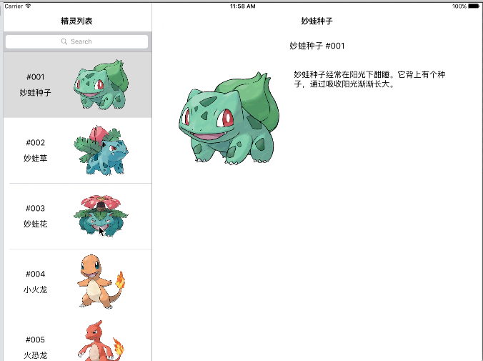

* ***Simple Rss Reader***

**AppDelegate.swift**

import UIKit

@UIApplicationMain

class AppDelegate: UIResponder, UIApplicationDelegate {

  var window: UIWindow?

    func application(_ application: UIApplication, didFinishLaunchingWithOptions launchOptions: [UIApplicationLaunchOptionsKey: Any]?) -> Bool {

    // Override point for customization after application launch.

    return true

  }

  func applicationWillResignActive(_ application: UIApplication) {

    // Sent when the application is about to move from active to inactive state. This can occur for certain types of temporary interruptions (such as an incoming phone call or SMS message) or when the user quits the application and it begins the transition to the background state.

    // Use this method to pause ongoing tasks, disable timers, and throttle down OpenGL ES frame rates. Games should use this method to pause the game.

  }

  func applicationDidEnterBackground(_ application: UIApplication) {

    // Use this method to release shared resources, save user data, invalidate timers, and store enough application state information to restore your application to its current state in case it is terminated later.

    // If your application supports background execution, this method is called instead of applicationWillTerminate: when the user quits.

  }

  func applicationWillEnterForeground(_ application: UIApplication) {

    // Called as part of the transition from the background to the inactive state; here you can undo many of the changes made on entering the background.

  }

  func applicationDidBecomeActive(_ application: UIApplication) {

    // Restart any tasks that were paused (or not yet started) while the application was inactive. If the application was previously in the background, optionally refresh the user interface.

  }

  func applicationWillTerminate(_ application: UIApplication) {

    // Called when the application is about to terminate. Save data if appropriate. See also applicationDidEnterBackground:.

  }

}

**NewsTableViewController.swift**

import UIKit

class NewsTableViewController: UITableViewController {

  fileprivate let feedParser = FeedParser()

  fileprivate let feedURL = "http://www.apple.com/main/rss/hotnews/hotnews.rss"

  fileprivate var rssItems: [(title: String, description: String, pubDate: String)]?

  fileprivate var cellStates: [CellState]?

  override func viewDidLoad() {

    super.viewDidLoad()

    tableView.estimatedRowHeight = 140

    tableView.rowHeight = UITableViewAutomaticDimension

    tableView.separatorStyle = UITableViewCellSeparatorStyle.singleLine

    feedParser.parseFeed(feedURL: feedURL) { [weak self] rssItems in

      self?.rssItems = rssItems

      self?.cellStates = Array(repeating: .collapsed, count: rssItems.count)

      DispatchQueue.main.async {

        self?.tableView.reloadSections(IndexSet(integer: 0), with: .none)

      }

    }

  }

  // MARK: - Table view data source

  override func numberOfSections(in tableView: UITableView) -> Int {

    return 1

  }

  override func tableView(_ tableView: UITableView, numberOfRowsInSection section: Int) -> Int {

    guard let rssItems = rssItems else {

      return 0

    }

    return rssItems.count

  }

  override func tableView(_ tableView: UITableView, cellForRowAt indexPath: IndexPath) -> UITableViewCell {

    let cell = tableView.dequeueReusableCell(withIdentifier: "Cell", for: indexPath) as! NewsTableViewCell

    if let item = rssItems?[indexPath.row] {

      (cell.titleLabel.text, cell.descriptionLabel.text, cell.dateLabel.text) = (item.title, item.description, item.pubDate)

      if let cellState = cellStates?[indexPath.row] {

        cell.descriptionLabel.numberOfLines = cellState == .expanded ? 0: 4

      }

    }

    return cell

  }

  override func tableView(_ tableView: UITableView, didSelectRowAt indexPath: IndexPath) {

    tableView.deselectRow(at: indexPath, animated: true)

    let cell = tableView.cellForRow(at: indexPath) as! NewsTableViewCell

    tableView.beginUpdates()

    cell.descriptionLabel.numberOfLines = cell.descriptionLabel.numberOfLines == 4 ? 0 : 4

    cellStates?[indexPath.row] = cell.descriptionLabel.numberOfLines == 4 ? .collapsed : .expanded

    tableView.endUpdates()

  }

}

**NewsTableViewCell.swift**

import UIKit

enum CellState {

  case expanded

  case collapsed

}

class NewsTableViewCell: UITableViewCell {

  @IBOutlet weak var titleLabel:UILabel!

  @IBOutlet weak var descriptionLabel:UILabel! {

    didSet {

      descriptionLabel.numberOfLines = 4

    }

  }

  @IBOutlet weak var dateLabel:UILabel!

  override func awakeFromNib() {

    super.awakeFromNib()

  }

  override func setSelected(_ selected: Bool, animated: Bool) {

    super.setSelected(selected, animated: animated)

      }

}

**Output:**

 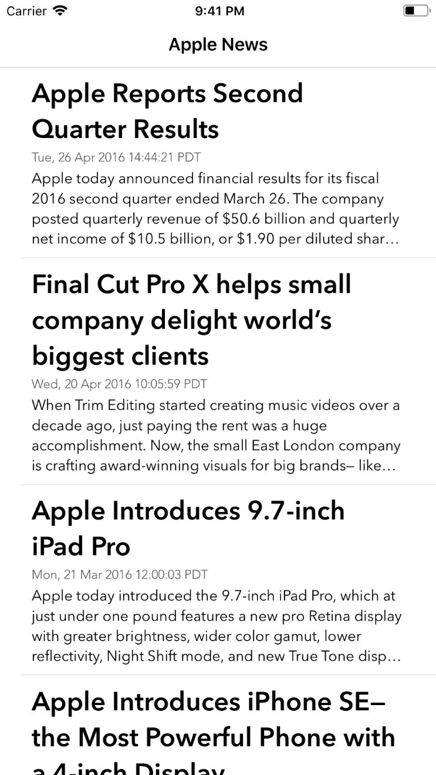

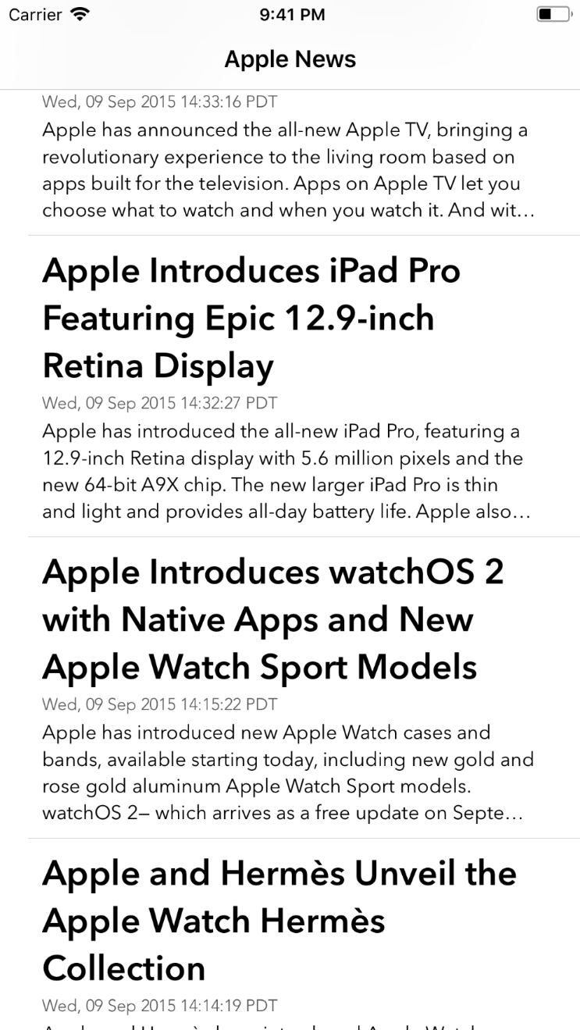

* ***FaceBookMe***

**AppDelegate.swift**

import UIKit

@UIApplicationMain

class AppDelegate: UIResponder, UIApplicationDelegate {

  var window: UIWindow?

  func application(_ application: UIApplication, didFinishLaunchingWithOptions launchOptions: [UIApplicationLaunchOptionsKey: Any]?) -> Bool {

    window = UIWindow(frame: UIScreen.main.bounds)

    window?.rootViewController = UINavigationController(rootViewController: FBMeViewController())

    window?.makeKeyAndVisible()

    return true

  }

}

**Specs.swift**

import UIKit

public struct Specs {

  public struct Color {

    public let tint = UIColor(hex: 0x3b5998)

    public let red = UIColor.red

    public let white = UIColor.white

    public let black = UIColor.black

    public let gray = UIColor.lightGray

  }

  public struct FontSize {

    public let tiny: CGFloat = 10

    public let small: CGFloat = 12

    public let regular: CGFloat = 14

    public let large: CGFloat = 16

  }

  public struct Font {

    private static let regularName = "Helvetica Neue"

    private static let boldName = "Helvetica Neue Bold"

    public let tiny = UIFont(name: regularName, size: Specs.fontSize.tiny)

    public let small = UIFont(name: regularName, size: Specs.fontSize.small)

    public let regular = UIFont(name: regularName, size: Specs.fontSize.regular)

    public let large = UIFont(name: regularName, size: Specs.fontSize.large)

    public let smallBold = UIFont(name: boldName, size: Specs.fontSize.small)

    public let regularBold = UIFont(name: boldName, size: Specs.fontSize.regular)

    public let largeBold = UIFont(name: boldName, size: Specs.fontSize.large)

  }

  public struct ImageName {

    public let friends = "fb_friends"

    public let events = "fb_events"

    public let groups = "fb_groups"

    public let education = "fb_education"

    public let townHall = "fb_town_hall"

    public let instantGames = "fb_games"

    public let settings = "fb_settings"

    public let privacyShortcuts = "fb_privacy_shortcuts"

    public let helpSupport = "fb_help_and_support"

    public let placeholder = "fb_placeholder"

  }

  public static var color: Color {

    return Color()

  }

  public static var fontSize: FontSize {

    return FontSize()

  }

  public static var font: Font {

    return Font()

  }

  public static var imageName: ImageName {

    return ImageName()

  }

}

**UIColor+Extension.swift**

import UIKit

public extension UIColor {

  convenience init(r: Int, g: Int, b: Int, a: CGFloat) {

    self.init(red: CGFloat(r) / 255, green: CGFloat(g) / 255, blue: CGFloat(b) / 255, alpha: a)

  }

  convenience init(hex: Int) {

    self.init(r: (hex & 0xff0000) >> 16, g: (hex & 0xff00) >> 8, b: (hex & 0xff), a: 1)

  }

}

**TableKeys.swift**

import Foundation

public struct TableKeys {

  static let Section = "section"

  static let Rows = "rows"

  static let ImageName = "imageName"

  static let Title = "title"

  static let SubTitle = "subTitle"

  static let seeMore = "See More..."

  static let addFavorites = "Add Favorites..."

  static let logout = "Log Out"

  static func populate(withUser user: FBMeUser) -> [[String: Any]] {

    return [

      [

        TableKeys.Rows: [

          [TableKeys.ImageName: user.avatarName, TableKeys.Title: user.name, TableKeys.SubTitle: "View your profile"]

        ]

      ],

      [

        TableKeys.Rows: [

          [TableKeys.ImageName: Specs.imageName.friends, TableKeys.Title: "Friends"],

          [TableKeys.ImageName: Specs.imageName.events, TableKeys.Title: "Events"],

          [TableKeys.ImageName: Specs.imageName.groups, TableKeys.Title: "Groups"],

          [TableKeys.ImageName: Specs.imageName.education, TableKeys.Title: user.education],

          [TableKeys.ImageName: Specs.imageName.townHall, TableKeys.Title: "Town Hall"],

          [TableKeys.ImageName: Specs.imageName.instantGames, TableKeys.Title: "Instant Games"],

          [TableKeys.Title: TableKeys.seeMore]

        ]

      ],

      [

        TableKeys.Section: "FAVORITES",

        TableKeys.Rows: [

          [TableKeys.Title: TableKeys.addFavorites]

        ]

      ],

      [

        TableKeys.Rows: [

          [TableKeys.ImageName: Specs.imageName.settings, TableKeys.Title: "Settings"],

          [TableKeys.ImageName: Specs.imageName.privacyShortcuts, TableKeys.Title: "Privacy Shortcuts"],

          [TableKeys.ImageName: Specs.imageName.helpSupport, TableKeys.Title: "Help and Support"]

        ]

      ],

      [

        TableKeys.Rows: [

          [TableKeys.Title: TableKeys.logout]

        ]

      ]

    ]

  }

}

**FBMeBaseViewController.swift**

import UIKit

class FBMeBaseViewController: UIViewController {

  override func viewDidLoad() {

    super.viewDidLoad()

    view.backgroundColor = Specs.color.gray

  }

}

**FBMeViewController.swift**

import UIKit

class FBMeViewController: FBMeBaseViewController {

  typealias RowModel = [String: String]

  fileprivate var user: FBMeUser {

    get {

      return FBMeUser(name: "BayMax", education: "CMU")

    }

  }

  fileprivate var tableViewDataSource: [[String: Any]] {

    get {

     return TableKeys.populate(withUser: user)

    }

  }

  private let tableView: UITableView = {

    let view = UITableView(frame: .zero, style: .grouped)

    view.register(FBMeBaseCell.self, forCellReuseIdentifier: FBMeBaseCell.identifier)

    return view

  }()

  override func viewDidLoad() {

    super.viewDidLoad()

    title = "Facebook"

    navigationController?.navigationBar.barTintColor = Specs.color.tint

    tableView.delegate = self

    tableView.dataSource = self

    view.addSubview(tableView)

    // Set layout for tableView.

    tableView.translatesAutoresizingMaskIntoConstraints = false

    view.addConstraints(NSLayoutConstraint.constraints(withVisualFormat: "H:|-0-[tableView]-0-|", options: .directionLeadingToTrailing, metrics: nil, views: ["tableView": tableView]))

    view.addConstraints(NSLayoutConstraint.constraints(withVisualFormat: "V:|-0-[tableView]-0-|", options: .directionLeadingToTrailing, metrics: nil, views: ["tableView": tableView]))

  }

  fileprivate func rows(at section: Int) -> [Any] {

    return tableViewDataSource[section][TableKeys.Rows] as! [Any]

  }

  fileprivate func title(at section: Int) -> String? {

    return tableViewDataSource[section][TableKeys.Section] as? String

  }

  fileprivate func rowModel(at indexPath: IndexPath) -> RowModel {

    return rows(at: indexPath.section)[indexPath.row] as! RowModel

  }

}

extension FBMeViewController: UITableViewDataSource {

  func numberOfSections(in tableView: UITableView) -> Int {

    return tableViewDataSource.count

  }

  func tableView(_ tableView: UITableView, numberOfRowsInSection section: Int) -> Int {

    return rows(at: section).count

  }

  func tableView(_ tableView: UITableView, titleForHeaderInSection section: Int) -> String? {

    return title(at: section)

  }

  func tableView(_ tableView: UITableView, cellForRowAt indexPath: IndexPath) -> UITableViewCell {

    let modelForRow = rowModel(at: indexPath)

    var cell = UITableViewCell()

    guard let title = modelForRow[TableKeys.Title] else {

      return cell

    }

    if title == user.name {

      cell = UITableViewCell.init(style: .subtitle, reuseIdentifier: nil)

    } else {

      cell = tableView.dequeueReusableCell(withIdentifier: FBMeBaseCell.identifier, for: indexPath)

    }

    cell.textLabel?.text = title

    if let imageName = modelForRow[TableKeys.ImageName] {

      cell.imageView?.image = UIImage(named: imageName)

    } else if title != TableKeys.logout {

      cell.imageView?.image = UIImage(named: Specs.imageName.placeholder)

    }

    if title == user.name {

      cell.detailTextLabel?.text = modelForRow[TableKeys.SubTitle]

    }

    return cell

  }

}

extension FBMeViewController: UITableViewDelegate {

  func tableView(_ tableView: UITableView, heightForRowAt indexPath: IndexPath) -> CGFloat {

    let modelForRow = rowModel(at: indexPath)

    guard let title = modelForRow[TableKeys.Title] else {

      return 0.0

    }

    if title == user.name {

      return 64.0

    } else {

      return 44.0

    }

  }

  func tableView(_ tableView: UITableView, willDisplay cell: UITableViewCell, forRowAt indexPath: IndexPath) {

    let modelForRow = rowModel(at: indexPath)

    guard let title = modelForRow[TableKeys.Title] else {

      return

    }

    if title == TableKeys.seeMore || title == TableKeys.addFavorites {

      cell.textLabel?.textColor = Specs.color.tint

      cell.accessoryType = .none

    } else if title == TableKeys.logout {

      cell.textLabel?.centerXAnchor.constraint(equalTo: cell.centerXAnchor).isActive = true

      cell.textLabel?.textColor = Specs.color.red

      cell.textLabel?.textAlignment = .center

      cell.accessoryType = .none

    } else {

      cell.accessoryType = .disclosureIndicator

    }

  }

}

**FBMeBaseCell.swift**

import UIKit

class FBMeBaseCell: UITableViewCell {

  static let identifier = "FBMeBaseCell"

  override init(style: UITableViewCellStyle, reuseIdentifier: String?) {

    super.init(style: .default, reuseIdentifier: reuseIdentifier)

    backgroundColor = Specs.color.white

    textLabel?.textColor = Specs.color.black

    textLabel?.font = Specs.font.large

    detailTextLabel?.font = Specs.font.small

    detailTextLabel?.textColor = Specs.color.gray

  }

  required init?(coder aDecoder: NSCoder) {

    fatalError("init(coder:) has not been implemented")

  }

}

**FBMeUser.swift**

import UIKit

class FBMeUser {

  var name: String

  var avatarName: String

  var education: String

  init(name: String, avatarName: String = "bayMax", education: String) {

    self.name = name

    self.avatarName = avatarName

    self.education = education

  }

}

**Output:**

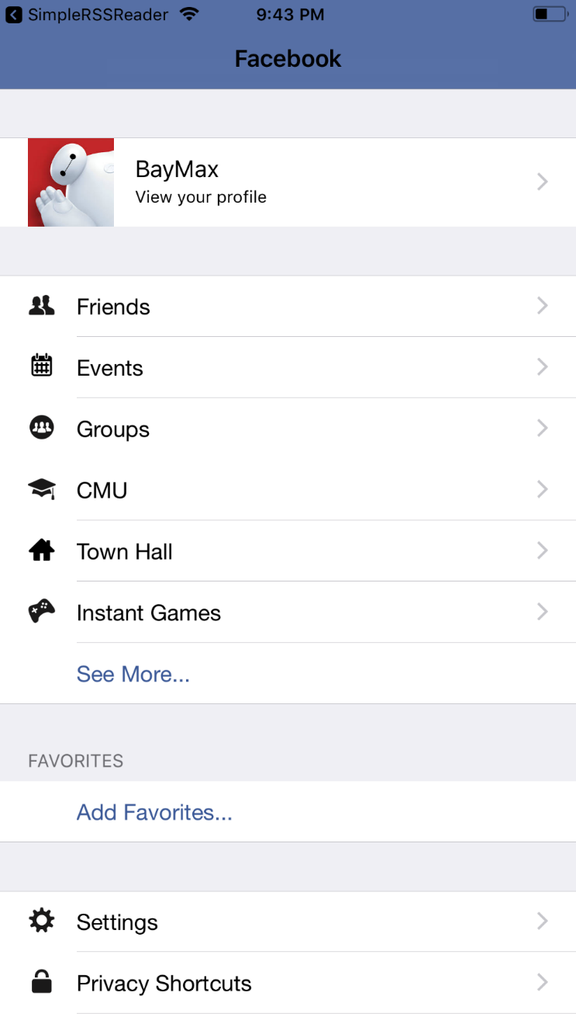

* ***Interests***

**AppDelegate.swift**

import UIKit

@UIApplicationMain

class AppDelegate: UIResponder, UIApplicationDelegate {

  var window: UIWindow?

  func application(_ application: UIApplication, didFinishLaunchingWithOptions launchOptions: [UIApplicationLaunchOptionsKey: Any]?) -> Bool {

    // Override point for customization after application launch.

    return true

  }

  func applicationWillResignActive(_ application: UIApplication) {

    // Sent when the application is about to move from active to inactive state. This can occur for certain types of temporary interruptions (such as an incoming phone call or SMS message) or when the user quits the application and it begins the transition to the background state.

    // Use this method to pause ongoing tasks, disable timers, and throttle down OpenGL ES frame rates. Games should use this method to pause the game.

  }

  func applicationDidEnterBackground(_ application: UIApplication) {

    // Use this method to release shared resources, save user data, invalidate timers, and store enough application state information to restore your application to its current state in case it is terminated later.

    // If your application supports background execution, this method is called instead of applicationWillTerminate: when the user quits.

  }

  func applicationWillEnterForeground(_ application: UIApplication) {

    // Called as part of the transition from the background to the inactive state; here you can undo many of the changes made on entering the background.

  }

  func applicationDidBecomeActive(_ application: UIApplication) {

    // Restart any tasks that were paused (or not yet started) while the application was inactive. If the application was previously in the background, optionally refresh the user interface.

  }

  func applicationWillTerminate(_ application: UIApplication) {

    // Called when the application is about to terminate. Save data if appropriate. See also applicationDidEnterBackground:.

  }

}

**InterestCollectionViewCell.swift**

import UIKit

class InterestCollectionViewCell: UICollectionViewCell {

  // MARK: - IBOutlets

  @IBOutlet weak var featuredImageView: UIImageView!

  @IBOutlet weak var titleLabel: UILabel!

  // MARK: - public API

  var interest: Interest! {

    didSet {

      updateUI()

    }

  }

  fileprivate func updateUI() {

    titleLabel.text = interest.title

    featuredImageView.image = interest.featuredImage

  }

  // MARK: - refactor layout

  override func layoutSubviews() {

    super.layoutSubviews()

    self.layer.cornerRadius = 8.0

    self.clipsToBounds = true

  }

}

**Interest.swift**

import UIKit

class Interest

{

  // MARK: - Public API

  var id = ""

  var title = ""

  var description = ""

  var numberOfMembers = 0

  var numberOfPosts = 0

  var featuredImage: UIImage!

  init(id: String, title: String, description: String, featuredImage: UIImage!)

  {

    self.id = id

    self.title = title

    self.description = description

    self.featuredImage = featuredImage

    numberOfMembers = 1

    numberOfPosts = 1

  }

  // MARK: - Private

  static func createInterests() -> [Interest]

  {

    return [

      Interest(id: "r1", title: "We Love Traveling Around the World", description: "We love backpack and adventures! We walked to Antartica yesterday, and camped with some cute pinguines, and talked about this wonderful app idea. 🐧⛺️✨", featuredImage: UIImage(named: "r1")!),

      Interest(id: "r2", title: "Romance Stories", description: "We love romantic stories. We walked to Antartica yesterday, and camped with some cute pinguines, and talked about this wonderful app idea. 🐧⛺️✨", featuredImage: UIImage(named: "r2")!),

      Interest(id: "r3", title: "iOS Dev", description: "Create beautiful apps. We walked to Antartica yesterday, and camped with some cute pinguines, and talked about this wonderful app idea. 🐧⛺️✨", featuredImage: UIImage(named: "r3")!),

      Interest(id: "r4", title: "Race", description: "Cars and aircrafts and boats and sky. We walked to Antartica yesterday, and camped with some cute pinguines, and talked about this wonderful app idea. 🐧⛺️✨", featuredImage: UIImage(named: "r4")!),

      Interest(id: "r5", title: "Personal Development", description: "Meet life with full presence. We walked to Antartica yesterday, and camped with some cute pinguines, and talked about this wonderful app idea. 🐧⛺️✨", featuredImage: UIImage(named: "r5")!),

      Interest(id: "r6", title: "Reading News", description: "Get up to date with breaking-news. We walked to Antartica yesterday, and camped with some cute pinguines, and talked about this wonderful app idea. 🐧⛺️✨", featuredImage: UIImage(named: "r6")!),

    ]

  }

}

**HomeViewController.swift**

import UIKit

class HomeViewController: UIViewController {

  // MARK: - IBOutlets

  @IBOutlet weak var backgroundImageView: UIImageView!

  @IBOutlet weak var collectionView: UICollectionView!

  fileprivate var interests = Interest.createInterests()

  fileprivate struct Storyboard {

    static let cellIdentifier = "Interest Cell"

  }

  override func viewDidLoad() {

    super.viewDidLoad()

  }

  override var preferredStatusBarStyle : UIStatusBarStyle {

    return .lightContent

  }

}

// MARK: - UICollectionViewDataSource

extension HomeViewController: UICollectionViewDataSource {

  func collectionView(_ collectionView: UICollectionView, numberOfItemsInSection section: Int) -> Int {

    return interests.count

  }

  func collectionView(_ collectionView: UICollectionView, cellForItemAt indexPath: IndexPath) -> UICollectionViewCell {

    let cell = collectionView.dequeueReusableCell(withReuseIdentifier: Storyboard.cellIdentifier, for: indexPath) as! InterestCollectionViewCell

    cell.interest = interests[(indexPath as NSIndexPath).item]

    return cell

  }

}

// MARK: - UIScrollViewDelegate

extension HomeViewController: UIScrollViewDelegate {

  func scrollViewWillEndDragging(_ scrollView: UIScrollView, withVelocity velocity: CGPoint, targetContentOffset: UnsafeMutablePointer<CGPoint>) {

    let layout = self.collectionView.collectionViewLayout as! UICollectionViewFlowLayout

    let cellWidthWithSpace = layout.itemSize.width + layout.minimumLineSpacing

    var offset = targetContentOffset.pointee

    let index = (offset.x + scrollView.contentInset.left) / cellWidthWithSpace

    let roundedIndex = round(index)

    offset = CGPoint(x: roundedIndex * cellWidthWithSpace - scrollView.contentInset.left, y: -scrollView.contentInset.top)

  }

}

**Output:**

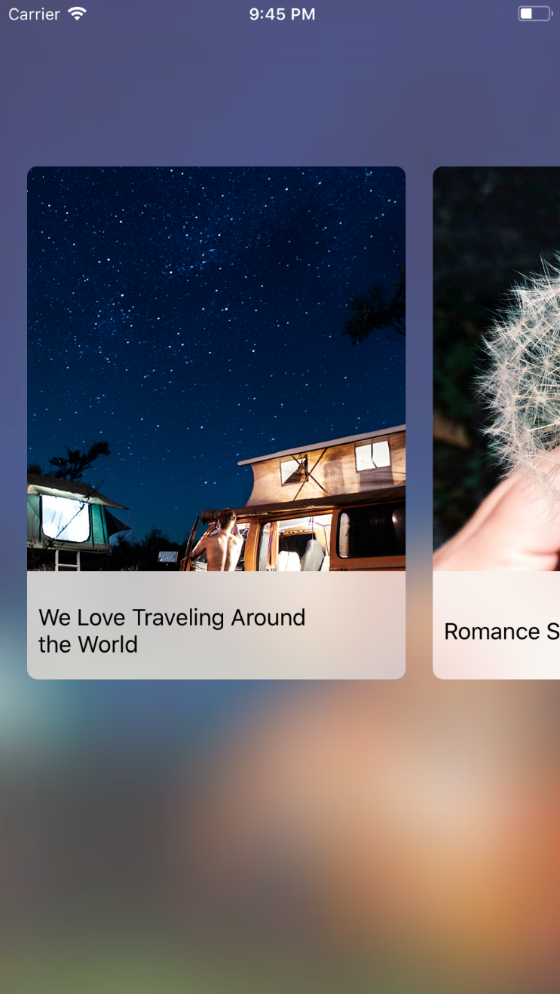 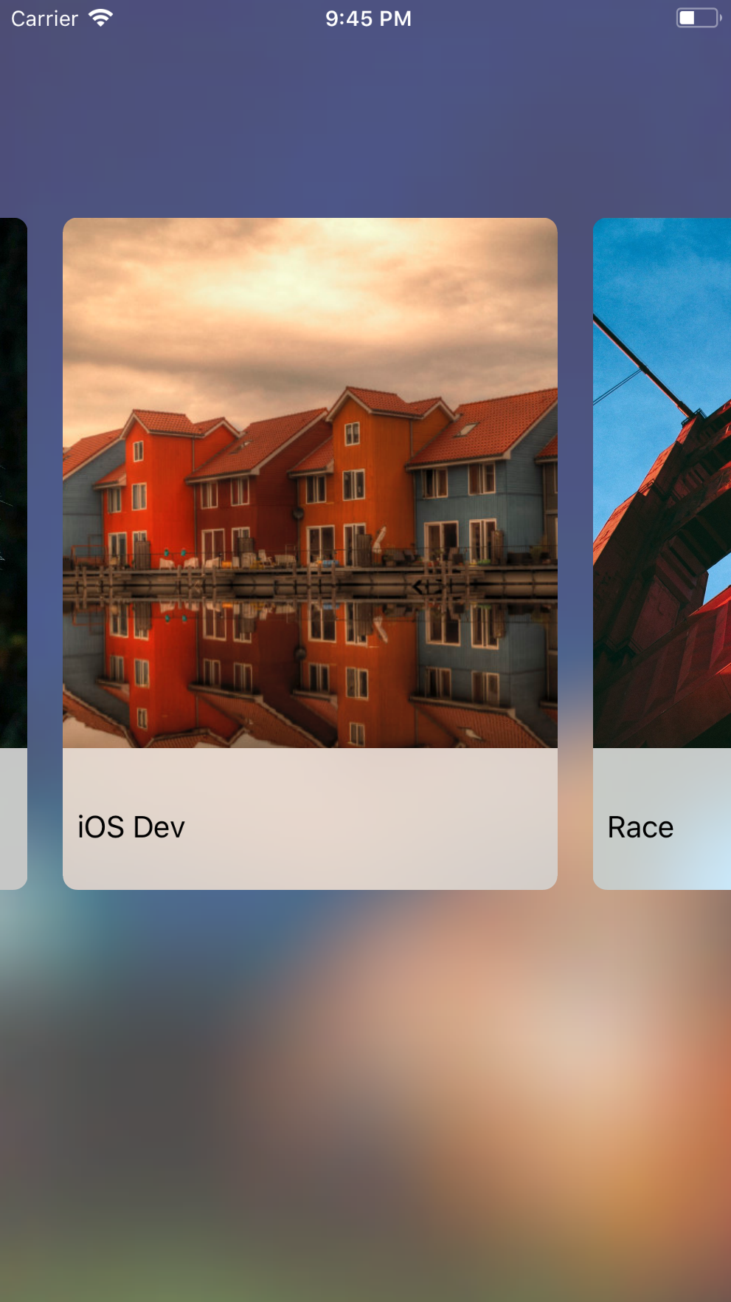

* ***PhotoScroll***

**AppDelegate.shift**

import UIKit

@UIApplicationMain

class AppDelegate: UIResponder, UIApplicationDelegate {

  var window: UIWindow?

  func application(_ application: UIApplication, didFinishLaunchingWithOptions launchOptions: [UIApplicationLaunchOptionsKey: Any]?) -> Bool {

    let pageControl = UIPageControl.appearance()

    pageControl.pageIndicatorTintColor = UIColor.lightGray

    pageControl.currentPageIndicatorTintColor = UIColor.red

    return true

  }

}

**UIImage**

import UIKit

extension UIImage {

  func thumbnailOfSize(_ size: CGFloat) -> UIImage {

    UIGraphicsBeginImageContext(CGSize(width: size, height: size))

    let rect = CGRect(x: 0.0, y: 0.0, width: size, height: size)

    UIGraphicsBeginImageContext(rect.size)

    draw(in: rect)

    let thumbnail = UIGraphicsGetImageFromCurrentImageContext();

    UIGraphicsEndImageContext()

    return thumbnail!

  }

}

**PhotoCell**

import UIKit

class PhotoCell : UICollectionViewCell {

  @IBOutlet weak var imageView: UIImageView!

}

**CollectionViewController**

import UIKit

class CollectionViewController: UICollectionViewController {

  fileprivate let reuseIdentifier = "PhotoCell"

  fileprivate let thumbnailSize:CGFloat = 70.0

  fileprivate let sectionInsets = UIEdgeInsets(top: 10, left: 5.0, bottom: 10.0, right: 5.0)

  fileprivate let photos = ["photo1", "photo2", "photo3", "photo4", "photo5"]

  override func prepare(for segue: UIStoryboardSegue, sender: Any?) {

    if let cell = sender as? UICollectionViewCell,

      let indexPath = collectionView?.indexPath(for: cell),

      let zoomedPhotoViewController = segue.destination as? ZoomedPhotoViewController {

      zoomedPhotoViewController.photoName = "photo\(indexPath.row + 1)"

    }

    if let cell = sender as? UICollectionViewCell,

      let indexPath = collectionView?.indexPath(for: cell),

      let photoCommentViewController = segue.destination as? PhotoCommentViewController {

      photoCommentViewController.photoName = "photo\(indexPath.row + 1)"

    }

    if let cell = sender as? UICollectionViewCell,

      let indexPath = collectionView?.indexPath(for: cell),

      let managePageViewController = segue.destination as? ManagePageViewController {

      managePageViewController.photos = photos

      managePageViewController.currentIndex = indexPath.row

    }

  }

}

// MARK: UICollectionViewDataSource

extension CollectionViewController {

  override func numberOfSections(in collectionView: UICollectionView) -> Int {

    return 1

  }

  override func collectionView(_ collectionView: UICollectionView, numberOfItemsInSection section: Int) -> Int {

    return photos.count

  }

  override func collectionView(_ collectionView: UICollectionView, cellForItemAt indexPath: IndexPath) -> UICollectionViewCell {

    let cell = collectionView.dequeueReusableCell(withReuseIdentifier: reuseIdentifier, for: indexPath) as! PhotoCell

    let fullSizedImage = UIImage(named:photos[indexPath.row])

    cell.imageView.image = fullSizedImage?.thumbnailOfSize(thumbnailSize)

    return cell

  }

}

// MARK:UICollectionViewDelegateFlowLayout

extension CollectionViewController : UICollectionViewDelegateFlowLayout {

  func collectionView(_ collectionView: UICollectionView, layout collectionViewLayout: UICollectionViewLayout, sizeForItemAt indexPath: IndexPath) -> CGSize {

    return CGSize(width: thumbnailSize, height: thumbnailSize)

  }

  func collectionView(_ collectionView: UICollectionView, layout collectionViewLayout: UICollectionViewLayout, insetForSectionAt section: Int) -> UIEdgeInsets {

    return sectionInsets

  }

}

**PhotoCommentViewController.swift**

import UIKit

class PhotoCommentViewController: UIViewController {

  @IBOutlet weak var imageView: UIImageView!

  @IBOutlet weak var scrollView: UIScrollView!

  @IBOutlet weak var nameTextField: UITextField!

  public var photoName: String!

  public var photoIndex: Int!

  override func viewDidLoad() {

    super.viewDidLoad()

    if let photoName = photoName {

      imageView.image = UIImage(named: photoName)

    }

    let generalTapGesture = UITapGestureRecognizer(target: self, action: Selector.generalTap)

    view.addGestureRecognizer(generalTapGesture)

    let zoomTapGesture = UITapGestureRecognizer(target: self, action: Selector.zoomTap)

    imageView.addGestureRecognizer(zoomTapGesture)

    NotificationCenter.default.addObserver(

      self,

      selector: Selector.keyboardWillShowHandler,

      name: NSNotification.Name.UIKeyboardWillShow,

      object: nil

    )

    NotificationCenter.default.addObserver(

      self,

      selector: Selector.keyboardWillHideHandler,

      name: NSNotification.Name.UIKeyboardWillHide,

      object: nil

    )

  }

  deinit {

    NotificationCenter.default.removeObserver(self)

  }

  fileprivate func adjustInsetForKeyboard(isShow: Bool, notification: Notification) {

    guard let value = notification.userInfo?[UIKeyboardFrameBeginUserInfoKey] as? NSValue else {

      return

    }

    let keyboardFrame = value.cgRectValue

    let adjustmentHeight = (keyboardFrame.height + 20) * (isShow ? 1 : -1)

    scrollView.contentInset.bottom += adjustmentHeight

    scrollView.scrollIndicatorInsets.bottom += adjustmentHeight

  }

  @objc func dismissKeyboard() {

    view.endEditing(true)

  }

  @objc func keyboardWillShow(notification: Notification) {

    adjustInsetForKeyboard(isShow: true, notification: notification)

  }

  @objc func keyboardWillHide(notification: Notification) {

    adjustInsetForKeyboard(isShow: false, notification: notification)

  }

  @objc func openZoomingController(sender: AnyObject) {

    performSegue(withIdentifier: "zooming", sender: nil)

  }

  override func prepare(for segue: UIStoryboardSegue, sender: Any?) {

    if let id = segue.identifier,

      let zoomedPhotoViewController = segue.destination as? ZoomedPhotoViewController {

      if id == "zooming" {

        zoomedPhotoViewController.photoName = photoName

      }

    }

  }

}

fileprivate extension Selector {

  static let keyboardWillShowHandler = #selector(PhotoCommentViewController.keyboardWillShow(notification:))

  static let keyboardWillHideHandler = #selector(PhotoCommentViewController.keyboardWillHide(notification:))

  static let generalTap = #selector(PhotoCommentViewController.dismissKeyboard)

  static let zoomTap = #selector(PhotoCommentViewController.openZoomingController(sender:))

}

**ZoomedPhotoViewController.swift**

import UIKit

class ZoomedPhotoViewController: UIViewController {

  @IBOutlet weak var imageView: UIImageView!

  @IBOutlet weak var scrollView: UIScrollView!

  @IBOutlet weak var imageViewTopConstraint: NSLayoutConstraint!

  @IBOutlet weak var imageViewBottomConstraint: NSLayoutConstraint!

  @IBOutlet weak var imageViewLeadingConstraint: NSLayoutConstraint!

  @IBOutlet weak var imageViewTrailingConstraint: NSLayoutConstraint!

  var photoName: String!

  override func viewDidLoad() {

    imageView.image = UIImage(named: photoName)

  }

  override func viewDidLayoutSubviews() {

    super.viewDidLayoutSubviews()

    updateMinZoomScale(forSize: view.bounds.size)

  }

  fileprivate func updateConstraints(forSize size: CGSize) {

    let yOffset = max(0, (size.height - imageView.frame.height) / 2)

    imageViewTopConstraint.constant = yOffset

    imageViewBottomConstraint.constant = yOffset

    let xOffset = max(0, (size.width - imageView.frame.width) / 2)

    imageViewLeadingConstraint.constant = xOffset

    imageViewTrailingConstraint.constant = xOffset

    view.layoutIfNeeded()

  }

  fileprivate func updateMinZoomScale(forSize size: CGSize) {

    let widthScale = size.width / imageView.bounds.width

    let heightScale = size.height / imageView.bounds.height

    let minScale = min(widthScale, heightScale)

    scrollView.minimumZoomScale = minScale

    /// set up the init zoom scale

    scrollView.zoomScale = minScale

  }

}

extension ZoomedPhotoViewController: UIScrollViewDelegate {

  /// Tell the delegate that the imageView will be made smaller or bigger.

  ///

  /// - Parameter scrollView: scrollView delegate to current view controller

  /// - Returns: the view is zoomed in and out

  func viewForZooming(in scrollView: UIScrollView) -> UIView? {

    return imageView

  }

  /// Called every time zoom in or out the scroll View

  func scrollViewDidZoom(_ scrollView: UIScrollView) {

    updateConstraints(forSize: view.bounds.size)

  }

}

**ManagePageViewController.swift**

import UIKit

class ManagePageViewController: UIPageViewController {

  var photos = ["photo1", "photo2", "photo3", "photo4", "photo5"]

  var currentIndex: Int!

  override func viewDidLoad() {

    super.viewDidLoad()

    dataSource = self

    if let viewController = viewPhotoCommentController(index: currentIndex ?? 0) {

      let viewControllers = [viewController]

      setViewControllers (

        viewControllers,

        direction: .forward,

        animated: false,

        completion: nil

      )

    }

  }

  fileprivate func viewPhotoCommentController(index: Int) -> PhotoCommentViewController? {

    if let storyboard = storyboard,

      let page = storyboard.instantiateViewController(withIdentifier: "PhotoCommentViewController")

        as? PhotoCommentViewController {

      page.photoName = photos[index]

      page.photoIndex = index

      return page

    }

    return nil

  }

}

extension ManagePageViewController: UIPageViewControllerDataSource {

  func pageViewController(_ pageViewController: UIPageViewController, viewControllerBefore viewController: UIViewController) -> UIViewController? {

    if let viewController = viewController as? PhotoCommentViewController {

      guard let index = viewController.photoIndex, index != 0 else {

        return nil

      }

      return viewPhotoCommentController(index: index - 1)

    }

    return nil

  }

  func pageViewController(_ pageViewController: UIPageViewController, viewControllerAfter viewController: UIViewController) -> UIViewController? {

    if let viewController = viewController as? PhotoCommentViewController {

      guard let index = viewController.photoIndex, index != photos.count - 1 else {

        return nil

      }

      return viewPhotoCommentController(index: index + 1)

    }

    return nil

  }

  func presentationCount(for pageViewController: UIPageViewController) -> Int {

    return photos.count

  }

  func presentationIndex(for pageViewController: UIPageViewController) -> Int {

    return currentIndex ?? 0

  }

}

**Output:**

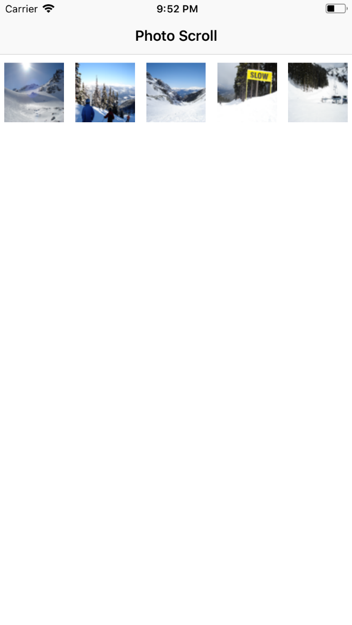

* ***Animation***

**AppDelegate.swift**

import UIKit

@UIApplicationMain

class AppDelegate: UIResponder, UIApplicationDelegate {

  var window: UIWindow?

  func application(_ application: UIApplication, didFinishLaunchingWithOptions launchOptions: [UIApplicationLaunchOptionsKey: Any]?) -> Bool {

    // Override point for customization after application launch.

    return true

  }

  func applicationWillResignActive(_ application: UIApplication) {

    // Sent when the application is about to move from active to inactive state. This can occur for certain types of temporary interruptions (such as an incoming phone call or SMS message) or when the user quits the application and it begins the transition to the background state.

    // Use this method to pause ongoing tasks, disable timers, and throttle down OpenGL ES frame rates. Games should use this method to pause the game.

  }

  func applicationDidEnterBackground(_ application: UIApplication) {

    // Use this method to release shared resources, save user data, invalidate timers, and store enough application state information to restore your application to its current state in case it is terminated later.

    // If your application supports background execution, this method is called instead of applicationWillTerminate: when the user quits.

  }

  func applicationWillEnterForeground(_ application: UIApplication) {

    // Called as part of the transition from the background to the inactive state; here you can undo many of the changes made on entering the background.

  }

  func applicationDidBecomeActive(_ application: UIApplication) {

    // Restart any tasks that were paused (or not yet started) while the application was inactive. If the application was previously in the background, optionally refresh the user interface.

  }

  func applicationWillTerminate(_ application: UIApplication) {

    // Called when the application is about to terminate. Save data if appropriate. See also applicationDidEnterBackground:.

  }

}

**ViewController.swift**

import UIKit

let headerHeight = 50.0

let segueDetailIdentifier = "toAnimateDetail"

let duration = 1.5

class ViewController: UIViewController {

  // MARK: - IBOutlets

  @IBOutlet weak var masterTableView: UITableView!

  // MARK: - Variables

  fileprivate let items = ["2-Color", "Simple 2D Rotation", "Multicolor", "Multi Point Position", "BezierCurve Position",

                       "Color and Frame Change", "View Fade In", "Pop"]

  // MARK: - Life Cycle

  override func viewDidLoad() {

    super.viewDidLoad()

  }

  override func viewWillAppear(_ animated: Bool) {

    animateTable()

  }

  func animateTable() {

    masterTableView.reloadData()

    let cells = masterTableView.visibleCells

    let tableHeight = masterTableView.bounds.size.height

    // move all cells to the bottom of the screen

    for cell in cells {

      cell.transform = CGAffineTransform(translationX: 0, y: tableHeight)

    }

    // move all cells from bottom to the right place

    var index = 0

    for cell in cells {

      UIView.animate(withDuration: duration, delay: 0.05 * Double(index), usingSpringWithDamping: 0.8, initialSpringVelocity: 0, options: [], animations: {

        cell.transform = CGAffineTransform(translationX: 0, y: 0)

        }, completion: nil)

      index += 1

    }

  }

  // MARK: - Segue

  override func prepare(for segue: UIStoryboardSegue, sender: Any?) {

    if segue.identifier == segueDetailIdentifier {

      let detailView = segue.destination as! DetailViewController

      let indexPath = masterTableView.indexPathForSelectedRow

      if let indexPath = indexPath {

        detailView.barTitle = self.items[(indexPath as NSIndexPath).row]

      }

    }

  }

}

// MARK: - UITableViewDelegate

extension ViewController: UITableViewDelegate {

  func tableView(_ tableView: UITableView, heightForHeaderInSection section: Int) -> CGFloat {

    return CGFloat(headerHeight)

  }

  func tableView(_ tableView: UITableView, titleForHeaderInSection section: Int) -> String? {

    return "Basic Animations"

  }

}

// MARK: - UITableViewDataSource

extension ViewController: UITableViewDataSource {

  func numberOfSections(in tableView: UITableView) -> Int {

    return 1

  }

  func tableView(_ tableView: UITableView, numberOfRowsInSection section: Int) -> Int {

    return items.count

  }

  func tableView(_ tableView: UITableView, cellForRowAt indexPath: IndexPath) -> UITableViewCell {

    let cellIdentifier = "cell"

    let cell = tableView.dequeueReusableCell(withIdentifier: cellIdentifier, for: indexPath)

    cell.textLabel?.text = self.items[(indexPath as NSIndexPath).row]

    return cell

  }

}

**DetailViewController.swift**

import UIKit

class DetailViewController: UIViewController {

  // MARK: - Variables

  var barTitle = ""

  var animateView: UIView!

  fileprivate let duration = 2.0

  fileprivate let delay = 0.2

  fileprivate let scale = 1.2

  // MARK: - Lifecycle

  override func viewDidLoad() {

    super.viewDidLoad()

    setupRect()

    setupNavigationBar()

  }

  fileprivate func setupNavigationBar() {

    navigationController?.navigationBar.topItem?.title = barTitle

  }

  fileprivate func setupRect() {

    if barTitle == "BezierCurve Position" {

      animateView = drawCircleView()

    } else if barTitle == "View Fade In" {

      animateView = UIImageView(image: UIImage(named: "whatsapp"))

      animateView.frame = generalFrame

      animateView.center = generalCenter

    } else {

      animateView = drawRectView(UIColor.red, frame: generalFrame, center: generalCenter)

    }

    view.addSubview(animateView)

  }

  // MARK: - IBAction

  @IBAction func didTapAnimate(_ sender: AnyObject) {

    switch barTitle {

    case "2-Color":

      changeColor(UIColor.green)

    case "Simple 2D Rotation":

      rotateView(Double.pi)

    case "Multicolor":

      multiColor(UIColor.green, UIColor.blue)

    case "Multi Point Position":

      multiPosition(CGPoint(x: animateView.frame.origin.x, y: 100), CGPoint(x: animateView.frame.origin.x, y: 350))

    case "BezierCurve Position":

      var controlPoint1 = self.animateView.center

      controlPoint1.y -= 125.0

      var controlPoint2 = controlPoint1

      controlPoint2.x += 40.0

      controlPoint2.y -= 125.0;

      var endPoint = self.animateView.center;

      endPoint.x += 75.0

      curvePath(endPoint, controlPoint1: controlPoint1, controlPoint2: controlPoint2)

    case "Color and Frame Change":

      let currentFrame = self.animateView.frame

      let firstFrame = currentFrame.insetBy(dx: -30, dy: -50)

      let secondFrame = firstFrame.insetBy(dx: 10, dy: 15)

      let thirdFrame = secondFrame.insetBy(dx: -15, dy: -20)

      colorFrameChange(firstFrame, secondFrame, thirdFrame, UIColor.orange, UIColor.yellow, UIColor.green)

    case "View Fade In":

      viewFadeIn()

    case "Pop":

      Pop()

    default:

      let alert = makeAlert("Alert", message: "The animation not implemented yet", actionTitle: "OK")

      self.present(alert, animated: true, completion: nil)

    }

  }

  // MARK: - Private Methods for Animations

  fileprivate func changeColor(_ color: UIColor) {

    UIView.animate(withDuration: self.duration, animations: {

      self.animateView.backgroundColor = color

      }, completion: nil)

  }

  fileprivate func multiColor(_ firstColor: UIColor, _ secondColor: UIColor) {

    UIView.animate(withDuration: duration, animations: {

      self.animateView.backgroundColor = firstColor

      }, completion: { finished in

        self.changeColor(secondColor)

    })

  }

  fileprivate func multiPosition(_ firstPos: CGPoint, _ secondPos: CGPoint) {

    func simplePosition(_ pos: CGPoint) {

      UIView.animate(withDuration: self.duration, animations: {

        self.animateView.frame.origin = pos

      }, completion: nil)

    }

    UIView.animate(withDuration: self.duration, animations: {

      self.animateView.frame.origin = firstPos

      }, completion: { finished in

        simplePosition(secondPos)

    })

  }

  fileprivate func rotateView(_ angel: Double) {

    UIView.animate(withDuration: duration, delay: delay, options: [.repeat], animations: {

      self.animateView.transform = CGAffineTransform(rotationAngle: CGFloat(angel))

      }, completion: nil)

  }

  fileprivate func colorFrameChange(_ firstFrame: CGRect, _ secondFrame: CGRect, _ thirdFrame: CGRect,

                                _ firstColor: UIColor, _ secondColor: UIColor, _ thirdColor: UIColor) {

    UIView.animate(withDuration: self.duration, animations: {

      self.animateView.backgroundColor = firstColor

      self.animateView.frame = firstFrame

      }, completion: { finished in

        UIView.animate(withDuration: self.duration, animations: {

          self.animateView.backgroundColor = secondColor

          self.animateView.frame = secondFrame

          }, completion: { finished in

            UIView.animate(withDuration: self.duration, animations: {

              self.animateView.backgroundColor = thirdColor

              self.animateView.frame = thirdFrame

              }, completion: nil)

        })

    })

  }

  fileprivate func curvePath(_ endPoint: CGPoint, controlPoint1: CGPoint, controlPoint2: CGPoint) {

    let path = UIBezierPath()

    path.move(to: self.animateView.center)

    path.addCurve(to: endPoint, controlPoint1: controlPoint1, controlPoint2: controlPoint2)

    // create a new CAKeyframeAnimation that animates the objects position

    let anim = CAKeyframeAnimation(keyPath: "position")

    // set the animations path to our bezier curve

    anim.path = path.cgPath

    // set some more parameters for the animation

    anim.duration = self.duration

    // add the animation to the squares 'layer' property

    self.animateView.layer.add(anim, forKey: "animate position along path")

    self.animateView.center = endPoint

  }

  fileprivate func viewFadeIn() {

    let secondView = UIImageView(image: UIImage(named: "facebook"))

    secondView.frame = self.animateView.frame

    secondView.alpha = 0.0

    view.insertSubview(secondView, aboveSubview: self.animateView)

    UIView.animate(withDuration: duration, delay: delay, options: .curveEaseOut, animations: {

      secondView.alpha = 1.0

      self.animateView.alpha = 0.0

      }, completion: nil)

  }

  fileprivate func Pop() {

    UIView.animate(withDuration: duration / 4,

      animations: {

      self.animateView.transform = CGAffineTransform(scaleX: CGFloat(self.scale), y: CGFloat(self.scale))

      }, completion: { finished in

        UIView.animate(withDuration: self.duration / 4, animations: {

          self.animateView.transform = CGAffineTransform.identity

        })

    })

  }

}

**Common.swift**

import Foundation

import UIKit

let screenRect = UIScreen.main.bounds

let generalFrame = CGRect(x: 0, y: 0, width: screenRect.width / 2.0, height: screenRect.height / 4.0)

let generalCenter = CGPoint(x: screenRect.midX, y: screenRect.midY - 50)

func drawRectView(_ color: UIColor, frame: CGRect, center: CGPoint) -> UIView {

  let view = UIView(frame: frame)

  view.center = center

  view.backgroundColor = color

  return view

}

func drawCircleView() -> UIView {

  let circlePath = UIBezierPath(arcCenter: CGPoint(x: 100,y: screenRect.midY - 50), radius: CGFloat(20), startAngle: CGFloat(0), endAngle:CGFloat(Double.pi * 2), clockwise: true)

  let shapeLayer = CAShapeLayer()

  shapeLayer.path = circlePath.cgPath

  shapeLayer.fillColor = UIColor.red.cgColor

  shapeLayer.strokeColor = UIColor.red.cgColor

  shapeLayer.lineWidth = 3.0

  let view = UIView()

  view.layer.addSublayer(shapeLayer)

  return view

}

func makeAlert(_ title: String, message: String, actionTitle: String) -> UIAlertController {

  let alert = UIAlertController(title: title, message: message, preferredStyle: UIAlertControllerStyle.alert)

  alert.addAction(UIAlertAction(title: actionTitle, style: UIAlertActionStyle.default, handler: nil))

  return alert

}

**Output:**

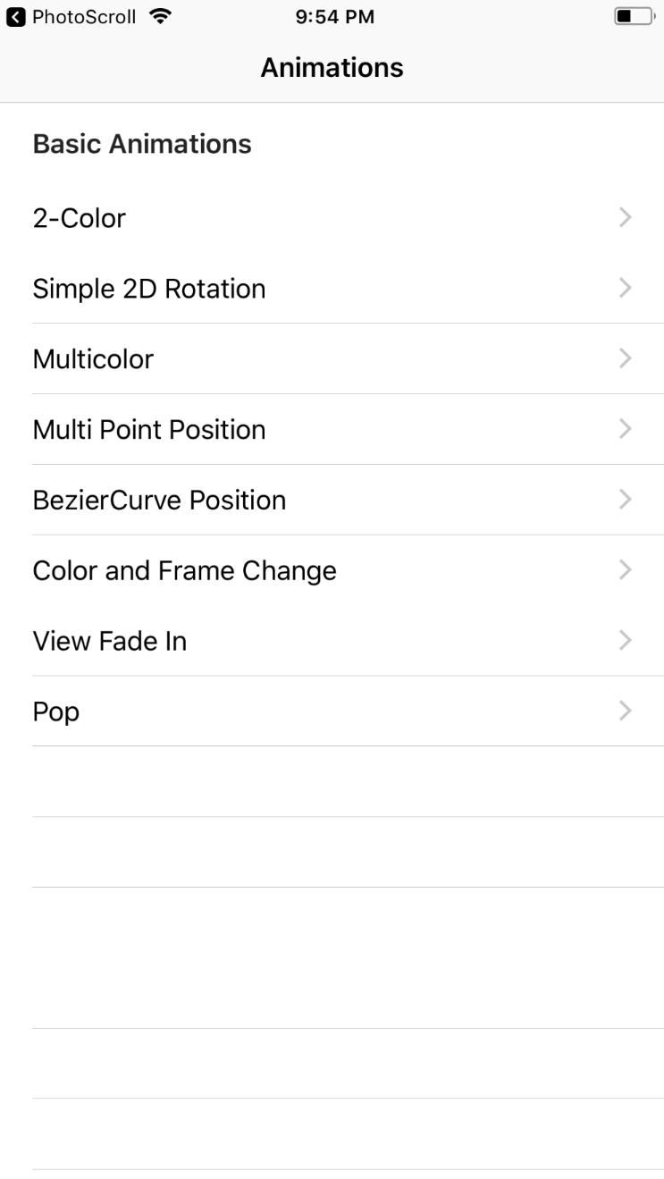 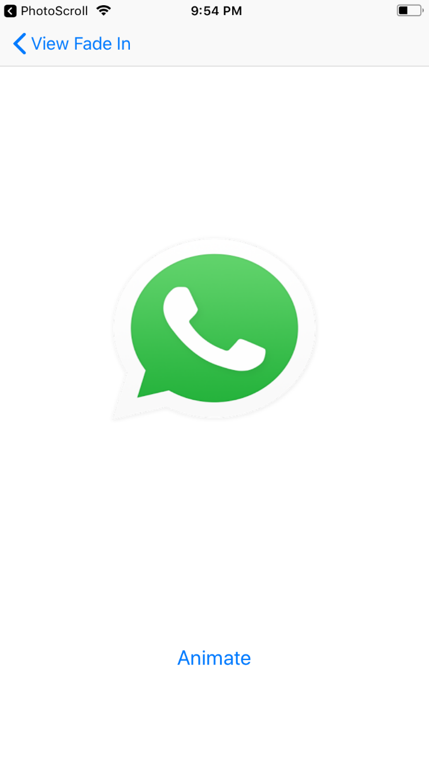

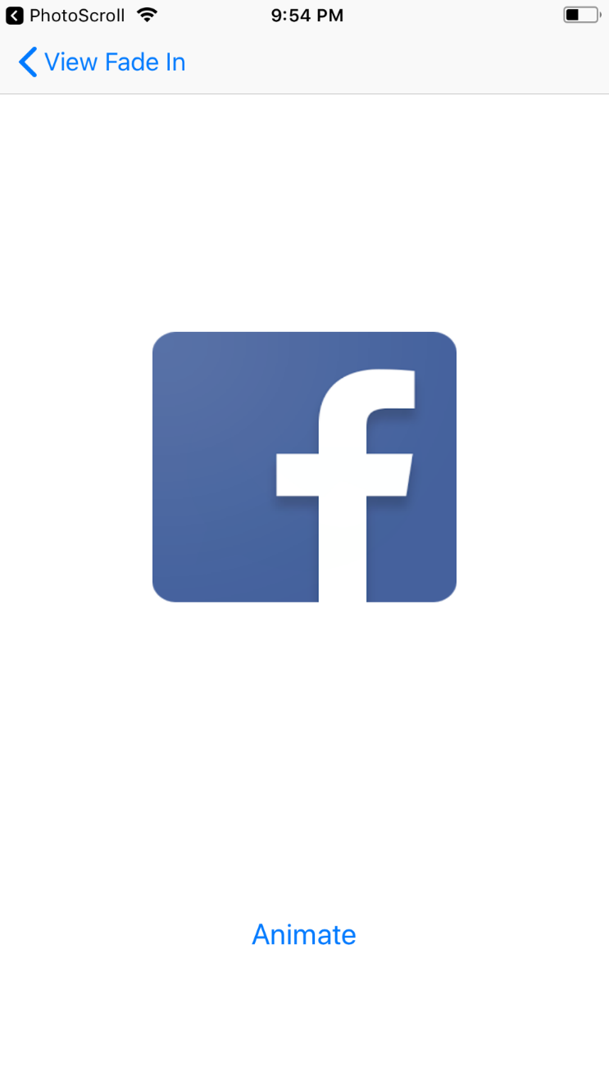 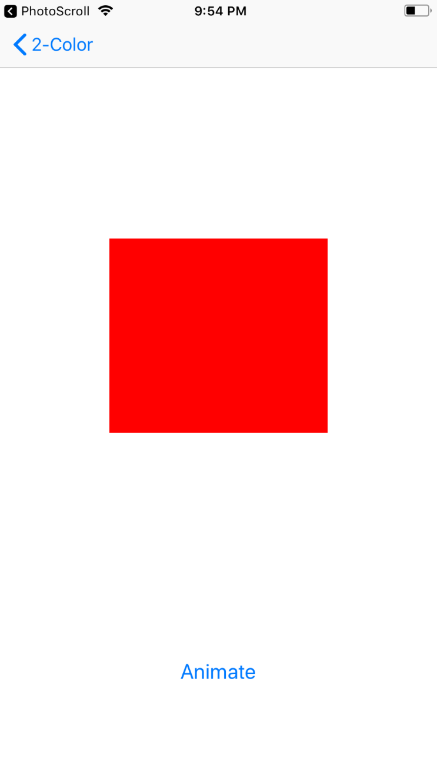

**PRACTICAL 14**

**14)** **Aim:PhotoTagger, Marslink, ceneDetector, Notification UI,Scale, Weather Extention, HitList & Birthdays in iOS**

* ***PhotoTagger***

**AppDelegate.shift**

import UIKit

@UIApplicationMain

class AppDelegate: UIResponder, UIApplicationDelegate {

  var window: UIWindow?

  func application(_ application: UIApplication, didFinishLaunchingWithOptions launchOptions: [UIApplicationLaunchOptionsKey: Any]?) -> Bool {

    return true

  }

}

**PhotoColor.swift**

import Foundation

struct PhotoColor {

  var red: Int?

  var green: Int?

  var blue: Int?

  var colorName: String?

}

**TagsColorsTableViewController.shift**

import UIKit

struct TagsColorTableData {

  var label: String

  var color: UIColor?

}

class TagsColorsTableViewController: UITableViewController {

  // MARK: - Properties

  var data: [TagsColorTableData]?

  // MARK: - UITableViewDataSource

  override func tableView(_ tableView: UITableView, numberOfRowsInSection section: Int) -> Int {

    guard let data = data else {

      return 0

    }

    return data.count

  }

  override func tableView(_ tableView: UITableView, cellForRowAt indexPath: IndexPath) -> UITableViewCell {

    guard let data = data else {

      fatalError("Application error no cell data available")

    }

    let cellData = data[indexPath.row]

    let cell = tableView.dequeueReusableCell(withIdentifier: "TagOrColorCell", for: indexPath)

    cell.textLabel?.text = cellData.label

    return cell

  }

  // MARK: - UITableViewDelegate

  override func tableView(_ tableView: UITableView, willDisplay cell: UITableViewCell, forRowAt indexPath: IndexPath) {

    guard let data = data else {

      fatalError("Application error no cell data available")

    }

    let cellData = data[indexPath.row]

    guard let color = cellData.color else {

      cell.textLabel?.textColor = UIColor.black

      cell.backgroundColor = UIColor.white

      return

    }

    var red = CGFloat(0.0), green = CGFloat(0.0), blue = CGFloat(0.0), alpha = CGFloat(0.0)

    color.getRed(&red, green: &green, blue: &blue, alpha: &alpha)

    let threshold = CGFloat(105)

    let bgDelta = ((red * 0.299) + (green * 0.587) + (blue * 0.114));

    let textColor = (255 - bgDelta < threshold) ? UIColor.black : UIColor.white;

    cell.textLabel?.textColor = textColor

    cell.backgroundColor = color

  }

}

**TagsColorsViewController**

import UIKit

class TagsColorsViewController: UIViewController {

  // MARK: - Properties

  var tags: [String]?

  var colors: [PhotoColor]?

  var tableViewController: TagsColorsTableViewController!

  // MARK: - IBOutlets

  @IBOutlet var segmentedControl: UISegmentedControl!

  // MARK: - View Life Cycle

  override func viewDidLoad() {

    super.viewDidLoad()

    setupTableData()

  }

  // MARK: - Navigation

  override func prepare(for segue: UIStoryboardSegue, sender: Any?) {

    if segue.identifier == "DataTable" {

      guard let controller = segue.destination as? TagsColorsTableViewController else {

        fatalError("Storyboard mis-configuration. Controller is not of expected type TagsColorTableViewController")

      }

      tableViewController = controller

    }

  }

  // MARK: - IBActions

  @IBAction func tagsColorsSegmentedControlChanged(_ sender: UISegmentedControl) {

    setupTableData()

  }

  // MARK: - Public

  func setupTableData() {

    if segmentedControl.selectedSegmentIndex == 0 {

      if let tags = tags {

        tableViewController.data = tags.map {

          TagsColorTableData(label: $0, color: nil)

        }

      } else {

        tableViewController.data = [TagsColorTableData(label: "No tags were fetched.", color: nil)]

      }

    } else {

      if let colors = colors {

        tableViewController.data = colors.map({ (photoColor: PhotoColor) -> TagsColorTableData in

          let uicolor = UIColor(red: CGFloat(photoColor.red!) / 255, green: CGFloat(photoColor.green!) / 255, blue: CGFloat(photoColor.blue!) / 255, alpha: 1.0)

          return TagsColorTableData(label: photoColor.colorName!, color: uicolor)

        })

      } else {

        tableViewController.data = [TagsColorTableData(label: "No colors were fetched.", color: nil)]

      }

    }

    tableViewController.tableView.reloadData()

  }

}

**ViewController**

import UIKit

import Alamofire

let kAuthorization = ""

class ViewController: UIViewController {

  // MARK: - IBOutlets

  @IBOutlet var takePictureButton: UIButton!

  @IBOutlet var imageView: UIImageView!

  @IBOutlet var progressView: UIProgressView!

  @IBOutlet var activityIndicatorView: UIActivityIndicatorView!

  // MARK: - Properties

  fileprivate var tags: [String]?

  fileprivate var colors: [PhotoColor]?

  // MARK: - View Life Cycle

  override func viewDidLoad() {

    super.viewDidLoad()

    if !UIImagePickerController.isSourceTypeAvailable(.camera) {

      takePictureButton.setTitle("Select Photo", for: UIControlState())

    }

  }

  override func viewDidDisappear(_ animated: Bool) {

    super.viewDidDisappear(animated)

    imageView.image = nil

  }

  // MARK: - Navigation

  override func prepare(for segue: UIStoryboardSegue, sender: Any?) {

    if segue.identifier == "ShowResults" {

      guard let controller = segue.destination as? TagsColorsViewController else {

        fatalError("Storyboard mis-configuration. Controller is not of expected type TagsColorsViewController")

      }

      controller.tags = tags

      controller.colors = colors

    }

  }

  // MARK: - IBActions

  @IBAction func takePicture(_ sender: UIButton) {

    let picker = UIImagePickerController()

    picker.delegate = self

    picker.allowsEditing = false

    if UIImagePickerController.isSourceTypeAvailable(.camera) {

      picker.sourceType = UIImagePickerControllerSourceType.camera

    } else {

      picker.sourceType = .photoLibrary

      picker.modalPresentationStyle = .fullScreen

    }

    present(picker, animated: true, completion: nil)

  }

}

// MARK: - UIImagePickerControllerDelegate

extension ViewController : UIImagePickerControllerDelegate, UINavigationControllerDelegate {

  func imagePickerController(_ picker: UIImagePickerController, didFinishPickingMediaWithInfo info: [String: Any]) {

    guard let image = info[UIImagePickerControllerOriginalImage] as? UIImage else {

      print("Info did not have the required UIImage for the Original Image")

      dismiss(animated: true)

      return

    }

    imageView.image = image

    takePictureButton.isHidden = true

    progressView.progress = 0.0

    progressView.isHidden = false

    activityIndicatorView.startAnimating()

    upload(

      image: image,

      progressCompletion: { [unowned self] percent in

        self.progressView.setProgress(percent, animated: true)

      },

      completion: { [unowned self] tags, colors in

        self.takePictureButton.isHidden = false

        self.progressView.isHidden = true

        self.activityIndicatorView.stopAnimating()

        self.tags = tags

        self.colors = colors

        self.performSegue(withIdentifier: "ShowResults", sender: self)

    })

    dismiss(animated: true)

  }

}

extension ViewController {

  func upload(image: UIImage,

              progressCompletion: @escaping (_ percent: Float) -> Void,

              completion: @escaping (_ tags: [String], _ colors: [PhotoColor]) -> Void) {

    guard let imageData = UIImageJPEGRepresentation(image, 0.5) else {

      print("Could not get JPEG representation of UIImage")

      return

    }

    Alamofire.upload(

      multipartFormData: { multipartFormData in

        multipartFormData.append(imageData,

                                 withName: "imagefile",

                                 fileName: "image.jpg",

                                 mimeType: "image/jpeg")

    },

      with: ImaggaRouter.content,

      encodingCompletion: { encodingResult in

        switch encodingResult {

        case .success(let upload, _, _):

          upload.uploadProgress { progress in

            progressCompletion(Float(progress.fractionCompleted))

          }

          upload.validate()

          upload.responseJSON { response in

            guard response.result.isSuccess else {

              print("Error while uploading file: \(response.result.error)")

              completion([String](), [PhotoColor]())

              return

            }

            guard let responseJSON = response.result.value as? [String: Any],

              let uploadedFiles = responseJSON["uploaded"] as? [Any],

              let firstFile = uploadedFiles.first as? [String: Any],

              let firstFileID = firstFile["id"] as? String else {

                print("Invalid information received from service")

                completion([String](), [PhotoColor]())

                return

            }

            print("Content uploaded with ID: \(firstFileID)")

            self.downloadTags(contentID: firstFileID) { tags in

              self.downloadColors(contentID: firstFileID) { colors in

                completion(tags, colors)

              }

            }

          }

        case .failure(let encodingError):

          print(encodingError)

        }

    }

    )

  }

  func downloadTags(contentID: String, completion: @escaping ([String]) -> Void) {

    Alamofire.request(ImaggaRouter.tags(contentID))

      .responseJSON { response in

        guard response.result.isSuccess else {

          print("Error while fetching tags: \(response.result.error)")

          completion([String]())

          return

        }

        guard let responseJSON = response.result.value as? [String: Any],

          let results = responseJSON["results"] as? [[String: Any]],

          let firstObject = results.first,

          let tagsAndConfidences = firstObject["tags"] as? [[String: Any]] else {

            print("Invalid tag information received from the service")

            completion([String]())

            return

        }

        let tags = tagsAndConfidences.flatMap({ dict in

          return dict["tag"] as? String

        })

        completion(tags)

    }

  }

  func downloadColors(contentID: String, completion: @escaping ([PhotoColor]) -> Void) {

    Alamofire.request(ImaggaRouter.colors(contentID))

      .responseJSON { response in

        guard response.result.isSuccess else {

          print("Error while fetching colors: \(response.result.error)")

          completion([PhotoColor]())

          return

        }

        guard let responseJSON = response.result.value as? [String: Any],

          let results = responseJSON["results"] as? [[String: Any]],

          let firstResult = results.first,

          let info = firstResult["info"] as? [String: Any],

          let imageColors = info["image_colors"] as? [[String: Any]] else {

            print("Invalid color information received from service")

            completion([PhotoColor]())

            return

        }

        let photoColors = imageColors.flatMap({ (dict) -> PhotoColor? in

          guard let r = dict["r"] as? String,

            let g = dict["g"] as? String,

            let b = dict["b"] as? String,

            let closestPaletteColor = dict["closest_palette_color"] as? String else {

              return nil

          }

          return PhotoColor(red: Int(r), green: Int(g), blue: Int(b), colorName: closestPaletteColor)

        })

        completion(photoColors)

    }

  }

}

**ImaggaRouter.swift**

import Foundation

import Alamofire

public enum ImaggaRouter: URLRequestConvertible {

  static let baseURLPath = "http://api.imagga.com/v1"

  static let authenticationToken = "Basic YWNjXzM5MWRkMjU2NjE4ZWU0Mzo2NWFjODVmMzNhNWE1YmQ3YTMzZGJkNzFjNTlmYTM5Yw=="

  case content

  case tags(String)

  case colors(String)

  var method: HTTPMethod {

    switch self {

    case .content:

      return .post

    case .tags, .colors:

      return .get

    }

  }

  var path: String {

    switch self {

    case .content:

      return "/content"

    case .tags:

      return "/tagging"

    case .colors:

      return "/colors"

    }

  }

  public func asURLRequest() throws -> URLRequest {

    let parameters: [String: Any] = {

      switch self {

      case .tags(let contentID):

        return ["content": contentID]

      case .colors(let contentID):

        return ["content": contentID, "extract_object_colors": 0]

      default:

        return [:]

      }

    }()

    let url = try ImaggaRouter.baseURLPath.asURL()

    var request = URLRequest(url: url.appendingPathComponent(path))

    request.httpMethod = method.rawValue

    request.setValue(ImaggaRouter.authenticationToken, forHTTPHeaderField: "Authorization")

    request.timeoutInterval = TimeInterval(10 * 1000)

    return try URLEncoding.default.encode(request, with: parameters)

  }

}

**Output:**

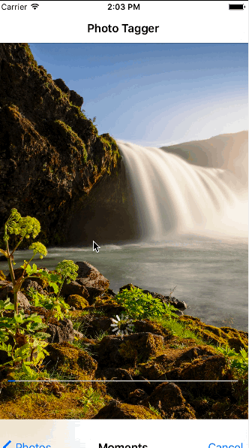 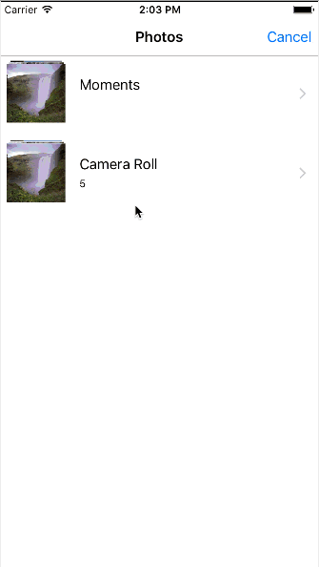

* ***MarsLink***

**AppDelegate.swift**

import UIKit

@UIApplicationMain

class AppDelegate: UIResponder, UIApplicationDelegate {

  var window: UIWindow?

  func application(_ application: UIApplication, didFinishLaunchingWithOptions launchOptions: [UIApplicationLaunchOptionsKey: Any]?) -> Bool {

    window = UIWindow(frame: UIScreen.main.bounds)

    window?.backgroundColor = UIColor.black

    let nav = UINavigationController(navigationBarClass: CustomNavigationBar.self, toolbarClass: nil)

    nav.pushViewController(FeedViewController(), animated: false)

    window?.rootViewController = nav

    window?.makeKeyAndVisible()

    return true

  }

}

**DateSortable.swift**

import Foundation

protocol DateSortable {

  var date: Date { get }

}

**JournalEntry.swift**

import Foundation

class JournalEntry: NSObject, DateSortable {

  let date: Date

  let text: String

  let user: User

  init(date: Date, text: String, user: User) {

    self.date = date

    self.text = text

    self.user = user

  } }

**Message.swift**

import UIKit

class Message: NSObject, DateSortable {

  let date: Date

  let text: String

  let user: User

  init(date: Date, text: String, user: User) {

    self.date = date

    self.text = text

    self.user = user

  }

}

**NSObject+IGListDiffable.swift**

import Foundation

import IGListKit

// MARK: - IGListDiffable

extension NSObject: IGListDiffable {

  public func diffIdentifier() -> NSObjectProtocol {

    return self

  }

  public func isEqual(toDiffableObject object: IGListDiffable?) -> Bool {

    return isEqual(object)

  }

}

**SolFormatter.swift**

import Foundation

struct SolFormatter {

  let landingDate: Date

  init(landingDate: Date = Date(timeIntervalSinceNow: -31725960)) {

    self.landingDate = landingDate

  }

  func sols(fromDate date: Date) -> Int {

    let martianDay: TimeInterval = 1477 * 60 // 24h37m

    let seconds = date.timeIntervalSince(landingDate)

    return lround(seconds / martianDay)

  }

}

**User.swift**

import Foundation

class User: NSObject {

  let id: Int

  let name: String

  init(id: Int, name: String) {

    self.id = id

    self.name = name

  }

}

**Weather.swift**

import UIKit

enum WeatherCondition: String {

  case cloudy = "Cloudy"

  case sunny = "Sunny"

  case partlyCloudy = "Partly Cloudy"

  case dustStorm = "Dust Storm"

  var emoji: String {

    switch self {

    case .cloudy: return "☁️"

    case .sunny: return "☀️"

    case .partlyCloudy: return "⛅️"

    case .dustStorm: return "🌪"

    }

  }

}

class Weather: NSObject {

  let temperature: Int

  let high: Int

  let low: Int

  let date: Date

  let sunrise: String

  let sunset: String

  let condition: WeatherCondition

  init(

    temperature: Int,

    high: Int,

    low: Int,

    date: Date,

    sunrise: String,

    sunset: String,

    condition: WeatherCondition

    ) {

    self.temperature = temperature

    self.high = high

    self.low = low

    self.date = date

    self.sunrise = sunrise

    self.sunset = sunset

    self.condition = condition

  }

}

**JournalSectionController.swift**

import IGListKit

class JournalSectionController: IGListSectionController {

  fileprivate let solFormatter = SolFormatter()

  fileprivate var entry: JournalEntry!

  override init() {

    super.init()

    inset = UIEdgeInsets(top: 0, left: 0, bottom: 15, right: 0)

  }

}

extension JournalSectionController: IGListSectionType {

  func numberOfItems() -> Int {

    return 2

  }

  func sizeForItem(at index: Int) -> CGSize {

    guard let context = collectionContext, let entry = entry else {

      return .zero

    }

    let width = context.containerSize.width

    if index == 0 {

      return CGSize(width: width, height: 30)

    } else {

      return JournalEntryCell.cellSize(width: width, text: entry.text)

    }

  }

  func cellForItem(at index: Int) -> UICollectionViewCell {

    let cellClass: AnyClass = index == 0 ? JournalEntryDateCell.self : JournalEntryCell.self

    let cell = collectionContext!.dequeueReusableCell(of: cellClass, for: self, at: index)

    if let cell = cell as? JournalEntryDateCell {

      cell.label.text = "SOL \(solFormatter.sols(fromDate: entry.date))"

    } else if let cell = cell as? JournalEntryCell {

      cell.label.text = entry.text

    }

    return cell

  }

  func didUpdate(to object: Any) {

    entry = object as? JournalEntry

  }

  func didSelectItem(at index: Int) {}

}

**MessageSectionController.swift**

import UIKit

import IGListKit

class MessageSectionController: IGListSectionController {

  fileprivate let solFormatter = SolFormatter()

  fileprivate var message: Message!

  override init() {

    super.init()

    inset = UIEdgeInsets(top: 0, left: 0, bottom: 15, right: 0)

  }

}

extension MessageSectionController: IGListSectionType {

  func numberOfItems() -> Int {

    return 1

  }

  func sizeForItem(at index: Int) -> CGSize {

    guard let context = collectionContext, let message = message else {

      return .zero

    }

    let width = context.containerSize.width

    return MessageCell.cellSize(width: width, text: message.text)

  }

  func cellForItem(at index: Int) -> UICollectionViewCell {

    let cell = collectionContext!.dequeueReusableCell(of: MessageCell.self, for: self, at: index) as! MessageCell

    cell.titleLabel.text = message.user.name.uppercased()

    cell.messageLabel.text = message.text

    return cell

  }

  func didUpdate(to object: Any) {

    message = object as? Message

  }

  func didSelectItem(at index: Int) {}

}

**WeatherSectionController.swift**

import UIKit

import IGListKit

class WeatherSectionController: IGListSectionController {

  fileprivate var expanded = false

  fileprivate var weather: Weather!

  override init() {

    super.init()

    inset = UIEdgeInsets(top: 0, left: 0, bottom: 15, right: 0)

  }

}

extension WeatherSectionController: IGListSectionType {

  func numberOfItems() -> Int {

    return expanded ? 5 : 1

  }

  func sizeForItem(at index: Int) -> CGSize {

    guard let context = collectionContext else {

      return .zero

    }

    let width = context.containerSize.width

    if index == 0 {

      return CGSize(width: width, height: 70)

    } else {

      return CGSize(width: width, height: 40)

    }

  }

  func cellForItem(at index: Int) -> UICollectionViewCell {

    let summaryCell = collectionContext!.dequeueReusableCell(of: WeatherSummaryCell.self, for: self, at: index) as! WeatherSummaryCell

    let detailCell = collectionContext!.dequeueReusableCell(of: WeatherDetailCell.self, for: self, at: index) as! WeatherDetailCell

    let detailInfo = [("Sunrise", weather.sunrise), ("Sunset", weather.sunset), ("High", "\(weather.high) C"), ("Low", "\(weather.low) C")]

    if index == 0 {

      summaryCell.setExpanded(expanded)

      return summaryCell

    } else {

      detailCell.titleLabel.text = detailInfo[index - 1].0

      detailCell.detailLabel.text = detailInfo[index - 1].1

      return detailCell

    }

  }

  func didUpdate(to object: Any) {

    weather = object as? Weather

  }

  func didSelectItem(at index: Int) {

    expanded = !expanded

    collectionContext?.reload(self)

  }

}

**JournalLoader.swift**

import Foundation

class JournalEntryLoader {

  var entries = [JournalEntry]()

  func loadLatest() {

    let user = User(id: 1, name: "Mark Watney")

    let entries = [

      JournalEntry(

        date: Date(timeIntervalSinceNow: -1727283),

        text: "Ok I think I have this potato thing figured out. I'm using some of the leftover fuel from the landing thruster and basically lighting it on fire. The hydrogen and oxygen combine to make water. If I throttle the reaction I can let this run all day and generate enough water in the air to hydrate my potatos.\n\nThough, I'm basically igniting jet fuel in my living room.",

        user: user

      ),

      JournalEntry(

        date: Date(timeIntervalSinceNow: -1382400),

        text: "I blew up.\n\nMy potato hydration system was working perfectly, but I forgot to account for excess oxygen from the reaction. I ended up with 30% pure oxygen in the HAB. Where I'm making mini explosions. Oh did I mention I live here?\n\nI survived but the HAB is basically gone, along with all my potatos. The cold air instantly froze the ones I have, so there's that at least.",

        user: user

      ),

      JournalEntry(

        date: Date(timeIntervalSinceNow: -823200),

        text: "I figured out how to communicate with NASA! Years ago we sent a small probe called Pathfinder to Mars to poke at the sand a bit. The little rover only lasted a couple months, but I found it! All I had to do was swap the batteries and its as good as new.\n\nWith all this in place I can send pictures to NASA, maybe Johansen can tell me how to hack this thing?",

        user: user

      ),

      JournalEntry(

        date: Date(timeIntervalSinceNow: -259200),

        text: "Alright, its time for me to leave the HAB and make the several-thousand kilometer trek to the next landing site. The MAV is already there, so I'm going to try to launch this thing and intercept with Hermes. Sounds crazy, right?\n\nBut it's the last chance I've got.",

        user: user

      )

    ]

    self.entries = entries

  }

}

**Pathfinder.swift**

import Foundation

protocol PathfinderDelegate: class {

  func pathfinderDidUpdateMessages(pathfinder: Pathfinder)

}

private func delay(time: Double = 1, execute work: @escaping @convention(block) () -> Swift.Void) {

  DispatchQueue.main.asyncAfter(deadline: DispatchTime.now() + time) {

    work()

  }

}

private func lewisMessage(text: String, interval: TimeInterval = 0) -> Message {

  let user = User(id: 2, name: "cpt.lewis")

  return Message(date: Date(timeIntervalSinceNow: interval), text: text, user: user)

}

class Pathfinder {

  weak var delegate: PathfinderDelegate?

  var messages: [Message] = {

    var arr = [Message]()

    arr.append(lewisMessage(text: "Mark, are you receiving me?", interval: -803200))

    arr.append(lewisMessage(text: "I think I left behind some ABBA, might help with the drive 😜", interval: -259200))

    return arr

    }() {

    didSet {

      delegate?.pathfinderDidUpdateMessages(pathfinder: self)

    }

  }

  func connect() {

    delay(time: 2.3) {

      self.messages.append(lewisMessage(text: "Liftoff in 3..."))

      delay {

        self.messages.append(lewisMessage(text: "2..."))

        delay {

          self.messages.append(lewisMessage(text: "1..."))

        }

      }

    }

  }

}

**TextSize.swift**

import UIKit

public struct TextSize {

  fileprivate struct CacheEntry: Hashable {

    let text: String

    let font: UIFont

    let width: CGFloat

    let insets: UIEdgeInsets

    fileprivate var hashValue: Int {

      return text.hashValue ^ Int(width) ^ Int(insets.top) ^ Int(insets.left) ^ Int(insets.bottom) ^ Int(insets.right)

    }

  }

  fileprivate static var cache = [CacheEntry: CGRect]() {

    didSet {

      assert(Thread.isMainThread)

    }

  }

  public static func size(_ text: String, font: UIFont, width: CGFloat, insets: UIEdgeInsets = UIEdgeInsets.zero) -> CGRect {

    let key = CacheEntry(text: text, font: font, width: width, insets: insets)

    if let hit = cache[key] {

      return hit

    }

    let constrainedSize = CGSize(width: width - insets.left - insets.right, height: CGFloat.greatestFiniteMagnitude)

    let attributes = [ NSAttributedStringKey.font: font ]

    let options: NSStringDrawingOptions = [.usesFontLeading, .usesLineFragmentOrigin]

    var bounds = (text as NSString).boundingRect(with: constrainedSize, options: options, attributes: attributes, context: nil)

    bounds.size.width = width

    bounds.size.height = ceil(bounds.height + insets.top + insets.bottom)

    cache[key] = bounds

    return bounds

  }

}

private func ==(lhs: TextSize.CacheEntry, rhs: TextSize.CacheEntry) -> Bool {

  return lhs.width == rhs.width && lhs.insets == rhs.insets && lhs.text == rhs.text

}

**Theme.swift**

import UIKit

extension UIColor {

  // https://github.com/yeahdongcn/UIColor-Hex-Swift/blob/master/HEXColor/UIColorExtension.swift

  public convenience init(hex6: UInt32, alpha: CGFloat = 1) {

    let divisor = CGFloat(255)

    let red     = CGFloat((hex6 & 0xFF0000) >> 16) / divisor

    let green   = CGFloat((hex6 & 0x00FF00) >>  8) / divisor

    let blue    = CGFloat( hex6 & 0x0000FF       ) / divisor

    self.init(red: red, green: green, blue: blue, alpha: alpha)

  }

}

let CommonInsets = UIEdgeInsets(top: 8, left: 15, bottom: 8, right: 15)

func AppFont(size: CGFloat = 18) -> UIFont {

  return UIFont(name: "OCRAStd", size: size)!

}

**WxScanner.swift**

import Foundation

class WxScanner {

  let currentWeather = Weather(

    temperature: 6,

    high: 13,

    low: -69,

    date: Date(),

    sunrise: "05:42",

    sunset: "17:58",

    condition: .dustStorm

  )

}

**ClassicFeedViewController.swift**

import UIKit

class ClassicFeedViewController: UIViewController {

  let loader = JournalEntryLoader()

  let solFormatter = SolFormatter()

  let collectionView: UICollectionView = {

    let layout = UICollectionViewFlowLayout()

    layout.minimumLineSpacing = 0

    layout.minimumInteritemSpacing = 0

    layout.sectionInset = UIEdgeInsets(top: 0, left: 0, bottom: 15, right: 0)

    let view = UICollectionView(frame: CGRect.zero, collectionViewLayout: layout)

    view.backgroundColor = UIColor.black

    view.alwaysBounceVertical = true

    return view

  }()

  override func viewDidLoad() {

    super.viewDidLoad()

    collectionView.register(JournalEntryCell.self, forCellWithReuseIdentifier: "JournalEntryCell")

    collectionView.register(JournalEntryDateCell.self, forCellWithReuseIdentifier: "JournalEntryDateCell")

    collectionView.dataSource = self

    collectionView.delegate = self

    view.addSubview(collectionView)

    loader.loadLatest()

  }

  override func viewDidLayoutSubviews() {

    super.viewDidLayoutSubviews()

    collectionView.frame = view.bounds

  }

}

//MARK: UICollectionViewDataSource

extension ClassicFeedViewController: UICollectionViewDataSource {

  func numberOfSections(in collectionView: UICollectionView) -> Int {

    return loader.entries.count

  }

  func collectionView(_ collectionView: UICollectionView, numberOfItemsInSection section: Int) -> Int {

    return 2

  }

  func collectionView(_ collectionView: UICollectionView, cellForItemAt indexPath: IndexPath) -> UICollectionViewCell {

    let identifier = (indexPath as NSIndexPath).item == 0 ? "JournalEntryDateCell" : "JournalEntryCell"

    let cell = collectionView.dequeueReusableCell(withReuseIdentifier: identifier, for: indexPath)

    let entry = loader.entries[(indexPath as NSIndexPath).section]

    if let cell = cell as? JournalEntryDateCell {

      cell.label.text = "SOL \(solFormatter.sols(fromDate: entry.date))"

    } else if let cell = cell as? JournalEntryCell {

      cell.label.text = entry.text

    }

    return cell

  }

}

//MARK: UICollectionViewDelegateFlowLayout

extension ClassicFeedViewController: UICollectionViewDelegateFlowLayout {

  func collectionView(_ collectionView: UICollectionView, layout collectionViewLayout: UICollectionViewLayout, sizeForItemAt indexPath: IndexPath) -> CGSize {

    let width = collectionView.bounds.width

    if indexPath.item == 0 {

      return CGSize(width: width, height: 30)

    } else {

      let entry = loader.entries[indexPath.section]

      return JournalEntryCell.cellSize(width: width, text: entry.text)

    }

  }

}

**FeedViewController.swift**

import UIKit

import IGListKit

class FeedViewController: UIViewController {

  fileprivate let loader = JournalEntryLoader()

  fileprivate let pathfinder = Pathfinder()

  fileprivate let wxScanner = WxScanner()

  fileprivate let collectionView: IGListCollectionView = {

    let view = IGListCollectionView(frame: .zero, collectionViewLayout: UICollectionViewFlowLayout())

    view.backgroundColor = UIColor.black

    return view

  }()

  fileprivate lazy var adapter: IGListAdapter = {

    return IGListAdapter(updater: IGListAdapterUpdater(), viewController: self, workingRangeSize: 0)

  }()

  override func viewDidLoad() {

    super.viewDidLoad()

    func setupUI() {

      view.addSubview(collectionView)

    }

    func setupDateSource() {

      loader.loadLatest()

      adapter.collectionView = collectionView

      adapter.dataSource = self

      pathfinder.delegate = self

      pathfinder.connect()

    }

    setupUI()

    setupDateSource()

  }

  override func viewDidLayoutSubviews() {

    super.viewDidLayoutSubviews()

    collectionView.frame = view.bounds

  }

}

extension FeedViewController: IGListAdapterDataSource {

  /// Populate data to collection view.

  ///

  /// - Parameter listAdapter: The adapter for IGList.

  /// - Returns: Data objects to show on collection view.

  func objects(for listAdapter: IGListAdapter) -> [IGListDiffable] {

    var items: [IGListDiffable] = [wxScanner.currentWeather]

    items += loader.entries as [IGListDiffable]

    items += pathfinder.messages as [IGListDiffable]

    return items.sorted(by: { (left: Any, right: Any) -> Bool in

      if let left = left as? DateSortable, let right = right as? DateSortable {

        return left.date > right.date

      }

      return false

    })

  }

  /// Asks the section controller for each data object.

  ///

  /// - Parameters:

  ///   - listAdapter: The adapter for IGList.

  ///   - object: The data object.

  /// - Returns: The secion controller for data object.

  func listAdapter(_ listAdapter: IGListAdapter, sectionControllerFor object: Any) -> IGListSectionController {

    if object is Message {

      return MessageSectionController()

    } else if object is Weather {

      return WeatherSectionController()

    } else {

      return JournalSectionController()

    }

  }

  /// Requests a view when list is empty.

  ///

  /// - Parameter listAdapter: The adapter for IGList.

  /// - Returns: The view shown when list is empty.

  func emptyView(for listAdapter: IGListAdapter) -> UIView? {

    return nil

  }

}

extension FeedViewController: PathfinderDelegate {

  func pathfinderDidUpdateMessages(pathfinder: Pathfinder) {

    adapter.performUpdates(animated: true)

  }

}

**CustomNavigationBar.swift**

import UIKit

class CustomNavigationBar: UINavigationBar {

  let titleLabel: UILabel = {

    let label = UILabel()

    label.backgroundColor = UIColor.clear

    label.text = "MARSLINK"

    label.font = AppFont()

    label.textAlignment = .center

    label.textColor = UIColor.white

    return label

  }()

  let statusLabel: UILabel = {

    let label = UILabel()

    label.backgroundColor = UIColor.clear

    label.text = "RECEIVING"

    label.font = AppFont(size: 13)

    label.textAlignment = .center

    label.textColor = UIColor(hex6: 0x42c84b)

    label.sizeToFit()

    return label

  }()

  let statusIndicator: CAShapeLayer = {

    let layer = CAShapeLayer()

    layer.strokeColor = UIColor.white.cgColor

    layer.lineWidth = 1

    layer.fillColor = UIColor.black.cgColor

    let size: CGFloat = 8

    let frame = CGRect(x: 0, y: 0, width: size, height: size)

    layer.path = UIBezierPath(roundedRect: frame, cornerRadius: size/2).cgPath

    layer.frame = frame

    return layer

  }()

  let highlightLayer: CAShapeLayer = {

    let layer = CAShapeLayer()

    layer.fillColor = UIColor(hex6: 0x76879D).cgColor

    return layer

  }()

  override init(frame: CGRect) {

    super.init(frame: frame)

    layer.addSublayer(highlightLayer)

    layer.addSublayer(statusIndicator)

    addSubview(titleLabel)

    addSubview(statusLabel)

    barTintColor = UIColor.black

    updateStatus()

  }

  required init?(coder aDecoder: NSCoder) {

    fatalError("init(coder:) has not been implemented")

  }

  override func layoutSubviews() {

    super.layoutSubviews()

    let titleWidth: CGFloat = 130

    let borderHeight: CGFloat = 4

    let path = UIBezierPath()

    path.move(to: .zero)

    path.addLine(to: CGPoint(x: titleWidth, y: 0))

    path.addLine(to: CGPoint(x: titleWidth, y: bounds.height - borderHeight))

    path.addLine(to: CGPoint(x: bounds.width, y: bounds.height - borderHeight))

    path.addLine(to: CGPoint(x: bounds.width, y: bounds.height))

    path.addLine(to: CGPoint(x: 0, y: bounds.height))

    path.close()

    highlightLayer.path = path.cgPath

    titleLabel.frame = CGRect(x: 0, y: 0, width: titleWidth, height: bounds.height)

    statusLabel.frame = CGRect(

      x: bounds.width - statusLabel.bounds.width - CommonInsets.right,

      y: bounds.height - borderHeight - statusLabel.bounds.height - 6,

      width: statusLabel.bounds.width,

      height: statusLabel.bounds.height

    )

    statusIndicator.position = CGPoint(x: statusLabel.center.x - 50, y: statusLabel.center.y - 1)

  }

  var statusOn = false

  func updateStatus() {

    statusOn = !statusOn

    CATransaction.begin()

    CATransaction.setValue(kCFBooleanTrue, forKey: kCATransactionDisableActions)

    statusIndicator.fillColor = (statusOn ? UIColor.white : UIColor.black).cgColor

    CATransaction.commit()

    DispatchQueue.main.asyncAfter(deadline: DispatchTime.now() + 0.6) {

      self.updateStatus()

    }

  }

}

**JournalEntryCell.swift**

import UIKit

class JournalEntryCell: UICollectionViewCell {

  static let font = AppFont()

  static let inset = UIEdgeInsets(top: 0, left: 15, bottom: 0, right: 15)

  static func cellSize(width: CGFloat, text: String) -> CGSize {

    return TextSize.size(text, font: JournalEntryCell.font, width: width, insets: JournalEntryCell.inset).size

  }

  let label: UILabel = {

    let label = UILabel()

    label.backgroundColor = UIColor.clear

    label.numberOfLines = 0

    label.font = JournalEntryCell.font

    label.textColor = UIColor.white

    return label

  }()

  override init(frame: CGRect) {

    super.init(frame: frame)

    contentView.backgroundColor = UIColor(hex6: 0x0c1f3f)

    contentView.addSubview(label)

  }

  required init?(coder aDecoder: NSCoder) {

    fatalError("init(coder:) has not been implemented")

  }

  override func layoutSubviews() {

    super.layoutSubviews()

    label.frame = UIEdgeInsetsInsetRect(bounds, JournalEntryCell.inset)

  }

}

**JournalEntryDateCell.swift**

import UIKit

class JournalEntryDateCell: UICollectionViewCell {

  let label: UILabel = {

    let label = UILabel()

    label.backgroundColor = UIColor.clear

    label.font = AppFont(size: 14)

    label.textColor = UIColor(hex6: 0x42c84b)

    return label

  }()

  override init(frame: CGRect) {

    super.init(frame: frame)

    contentView.backgroundColor = UIColor(hex6: 0x0c1f3f)

    contentView.addSubview(label)

  }

  required init?(coder aDecoder: NSCoder) {

    fatalError("init(coder:) has not been implemented")

  }

  override func layoutSubviews() {

    super.layoutSubviews()

    let padding = CommonInsets

    label.frame = UIEdgeInsetsInsetRect(bounds, UIEdgeInsetsMake(0, padding.left, 0, padding.right))

  }

}

**MessageCell.swift**

import UIKit

class MessageCell: UICollectionViewCell {

  static let titleHeight: CGFloat = 30

  static let font = AppFont()

  static func cellSize(width: CGFloat, text: String) -> CGSize {

    let labelBounds = TextSize.size(text, font: MessageCell.font, width: width, insets: CommonInsets)

    return CGSize(width: width, height: labelBounds.height + MessageCell.titleHeight)

  }

  let messageLabel: UILabel = {

    let label = UILabel()

    label.backgroundColor = UIColor.clear

    label.numberOfLines = 0

    label.font = MessageCell.font

    label.textColor = UIColor.white

    return label

  }()

  let titleLabel: UILabel = {

    let label = UILabel()

    label.backgroundColor = UIColor.clear

    label.font = AppFont(size: 14)

    label.textColor = UIColor(hex6: 0x42c84b)

    return label

  }()

  let statusLabel: UILabel = {

    let label = UILabel()

    label.layer.borderColor = UIColor(hex6: 0x76879d).cgColor

    label.layer.borderWidth = 1

    label.backgroundColor = UIColor.clear

    label.font = AppFont(size: 8)

    label.textColor = UIColor(hex6: 0x76879d)

    label.textAlignment = .center

    label.text = "NEW MESSAGE"

    return label

  }()

  override init(frame: CGRect) {

    super.init(frame: frame)

    contentView.backgroundColor = UIColor(hex6: 0x0c1f3f)

    contentView.addSubview(messageLabel)

    contentView.addSubview(titleLabel)

    contentView.addSubview(statusLabel)

  }

  required init?(coder aDecoder: NSCoder) {

    fatalError("init(coder:) has not been implemented")

  }

  override func layoutSubviews() {

    super.layoutSubviews()

    titleLabel.frame = CGRect(x: CommonInsets.left, y: 0, width: bounds.width - CommonInsets.left - CommonInsets.right, height: MessageCell.titleHeight)

    statusLabel.frame = CGRect(x: bounds.width - 80, y: 4, width: 70, height: 18)

    let messageFrame = CGRect(x: 0, y: titleLabel.frame.maxY, width: bounds.width, height: bounds.height - MessageCell.titleHeight)

    messageLabel.frame = UIEdgeInsetsInsetRect(messageFrame, CommonInsets)

  }

}

**WeatherDetailCell.swift**

import UIKit

class WeatherDetailCell: UICollectionViewCell {

  let titleLabel: UILabel = {

    let label = UILabel()

    label.backgroundColor = UIColor.clear

    label.font = AppFont()

    label.textColor = UIColor(hex6: 0x42c84b)

    return label

  }()

  let detailLabel: UILabel = {

    let label = UILabel()

    label.backgroundColor = UIColor.clear

    label.font = AppFont()

    label.textColor = UIColor(hex6: 0x42c84b)

    label.textAlignment = .right

    return label

  }()

  override init(frame: CGRect) {

    super.init(frame: frame)

    contentView.addSubview(titleLabel)

    contentView.addSubview(detailLabel)

    contentView.backgroundColor = UIColor(hex6: 0x0c1f3f)

  }

  required init?(coder aDecoder: NSCoder) {

    fatalError("init(coder:) has not been implemented")

  }

  override func layoutSubviews() {

    super.layoutSubviews()

    let insetBounds = UIEdgeInsetsInsetRect(bounds, CommonInsets)

    titleLabel.frame = insetBounds

    detailLabel.frame = insetBounds

  }

}

**WeatherSummaryCell.swift**

import UIKit

class WeatherSummaryCell: UICollectionViewCell {

  private let expandLabel: UILabel = {

    let label = UILabel()

    label.backgroundColor = UIColor.clear

    label.font = AppFont(size: 30)

    label.textColor = UIColor(hex6: 0x44758b)

    label.textAlignment = .center

    label.text = ">>"

    label.sizeToFit()

    return label

  }()

  let titleLabel: UILabel = {

    let label = UILabel()

    label.backgroundColor = .clear

    label.numberOfLines = 0

    let paragraphStyle = NSMutableParagraphStyle()

    paragraphStyle.paragraphSpacing = 4

    let subtitleAttributes = [

      NSAttributedStringKey.font: AppFont(size: 14),

      NSAttributedStringKey.foregroundColor: UIColor(hex6: 0x42c84b),

      NSAttributedStringKey.paragraphStyle: paragraphStyle

    ]

    let titleAttributes = [

      NSAttributedStringKey.font: AppFont(size: 24),

      NSAttributedStringKey.foregroundColor: UIColor.white

    ]

    let attributedText = NSMutableAttributedString(string: "LATEST\n", attributes: subtitleAttributes)

    attributedText.append(NSAttributedString(string: "WEATHER", attributes: titleAttributes))

    label.attributedText = attributedText

    label.sizeToFit()

    return label

  }()

  func setExpanded(_ expanded: Bool) {

    self.expandLabel.transform = expanded ? CGAffineTransform(rotationAngle: CGFloat.pi / 2) : CGAffineTransform.identity

  }

  override init(frame: CGRect) {

    super.init(frame: frame)

    contentView.addSubview(expandLabel)

    contentView.addSubview(titleLabel)

    contentView.backgroundColor = UIColor(hex6: 0x0c1f3f)

  }

  required init?(coder aDecoder: NSCoder) {

    fatalError("init(coder:) has not been implemented")

  }

  override func layoutSubviews() {

    super.layoutSubviews()

    let insets = CommonInsets

    titleLabel.frame = CGRect(x: insets.left, y: 0, width: titleLabel.bounds.width, height: bounds.height)

    expandLabel.center = CGPoint(x: bounds.width - expandLabel.bounds.width/2 - insets.right, y: bounds.height/2)

  }

}

**Output:**

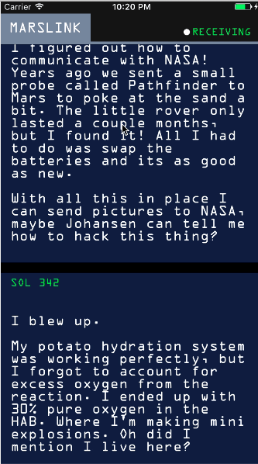

* ***Scene detector***

**AppDelegate.shift**

import UIKit

@UIApplicationMain

class AppDelegate: UIResponder, UIApplicationDelegate {

  var window: UIWindow?

  func application(_ application: UIApplication,

                   didFinishLaunchingWithOptions launchOptions: [UIApplicationLaunchOptionsKey: Any]?) -> Bool {

    return true

  }

}

**ViewController.shift**

import UIKit

import CoreML

import Vision

class ViewController: UIViewController {

  // MARK: - IBOutlets

  @IBOutlet weak var scene: UIImageView!

  @IBOutlet weak var answerLabel: UILabel!

  override func viewDidLoad() {

    super.viewDidLoad()

    guard let image = UIImage(named: "train_night") else {

      fatalError("no starting image")

    }

    scene.image = image

  }

}

extension ViewController {

  @IBAction func pickImage(_ sender: Any) {

    let pickerController = UIImagePickerController()

    pickerController.delegate = self

    pickerController.sourceType = .savedPhotosAlbum

    present(pickerController, animated: true)

  }

}

extension ViewController: UIImagePickerControllerDelegate {

  func imagePickerController(_ picker: UIImagePickerController, didFinishPickingMediaWithInfo info: [String : Any]) {

    dismiss(animated: true)

    guard let image = info[UIImagePickerControllerOriginalImage] as? UIImage else {

      fatalError("couldn't load image from Photos")

    }

    scene.image = image

    guard let ciImage = CIImage(image: image) else {

      fatalError("couldn't convert UIImage to CIImage")

    }

    detectScene(image: ciImage)

  }

}

// MARK: - UINavigationControllerDelegate

extension ViewController: UINavigationControllerDelegate {

}

// MARK: - Private functions

extension ViewController {

  func detectScene(image: CIImage) {

    answerLabel.text = "detecting scene..."

    // Load the ML model through its generated class

    guard let model = try? VNCoreMLModel(for: GoogLeNetPlaces().model) else {

      fatalError("can't load Places ML model")

    }

    // Define a Vision request service with the ML model

    let request = VNCoreMLRequest(model: model) { [weak self] request, error in

      guard let results = request.results,

        let topResult = results.first as? VNClassificationObservation else {

          fatalError("unexpected result type from VNCoreMLRequest")

      }

      // Update UI on main queue

      let article = (["a", "e", "i", "o", "u"].contains(topResult.identifier.first!)) ? "an" : "a"

      DispatchQueue.main.async { [weak self] in

        self?.answerLabel.text = "\(Int(topResult.confidence * 100))% it's \(article) \(topResult.identifier)"

      }

    }

    // Create a request handler with the image provided

    let handler = VNImageRequestHandler(ciImage: image)

    // Perform the request service with the request handler

    DispatchQueue.global(qos: .userInteractive).async {

      do {

        try handler.perform([request])

      } catch {

        print(error)

      }

    }

  }

}

**Output:**

 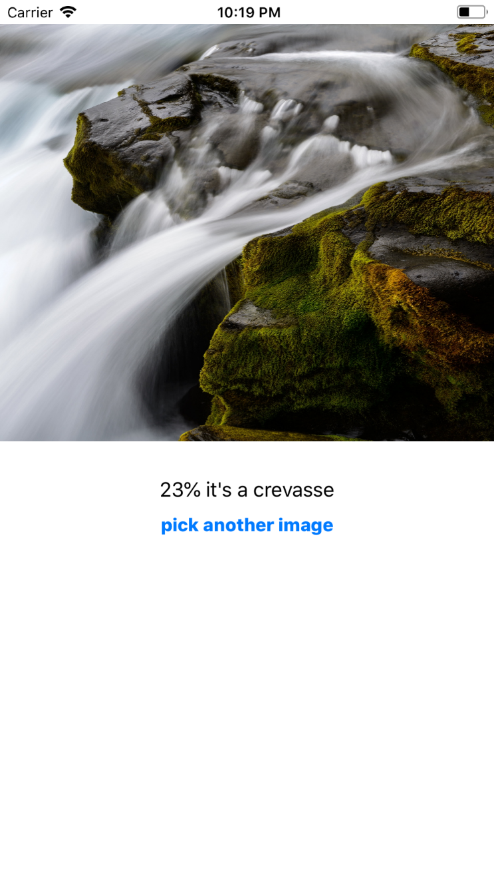

* ***NotificationUI***

**AppDelegate.swift**

import UIKit

import UserNotifications

@UIApplicationMain class AppDelegate: UIResponder, UIApplicationDelegate {

  var window: UIWindow?

  func application(_ application: UIApplication, didFinishLaunchingWithOptions launchOptions: [UIApplicationLaunchOptionsKey: Any]?) -> Bool {

    /// Request local notification authorizations.

    UNUserNotificationCenter.current().requestAuthorization(options: [.alert, .sound, .badge]) { accepted, error in

      if !accepted {

        print("Notification access denied.")

      }

    }

    /// Render actions for notification.

    let action = UNNotificationAction(identifier: "remindLater", title: "Remind me later", options: [])

    let category = UNNotificationCategory(identifier: "normal", actions: [action], intentIdentifiers: [], options: [])

    UNUserNotificationCenter.current().setNotificationCategories([category])

    return true

  }

  /// Create a local notification at specific date.

  ///

  /// - Parameter date: Time to trigger notification.

  func scheduleNotification(at date: Date) {

    UNUserNotificationCenter.current().delegate = self

    /// Create date component from date.

    let calendar = Calendar(identifier: .gregorian)

    let components = calendar.dateComponents(in: .current, from: date)

    let newComponents = DateComponents.init(calendar: calendar, timeZone: .current, month: components.month, day: components.day, hour: components.hour, minute: components.minute)

    /// Create trigger and content.

    let trigger = UNCalendarNotificationTrigger(dateMatching: newComponents, repeats: false)

    let content = UNMutableNotificationContent()

    content.title = "Coding Reminder"

    content.body = "Ready to code? Let us do some Swift!"

    content.sound = UNNotificationSound.default()

    content.categoryIdentifier = "normal"

    /// Add a image as attachment.

    if let path = Bundle.main.path(forResource: "Swift", ofType: "png") {

      let url = URL(fileURLWithPath: path)

      do {

        let attachment = try UNNotificationAttachment(identifier: "Swift", url: url, options: nil)

        content.attachments = [attachment]

      } catch {

        print("The attachment was not loaded.")

      }

    }

    /// Make a notification request.

    let request = UNNotificationRequest(identifier: "textNotification", content: content, trigger: trigger)

    /// Remove pending notifications to avoid duplicates.

    UNUserNotificationCenter.current().removeAllPendingNotificationRequests()

    /// Provide request to notification center.

    UNUserNotificationCenter.current().add(request) { (error) in

      if let error = error {

        print("Error: " + error.localizedDescription)

      }

    }

  }

}

extension AppDelegate: UNUserNotificationCenterDelegate {

  func userNotificationCenter(_ center: UNUserNotificationCenter, didReceive response: UNNotificationResponse, withCompletionHandler completionHandler: @escaping () -> Void) {

    if response.actionIdentifier == "remindLater" {

      let newDate = Date(timeInterval: 60, since: Date())

      scheduleNotification(at: newDate)

    }

  }

}

**ViewController.swift**

import UIKit

class ViewController: UIViewController {

    @IBAction func datePickerDidSelectNewDate(_ sender: UIDatePicker) {

      if let delegate = UIApplication.shared.delegate as? AppDelegate {

        delegate.scheduleNotification(at: sender.date)

      }

    }

}

**Output:**

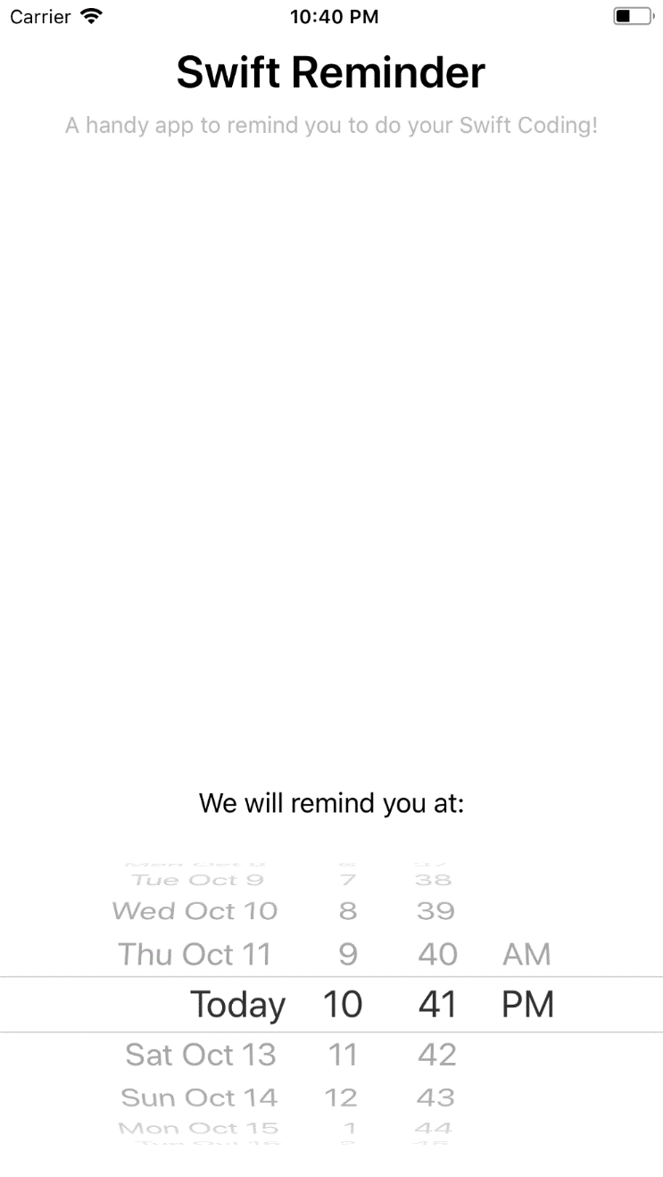

* ***Scale***

**AppDelegate.swift**

import UIKit

enum Shortcut: String {

  case openBlue = "OpenBlue"

}

@UIApplicationMain

class AppDelegate: UIResponder, UIApplicationDelegate {

  var window: UIWindow?

  func application(_ application: UIApplication, didFinishLaunchingWithOptions launchOptions:

    [UIApplicationLaunchOptionsKey: Any]?) -> Bool {

    print("didFinishLaunchingWithOptions called")

    var isLaunchedFromQuickAction = false

    if let shortcutItem = launchOptions?[UIApplicationLaunchOptionsKey.shortcutItem] as? UIApplicationShortcutItem {

      isLaunchedFromQuickAction = true

      let _ = handleQuickAction(shortcutItem)

    } else {

      self.window?.backgroundColor = UIColor.white

    }

    return !isLaunchedFromQuickAction

  }

  func application(_ application: UIApplication, willFinishLaunchingWithOptions launchOptions: [UIApplicationLaunchOptionsKey: Any]?) -> Bool {

    return true

  }

  func handleQuickAction(_ shortcutItem: UIApplicationShortcutItem) -> Bool {

    var quickActionHandled = false

    let type = shortcutItem.type.components(separatedBy: ".").last!

    if let shortcutType = Shortcut.init(rawValue: type) {

      switch shortcutType {

      case .openBlue:

        self.window?.backgroundColor = UIColor(red: 151.0/255.0, green: 187.0/255.0, blue: 255.0/255.0, alpha: 1.0)

        quickActionHandled = true

      }

    }

    return quickActionHandled  }

}

**ViewController.swift**

import UIKit

class ViewController: UIViewController {

  // MARK: - IBOutlets

  @IBOutlet weak var forceLabel: UILabel!

  // MARK: - init

  override func viewDidLoad() {

    super.viewDidLoad()

  }

  override func didReceiveMemoryWarning() {

    super.didReceiveMemoryWarning()  }

  override func touchesMoved(_ touches: Set<UITouch>, with event: UIEvent?) {

    // check only one object in touches

    guard let touch = touches.first else {

      return

    }

    if traitCollection.forceTouchCapability == UIForceTouchCapability.available {

      if touch.force >= touch.maximumPossibleForce {

        forceLabel.text = "385+ g"

      } else {

        let force = touch.force / touch.maximumPossibleForce

        let grams = Int(force * 385)

        forceLabel.text = "\(grams) g"

      }    }  }

  override func touchesEnded(_ touches: Set<UITouch>, with event: UIEvent?) {

    forceLabel.text = "0 g"

  }}

**Output:**

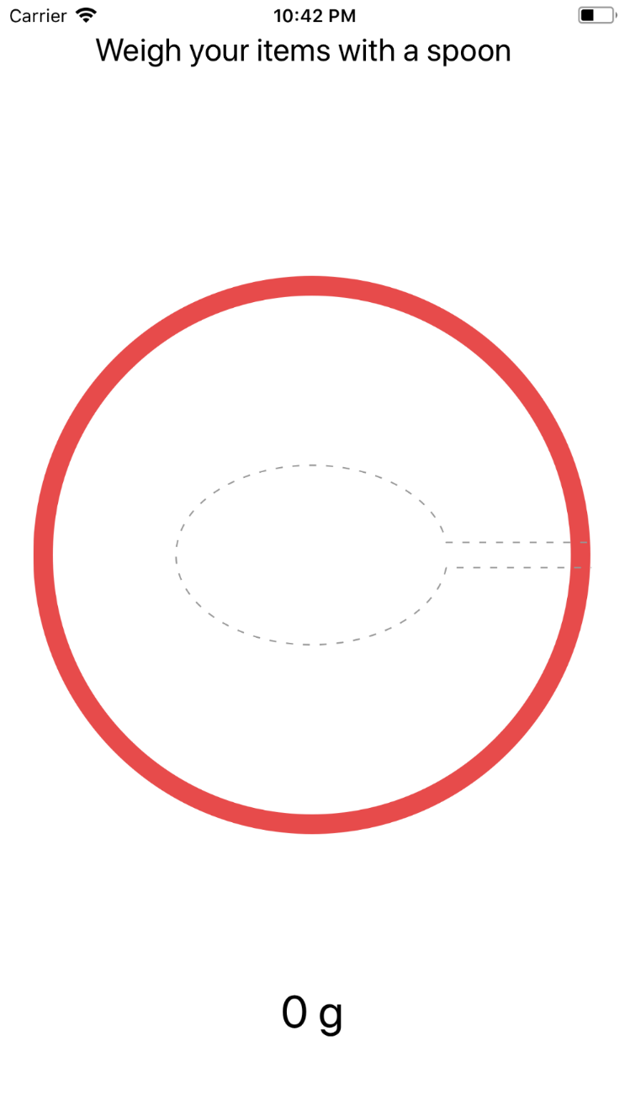

* ***WeatherExtension***

**AppDelegate.swift**

import UIKit

@UIApplicationMain

class AppDelegate: UIResponder, UIApplicationDelegate {

    var window: UIWindow?

    func application(_ application: UIApplication, didFinishLaunchingWithOptions launchOptions: [UIApplicationLaunchOptionsKey: Any]?) -> Bool {

        // Override point for customization after application launch.

        return true

    }

    func applicationWillResignActive(_ application: UIApplication) {

        // Sent when the application is about to move from active to inactive state. This can occur for certain types of temporary interruptions (such as an incoming phone call or SMS message) or when the user quits the application and it begins the transition to the background state.

        // Use this method to pause ongoing tasks, disable timers, and throttle down OpenGL ES frame rates. Games should use this method to pause the game.

    }

    func applicationDidEnterBackground(_ application: UIApplication) {

        // Use this method to release shared resources, save user data, invalidate timers, and store enough application state information to restore your application to its current state in case it is terminated later.

        // If your application supports background execution, this method is called instead of applicationWillTerminate: when the user quits.

    }

    func applicationWillEnterForeground(_ application: UIApplication) {

        // Called as part of the transition from the background to the inactive state; here you can undo many of the changes made on entering the background.

    }

    func applicationDidBecomeActive(_ application: UIApplication) {

        // Restart any tasks that were paused (or not yet started) while the application was inactive. If the application was previously in the background, optionally refresh the user interface.

    }

    func applicationWillTerminate(_ application: UIApplication) {

        // Called when the application is about to terminate. Save data if appropriate. See also applicationDidEnterBackground:.

    }

}

**ViewController.swift**

import UIKit

import WeatherKit

class ViewController: UIViewController {

    @IBOutlet weak var cityLabel:UILabel!

    @IBOutlet weak var countryLabel:UILabel!

    @IBOutlet weak var weatherLabel:UILabel!

    @IBOutlet weak var temperatureLabel:UILabel!

    var city = "San Francisco"

    var country = "U.S."

    override func viewDidLoad() {

        super.viewDidLoad()

        weatherLabel.text = ""

        temperatureLabel.text = ""

        displayCurrentWeather()

    }

    override func didReceiveMemoryWarning() {

        super.didReceiveMemoryWarning()

        // Dispose of any resources that can be recreated.

    }

    func displayCurrentWeather() {

        // Update location

        cityLabel.text = city

        countryLabel.text = country

        // Invoke weather service to get the weather data

        WeatherService.sharedWeatherService().getCurrentWeather(city + "," + country, completion: { (data) -> () in

            OperationQueue.main.addOperation({ () -> Void in

                if let weatherData = data {

                    self.weatherLabel.text = weatherData.weather.capitalized

                    self.temperatureLabel.text = String(format: "%d", weatherData.temperature) + "\u{00B0}"

                }

            })

        })

    }

    @IBAction func unwindToHome(_ segue: UIStoryboardSegue) {

    }

    @IBAction func updateWeatherInfo(_ segue: UIStoryboardSegue) {

        let sourceViewController = segue.source as! LocationTableViewController

        var selectedLocation = sourceViewController.selectedLocation.characters.split { $0 == "," }.map { String($0) }

        city = selectedLocation[0]

        country = selectedLocation[1].trimmingCharacters(in: CharacterSet.whitespaces)

        displayCurrentWeather()

    }

    // MARK: - Navigation

    // In a storyboard-based application, you will often want to do a little preparation before navigation

    override func prepare(for segue: UIStoryboardSegue, sender: Any?) {

        // Get the new view controller using [segue destinationViewController].

        // Pass the selected object to the new view controller.

        if segue.identifier == "showLocations" {

            let destinationController = segue.destination as! UINavigationController

            let locationTableViewController = destinationController.viewControllers[0] as! LocationTableViewController

            locationTableViewController.selectedLocation = "\(city), \(country)"

        }

    }

}

**Output:**



* ***Hitlist***

**AppDelegate.swift**

import UIKit

import CoreData

@UIApplicationMain

class AppDelegate: UIResponder, UIApplicationDelegate {

  var window: UIWindow?

  func application(_ application: UIApplication, didFinishLaunchingWithOptions launchOptions: [UIApplicationLaunchOptionsKey: Any]?) -> Bool {

    // Override point for customization after application launch.

    return true

  }

  func applicationWillResignActive(_ application: UIApplication) {

    // Sent when the application is about to move from active to inactive state. This can occur for certain types of temporary interruptions (such as an incoming phone call or SMS message) or when the user quits the application and it begins the transition to the background state.

    // Use this method to pause ongoing tasks, disable timers, and throttle down OpenGL ES frame rates. Games should use this method to pause the game.

  }

  func applicationDidEnterBackground(_ application: UIApplication) {

    // Use this method to release shared resources, save user data, invalidate timers, and store enough application state information to restore your application to its current state in case it is terminated later.

    // If your application supports background execution, this method is called instead of applicationWillTerminate: when the user quits.

  }

  func applicationWillEnterForeground(_ application: UIApplication) {

    // Called as part of the transition from the background to the inactive state; here you can undo many of the changes made on entering the background.

  }

  func applicationDidBecomeActive(_ application: UIApplication) {

    // Restart any tasks that were paused (or not yet started) while the application was inactive. If the application was previously in the background, optionally refresh the user interface.

  }

  func applicationWillTerminate(_ application: UIApplication) {

    // Called when the application is about to terminate. Save data if appropriate. See also applicationDidEnterBackground:.

    // Saves changes in the application's managed object context before the application terminates.

    self.saveContext()

  }

  // MARK: - Core Data stack

  lazy var applicationDocumentsDirectory: URL = {

      // The directory the application uses to store the Core Data store file. This code uses a directory named "com.yigu.HitList" in the application's documents Application Support directory.

      let urls = FileManager.default.urls(for: .documentDirectory, in: .userDomainMask)

      return urls[urls.count-1]

  }()

  lazy var managedObjectModel: NSManagedObjectModel = {

      // The managed object model for the application. This property is not optional. It is a fatal error for the application not to be able to find and load its model.

      let modelURL = Bundle.main.url(forResource: "HitList", withExtension: "momd")!

      return NSManagedObjectModel(contentsOf: modelURL)!

  }()

  lazy var persistentStoreCoordinator: NSPersistentStoreCoordinator = {

      // The persistent store coordinator for the application. This implementation creates and returns a coordinator, having added the store for the application to it. This property is optional since there are legitimate error conditions that could cause the creation of the store to fail.

      // Create the coordinator and store

      let coordinator = NSPersistentStoreCoordinator(managedObjectModel: self.managedObjectModel)

      let url = self.applicationDocumentsDirectory.appendingPathComponent("SingleViewCoreData.sqlite")

      var failureReason = "There was an error creating or loading the application's saved data."

      do {

          try coordinator.addPersistentStore(ofType: NSSQLiteStoreType, configurationName: nil, at: url, options: nil)

      } catch {

          // Report any error we got.

          var dict = [String: AnyObject]()

          dict[NSLocalizedDescriptionKey] = "Failed to initialize the application's saved data" as AnyObject?

          dict[NSLocalizedFailureReasonErrorKey] = failureReason as AnyObject?

          dict[NSUnderlyingErrorKey] = error as NSError

          let wrappedError = NSError(domain: "YOUR_ERROR_DOMAIN", code: 9999, userInfo: dict)

          // Replace this with code to handle the error appropriately.

          // abort() causes the application to generate a crash log and terminate. You should not use this function in a shipping application, although it may be useful during development.

          NSLog("Unresolved error \(wrappedError), \(wrappedError.userInfo)")

          abort()

      }

      return coordinator

  }()

  lazy var managedObjectContext: NSManagedObjectContext = {

      // Returns the managed object context for the application (which is already bound to the persistent store coordinator for the application.) This property is optional since there are legitimate error conditions that could cause the creation of the context to fail.

      let coordinator = self.persistentStoreCoordinator

      var managedObjectContext = NSManagedObjectContext(concurrencyType: .mainQueueConcurrencyType)

      managedObjectContext.persistentStoreCoordinator = coordinator

      return managedObjectContext

  }()

  // MARK: - Core Data Saving support

  func saveContext () {

      if managedObjectContext.hasChanges {

          do {

              try managedObjectContext.save()

          } catch {

              // Replace this implementation with code to handle the error appropriately.

              // abort() causes the application to generate a crash log and terminate. You should not use this function in a shipping application, although it may be useful during development.

              let nserror = error as NSError

              NSLog("Unresolved error \(nserror), \(nserror.userInfo)")

              abort()

          }

      }

  }

}

**ViewController.swift**

import UIKit

import CoreData

class ViewController: UIViewController, UITableViewDataSource {

  @IBOutlet weak var tableView: UITableView!

  var people: [NSManagedObject] = []

  // MARK - LifeCycle

  override func viewDidLoad() {

    super.viewDidLoad()

    self.setupNavigationTitle()

    let appDelegate = UIApplication.shared.delegate as! AppDelegate

    let managedContext = appDelegate.managedObjectContext

    self.fetchCoreData(managedContext)

  }

  func setupNavigationTitle() {

    title = "The List"

  }

  func fetchCoreData(_ managedContext: NSManagedObjectContext) {

    let fetchRequest = NSFetchRequest<NSFetchRequestResult>(entityName: "Person")

    do {

      let results =

      try managedContext.fetch(fetchRequest)

      people = results as! [NSManagedObject]

    } catch let error as NSError {

      print("Could not fetch \(error), \(error.userInfo)")

    }

  }

  // MARK - UITableViewDataSource

  func tableView(_ tableView: UITableView, numberOfRowsInSection section: Int) -> Int {

    return people.count

  }

  func tableView(_ tableView: UITableView, cellForRowAt indexPath: IndexPath) -> UITableViewCell {

    let identifier: String = "cell"

    let cell = tableView.dequeueReusableCell(withIdentifier: identifier, for: indexPath)

    let person = people[indexPath.row]

    cell.textLabel!.text = person.value(forKey: "name") as? String

    return cell

  }

  func tableView(_ tableView: UITableView, commit editingStyle: UITableViewCellEditingStyle, forRowAt indexPath: IndexPath) {

    switch editingStyle {

    case .delete:

      // remove the deleted item from the model

      let appDelegate = UIApplication.shared.delegate as! AppDelegate

      let managedContext = appDelegate.managedObjectContext

      managedContext.delete(people[indexPath.row] as NSManagedObject)

      do {

        try managedContext.save()

        people.remove(at: indexPath.row)

      } catch let error as NSError  {

        print("Could not save \(error), \(error.userInfo)")

      }

      //tableView.reloadData()

      // remove the deleted item from the `UITableView`

      self.tableView.deleteRows(at: [indexPath], with: .fade)

    default:

      return

    }

  }

  // MARK - IBActions

  @IBAction func addName(_ sender: AnyObject) {

    let alert = UIAlertController(title: "New Name", message: "Add a new name", preferredStyle: .alert)

    let saveAction = UIAlertAction(title: "Save", style: .default, handler: {(action: UIAlertAction) -> Void in

      let textField = alert.textFields!.first

      self.saveName(textField!.text!)

      self.tableView.reloadData()

    })

    let cancelAction = UIAlertAction(title: "Cancel", style: .default, handler: {(action: UIAlertAction) -> Void in

    })

    alert.addTextField {

      (textField: UITextField) -> Void in

    }

    alert.addAction(saveAction)

    alert.addAction(cancelAction)

    present(alert, animated: true, completion: nil)

  }

  // MARK - CoreData func

  func saveName(_ name: String) {

    let appDelegate = UIApplication.shared.delegate as! AppDelegate

    let managedContext = appDelegate.managedObjectContext

    let entity =  NSEntityDescription.entity(forEntityName: "Person",

      in:managedContext)

    let person = NSManagedObject(entity: entity!,

      insertInto: managedContext)

    person.setValue(name, forKey: "name")

    do {

      try managedContext.save()

      people.append(person)

    } catch let error as NSError  {

      print("Could not save \(error), \(error.userInfo)")

    }

  }

}

Output:

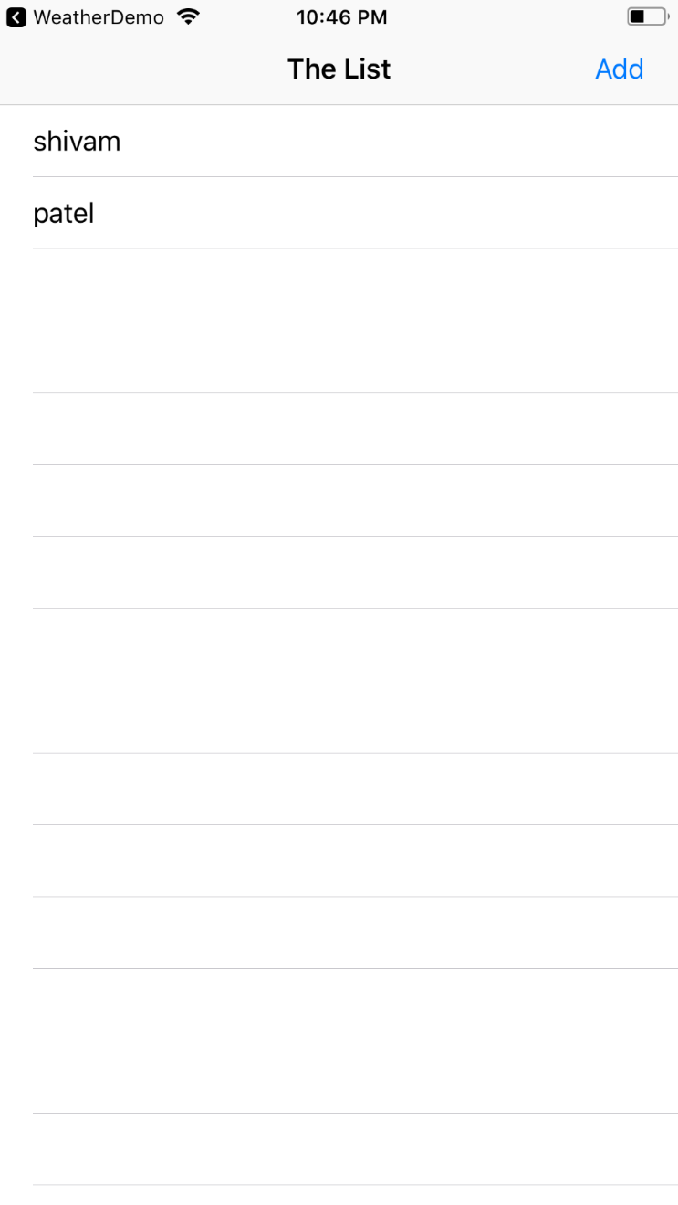 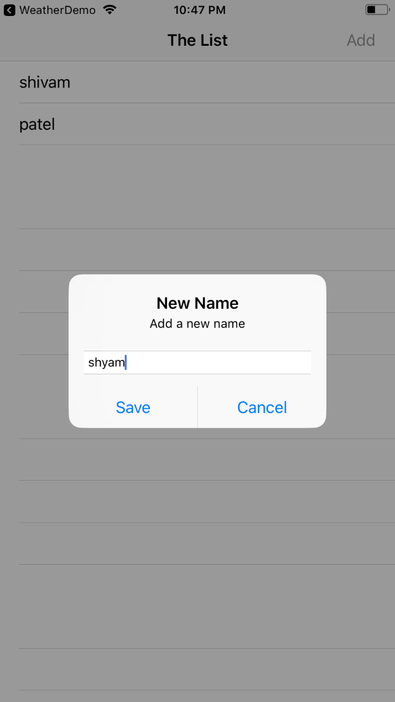

* ***birthdays***

**AppDelegate.swift**

import UIKit

import Contacts

@UIApplicationMain

class AppDelegate: UIResponder, UIApplicationDelegate {

  static var appDelegate: AppDelegate { return UIApplication.shared.delegate as! AppDelegate }

  var window: UIWindow?

  var contactStore = CNContactStore()

  func application(_ application: UIApplication, didFinishLaunchingWithOptions launchOptions: [UIApplicationLaunchOptionsKey: Any]?) -> Bool {

    // Override point for customization after application launch.

    return true

  }

  func requestForAccess(completionHandler: @escaping (_ accessGranted: Bool) -> Void) {

    let authorizationStatus = CNContactStore.authorizationStatus(for: CNEntityType.contacts)

    switch authorizationStatus {

    case .authorized:

      completionHandler(true)

    case .denied, .notDetermined:

      self.contactStore.requestAccess(for: CNEntityType.contacts, completionHandler: { (access, accessError) -> Void in

        if access {

          completionHandler(access)

        } else {

          if authorizationStatus == CNAuthorizationStatus.denied {

            DispatchQueue.main.async {

              let message = "\(accessError!.localizedDescription)\n\nPlease allow the app to access your contacts through the Settings."

              Helper.show(message: message)

            }

          }

        }

      })

    default:

      completionHandler(false)

    }

  }

}

**Helper.swift**

import Foundation

import UIKit

class Helper {

  static func show(message: String) {

    let alertController = UIAlertController(title: "Birthdays", message: message, preferredStyle: .alert)

    let dismissAction = UIAlertAction(title: "OK", style: .default, handler: nil)

    alertController.addAction(dismissAction)

    let pushedViewControllers = (UIApplication.shared.keyWindow?.rootViewController as! UINavigationController).viewControllers

    let presentedViewController = pushedViewControllers.last

    presentedViewController?.present(alertController, animated: true, completion: nil)

  }

}

extension DateComponents {

  var asString: String? {

    if let date = Calendar.current.date(from: self) {

      let dateFormatter = DateFormatter()

      dateFormatter.locale = Locale.current

      dateFormatter.dateStyle = .medium

      let dateString = dateFormatter.string(from: date)

      return dateString

    }

    return nil

  }

}

**ViewController.swift**

import UIKit

import Contacts

import ContactsUI

class ViewController: UIViewController {

  @IBOutlet weak var tblContacts: UITableView!

  var contacts = [CNContact]()

  override func viewDidLoad() {

    super.viewDidLoad()

    navigationController?.navigationBar.tintColor = UIColor(red: 241.0/255.0, green: 107.0/255.0, blue: 38.0/255.0, alpha: 1.0)

    configureTableView()

  }

  // MARK: IBAction functions

  @IBAction func addContact(_ sender: AnyObject) {

    performSegue(withIdentifier: "idSegueAddContact", sender: self)

  }

  // MARK: Custom functions

  func configureTableView() {

    tblContacts.delegate = self

    tblContacts.dataSource = self

    tblContacts.register(UINib(nibName: "ContactBirthdayCell", bundle: nil), forCellReuseIdentifier: "idCellContactBirthday")

  }

  /// Set ViewController class as the delegate of the AddContactViewControllerDelegate protocol

  override func prepare(for segue: UIStoryboardSegue, sender: Any?) {

    if let identifier = segue.identifier {

      if identifier == "idSegueAddContact" {

        let addContactViewController = segue.destination as! AddContactViewController

        addContactViewController.delegate = self

      }

    }

  }

}

// MARK: UITableView Delegate and Datasource functions

extension ViewController: UITableViewDataSource {

  func numberOfSections(in tableView: UITableView) -> Int {

    return 1

  }

  func tableView(_ tableView: UITableView, numberOfRowsInSection section: Int) -> Int {

    return contacts.count

  }

  func tableView(_ tableView: UITableView, cellForRowAt indexPath: IndexPath) -> UITableViewCell {

    let cell = tableView.dequeueReusableCell(withIdentifier: "idCellContactBirthday") as! ContactBirthdayCell

    let currentContact = contacts[indexPath.row]

    cell.lblFullname.text = CNContactFormatter.string(from: currentContact, style: .fullName)

    if !currentContact.isKeyAvailable(CNContactBirthdayKey) || !currentContact.isKeyAvailable(CNContactImageDataKey) ||  !currentContact.isKeyAvailable(CNContactEmailAddressesKey) {

      refetch(contact: currentContact, atIndexPath: indexPath)

    } else {

      // Set the birthday info.

      if let birthday = currentContact.birthday {

        cell.lblBirthday.text = birthday.asString

      }

      else {

        cell.lblBirthday.text = "Not available birthday data"

      }

      // Set the contact image.

      if let imageData = currentContact.imageData {

        cell.imgContactImage.image = UIImage(data: imageData)

      }

      // Set the contact's home email address.

      var homeEmailAddress: String!

      for emailAddress in currentContact.emailAddresses {

        if emailAddress.label == CNLabelHome {

          homeEmailAddress = emailAddress.value as String

          break

        }

      }

      if let homeEmailAddress = homeEmailAddress {

        cell.lblEmail.text = homeEmailAddress

      } else {

        cell.lblEmail.text = "Not available home email"

      }

    }

    return cell

  }

  fileprivate func refetch(contact: CNContact, atIndexPath indexPath: IndexPath) {

    AppDelegate.appDelegate.requestForAccess { (accessGranted) -> Void in

      if accessGranted {

        let keys = [CNContactFormatter.descriptorForRequiredKeys(for: CNContactFormatterStyle.fullName), CNContactEmailAddressesKey, CNContactBirthdayKey, CNContactImageDataKey] as [Any]

        do {

          let contactRefetched = try AppDelegate.appDelegate.contactStore.unifiedContact(withIdentifier: contact.identifier, keysToFetch: keys as! [CNKeyDescriptor])

          self.contacts[indexPath.row] = contactRefetched

          DispatchQueue.main.async {

            self.tblContacts.reloadRows(at: [indexPath], with: .automatic)

          }

        }

        catch {

          print("Unable to refetch the contact: \(contact)", separator: "", terminator: "\n")

        }

      }

    }

  }

}

extension ViewController: UITableViewDelegate {

  func tableView(_ tableView: UITableView, heightForRowAt indexPath: IndexPath) -> CGFloat {

    return 100.0

  }

  func tableView(_ tableView: UITableView, canEditRowAt indexPath: IndexPath) -> Bool {

    return true

  }

  func tableView(_ tableView: UITableView, commit editingStyle: UITableViewCellEditingStyle, forRowAt indexPath: IndexPath) {

    if editingStyle == .delete {

      contacts.remove(at: indexPath.row)

      tblContacts.reloadData()

    }

  }

  func tableView(_ tableView: UITableView, didSelectRowAt indexPath: IndexPath) {

    let selectedContact = contacts[indexPath.row]

    let keys = [CNContactFormatter.descriptorForRequiredKeys(for: CNContactFormatterStyle.fullName), CNContactEmailAddressesKey, CNContactBirthdayKey, CNContactImageDataKey] as [Any]

    if selectedContact.areKeysAvailable([CNContactViewController.descriptorForRequiredKeys()]) {

      let contactViewController = CNContactViewController(for: selectedContact)

      contactViewController.contactStore = AppDelegate.appDelegate.contactStore

      contactViewController.displayedPropertyKeys = keys

      navigationController?.pushViewController(contactViewController, animated: true)

    }

    else {

      AppDelegate.appDelegate.requestForAccess(completionHandler: { (accessGranted) -> Void in

        if accessGranted {

          do {

            let contactRefetched = try AppDelegate.appDelegate.contactStore.unifiedContact(withIdentifier: selectedContact.identifier, keysToFetch: [CNContactViewController.descriptorForRequiredKeys()])

            DispatchQueue.main.async {

              let contactViewController = CNContactViewController(for: contactRefetched)

              contactViewController.contactStore = AppDelegate.appDelegate.contactStore

              contactViewController.displayedPropertyKeys = keys

              self.navigationController?.pushViewController(contactViewController, animated: true)

            }

          }

          catch {

            print("Unable to refetch the selected contact.", separator: "", terminator: "\n")

          }

        }

      })

    }

  }

}

extension ViewController: AddContactViewControllerDelegate {

  func didFetchContacts(_ contacts: [CNContact]) {

    for contact in contacts {

      self.contacts.append(contact)

    }

    tblContacts.reloadData()

  }

}

**AddContactViewController.swift**

import UIKit

import Contacts

import ContactsUI

protocol AddContactViewControllerDelegate {

  func didFetchContacts(_ contacts: [CNContact])

}

class AddContactViewController: UIViewController {

  @IBOutlet weak var txtLastName: UITextField!

  @IBOutlet weak var pickerMonth: UIPickerView!

  let months = ["January", "February", "March", "April", "May", "June", "July", "August", "September", "October", "November", "December"]

  var currentlySelectedMonthIndex = 1

  var delegate: AddContactViewControllerDelegate!

  override func viewDidLoad() {

    super.viewDidLoad()

    pickerMonth.delegate = self

    txtLastName.delegate = self

    let doneBarButtonItem = UIBarButtonItem(barButtonSystemItem: UIBarButtonSystemItem.done, target: self, action: #selector(AddContactViewController.performDoneItemTap))

    navigationItem.rightBarButtonItem = doneBarButtonItem

  }

}

  // MARK: IBAction functions

extension AddContactViewController: CNContactPickerDelegate {

  @IBAction func showContacts(_ sender: AnyObject) {

    let contactPickerViewController = CNContactPickerViewController()

    contactPickerViewController.predicateForEnablingContact = NSPredicate(format: "birthday != nil")

    contactPickerViewController.delegate = self

    contactPickerViewController.displayedPropertyKeys = [CNContactGivenNameKey, CNContactFamilyNameKey, CNContactEmailAddressesKey, CNContactBirthdayKey, CNContactImageDataKey]

    present(contactPickerViewController, animated: true, completion: nil)

  }

  func contactPicker(picker: CNContactPickerViewController, didSelectContact contact: CNContact) {

    delegate.didFetchContacts([contact])

    navigationController?.popViewController(animated: true)

  }

}

// MARK: UIPickerView Delegate and Datasource functions

extension AddContactViewController: UIPickerViewDelegate {

  func pickerView(_ pickerView: UIPickerView, numberOfRowsInComponent component: Int) -> Int {

    return months.count

  }

  func pickerView(_ pickerView: UIPickerView, titleForRow row: Int, forComponent component: Int) -> String? {

    return months[row]

  }

  func pickerView(_ pickerView: UIPickerView, didSelectRow row: Int, inComponent component: Int) {

    currentlySelectedMonthIndex = row + 1

  }

}

// MARK: UITextFieldDelegate functions

extension AddContactViewController: UITextFieldDelegate {

  func textFieldShouldReturn(_ textField: UITextField) -> Bool {

    AppDelegate.appDelegate.requestForAccess { (accessGranted) -> Void in

      if accessGranted {

        let predicate = CNContact.predicateForContacts(matchingName: self.txtLastName.text!)

        let keys = [CNContactFormatter.descriptorForRequiredKeys(for: CNContactFormatterStyle.fullName), CNContactEmailAddressesKey, CNContactBirthdayKey] as [Any]

        var contacts = [CNContact]()

        var warningMessage: String!

        let contactsStore = AppDelegate.appDelegate.contactStore

        do {

          contacts = try contactsStore.unifiedContacts(matching: predicate, keysToFetch: keys as! [CNKeyDescriptor])

          if contacts.count == 0 {

            warningMessage = "No contacts were found matching the given name."

          }

        } catch {

          warningMessage = "Unable to fetch contacts."

        }

        if let warningMessage = warningMessage {

          DispatchQueue.main.async {

            Helper.show(message: warningMessage)

          }

        } else {

          DispatchQueue.main.async {

            self.delegate.didFetchContacts(contacts)

            self.navigationController?.popViewController(animated: true)

          }

        }

      }

    }

    return true

  }

  // MARK: Custom functions

  @objc func performDoneItemTap() {

    AppDelegate.appDelegate.requestForAccess { (accessGranted) -> Void in

      if accessGranted {

        var contacts = [CNContact]()

        let keys = [CNContactFormatter.descriptorForRequiredKeys(for: CNContactFormatterStyle.fullName), CNContactEmailAddressesKey, CNContactBirthdayKey, CNContactImageDataKey] as [Any]

        do {

          let contactStore = AppDelegate.appDelegate.contactStore

          try contactStore.enumerateContacts(with: CNContactFetchRequest(keysToFetch: keys as! [CNKeyDescriptor])) { [weak self] (contact, pointer) -> Void in

            if contact.birthday != nil && contact.birthday!.month == self?.currentlySelectedMonthIndex {

              contacts.append(contact)

            }

          }

          DispatchQueue.main.async {

            self.delegate.didFetchContacts(contacts)

            self.navigationController?.popViewController(animated: true)

          }

        }

        catch let error as NSError {

          print(error.description, separator: "", terminator: "\n")

        }

      }

    }

  }

}

**CreateContactViewController.swift**

import UIKit

import Contacts

class CreateContactViewController: UIViewController {

  @IBOutlet weak var txtFirstname: UITextField!

  @IBOutlet weak var txtLastname: UITextField!

  @IBOutlet weak var txtHomeEmail: UITextField!

  @IBOutlet weak var datePicker: UIDatePicker!

  override func viewDidLoad() {

    super.viewDidLoad()

    txtFirstname.delegate = self

    txtLastname.delegate = self

    txtHomeEmail.delegate = self

    let saveBarButtonItem = UIBarButtonItem(barButtonSystemItem: UIBarButtonSystemItem.save, target: self, action: #selector(CreateContactViewController.createContact))

    navigationItem.rightBarButtonItem = saveBarButtonItem

  }

  override func didReceiveMemoryWarning() {

    super.didReceiveMemoryWarning()

    // Dispose of any resources that can be recreated.

  }

    @objc func createContact() {

    let newContact = CNMutableContact()

    newContact.givenName = txtFirstname.text!

    newContact.familyName = txtLastname.text!

    if let homeEmail = txtHomeEmail.text {

      let homeEmail = CNLabeledValue(label: CNLabelHome, value: homeEmail as NSString)

      newContact.emailAddresses = [homeEmail]

    }

     let birthdayComponents = Calendar.current.dateComponents([Calendar.Component.year, Calendar.Component.month, Calendar.Component.day], from: datePicker.date)

    newContact.birthday = birthdayComponents

      do {

      let saveRequest = CNSaveRequest()

      saveRequest.add(newContact, toContainerWithIdentifier: nil)

      try AppDelegate.appDelegate.contactStore.execute(saveRequest)

        navigationController?.popViewController(animated: true)

    } catch {

      Helper.show(message: "Unable to save the new contact.")

    }

  }

}

extension CreateContactViewController: UITextFieldDelegate {

  func textFieldShouldReturn(_ textField: UITextField) -> Bool {

    textField.resignFirstResponder()

    return true

  }

}

**ContactBirthdayCell.swift**

import UIKit

class ContactBirthdayCell: UITableViewCell {

  @IBOutlet weak var lblFullname: UILabel!

  @IBOutlet weak var lblBirthday: UILabel!

  @IBOutlet weak var imgContactImage: UIImageView!

  @IBOutlet weak var lblEmail: UILabel!

  override func awakeFromNib() {

    super.awakeFromNib()

    imgContactImage.layer.cornerRadius = 25.0

  }

  override func setSelected(_ selected: Bool, animated: Bool) {

    super.setSelected(selected, animated: animated)

  }

  }

**Output:**

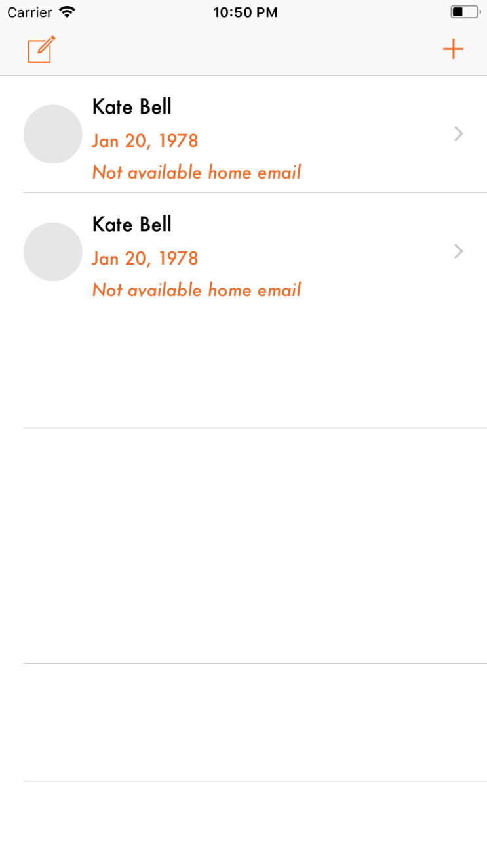 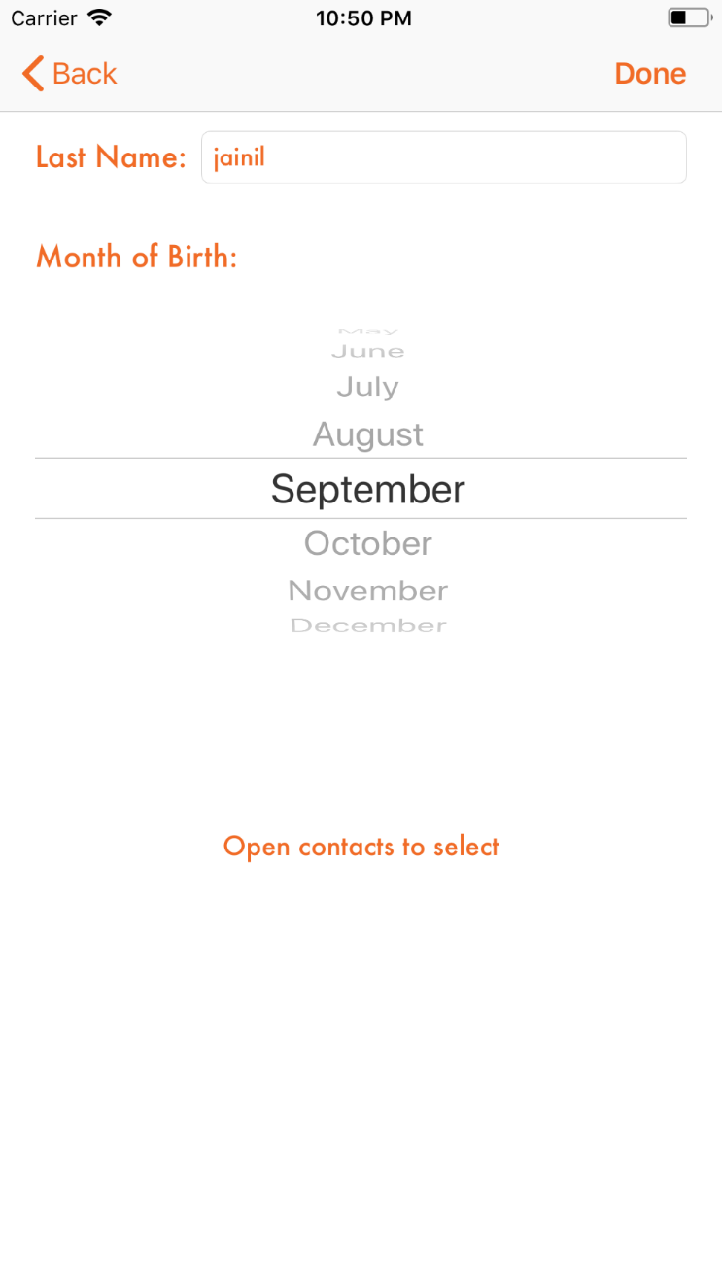

**PRACTICAL 20**

**20) Aim:** **Deploying all Apps in Particular App Store/Hosting**

**A)On app store**

## 1. Is Your Application Ready?

### Step 1: Testing

An application isn't necessarily ready when you've written the last line of code or implemented the final feature of the application's specification.

Have you tested your application on one or more physical devices? Have you profiled your application for memory leaks and performance issues? Does your application crash from time to time?

The family of iOS devices has grown substantially over the years, and it is important to test your application on as many iOS devices as you can lay your hands on. Common issues include not optimizing an application for certain screen sizes. The iOS Simulator is a great tool, but it runs on your Mac, which has more memory and processing power than the phone in your pocket.

Apple's Review Process isn't airtight, but it is very capable of identifying problems that might affect your application's user experience. If your application crashes from time to time or it becomes slow after ten minutes of use, then you have some work to do before submitting it to the App Store.

Even if Apple's review team doesn't spot the problem, your users will. If the people using your application are not pleased, they will leave bad reviews on the App Store, which may harm sales or inhibit downloads.

### Step 2: Rules and Guidelines

As I mentioned earlier, Apple provides developers with a number of documents that are a great help during the creation and development process of your application.

The documents that you should be aware of are the [iOS Human Interface Guidelines](https://developer.apple.com/library/ios/#documentation/userexperience/conceptual/mobilehig/Introduction/Introduction.html) and the [App Store Review Guidelines](https://developer.apple.com/appstore/resources/approval/guidelines.html). Despite the availability of these documents, it seems that few developers take the time to browse them, let alone read them. It shouldn't be a surprise that some applications are therefore rejected even though the reason for the rejection is clearly stated in these documents.

Even if you don't intend to read the iOS Human Interface Guidelines or the App Store Review Guidelines, it is important to know some of the rules that they talk about. Take a look at the short list below to get an idea of what your application should and shouldn't do.

Your application:

* shouldn't crash
* shouldn't use private APIs
* shouldn't replicate the functionality of native applications
* should use In App Purchase for in-app (financial) transactions
* shouldn't use the camera or microphone without the user's knowledge
* should only use artwork that is your copyright or that you have permission to use

Keep in mind that this is a tiny subset of the guidelines included in the aforementioned documents. The majority of the rules and guidelines are trivial, but some are not, and you might even violate some of them inadvertently.

Let me give you an example. Before Apple started using its own maps (a really long time ago), the MapKit framework used Google's maps. This was clear to the user because of the small Google logo in the bottom left corner of each map. However, if some part of your application's user interface covered or obscured Google's logo, your application would get rejected. This rule seems trivial, but it is a rule that is easily violated if you're not careful. Even automated tests won't cover you in this case.

## 2. Prerequisites

Before you can even start thinking about submitting your application to the App Store, you need to make sure that you have an App ID, a valid distribution certificate, and a valid provisioning profile. Let me show you what this entails.

### Step 1: App ID

Every application needs an App ID or application identifier. There are two types of application identifiers: an **explicit App ID** and a **wildcard App ID**. A wildcard App ID can be used for building and installing multiple applications. Despite the convenience of a wildcard App ID, an explicit App ID is *required* if your application uses iCloud or makes use of other iOS features, such as Game Center, Apple Push Notifications, or In App Purchase.

### Step 2: Distribution Certificate

To submit an application to the App Store, you need to create an iOS provisioning profile for distribution. To create such a provisioning profile, you first need to create a distribution certificate. The process for creating a distribution certificate is very similar to creating a development certificate. If you have tested your application on a physical device, then you are probably already familiar with the creation of a development certificate.

If you need to refresh your memory, I suggest reading Apple's guide, [Code Signing your Apps](https://developer.apple.com/support/code-signing/), about signing certificates and provisioning profiles. The process is not difficult once you understand how the various pieces of the puzzle fit together.

### Step 3: Provisioning Profile

Once you've created an App ID and a distribution certificate, you can create an iOS provisioning profile for distributing your application through the App Store.

Keep in mind that you cannot use the same provisioning profile that you use for ad hoc distribution. You need to create a separate provisioning profile for App Store distribution. If you use a wildcard App ID for your project, then you can use the same provisioning profile for multiple applications.

### Step 4: Build Settings

With the App ID, distribution certificate, and provisioning profile in place, it is time to configure your target's build settings in Xcode. This means selecting the target from the list of targets in Xcode's **Project Navigator**, opening the **Build Settings** tab at the top, and updating the settings in the **Signing** section. You will need to set the **Code Signing**to **Automatic.**

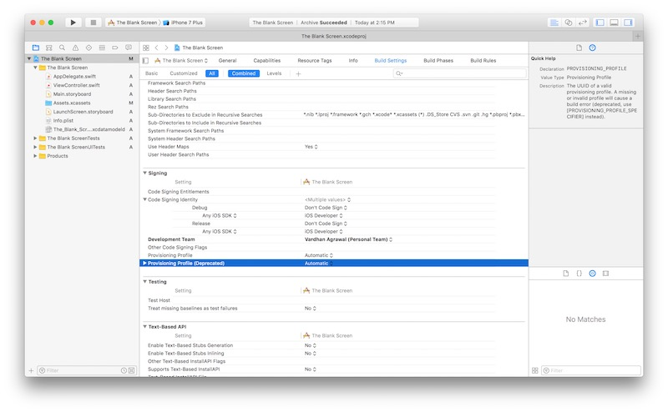

Even though the code signing process is fairly simple once you understand it, it is something that trips up a lot of developers. I don't know a single Cocoa developer who hasn't run into code signing issues at some point in their career. Once you've cleared this hurdle, the rest of the submission process is fairly easy.

### Step 5: Deployment Target

It is useful to think a little about your application's deployment target. Each target in an Xcode project has a deployment target, which indicates the minimum version of the operating system that the application can run on.

It is up to you to set the deployment target, but keep in mind that modifying the deployment target is not something you can do without consequences once your application is in the App Store. If you increase the deployment target for an update of your application, then users who have already purchased your application but don't meet the new deployment target cannot run the update.

It gets really problematic when a user downloads an update through iTunes (not the device), replacing the previous version on their computer, and then discovers that the new update doesn't run on their device.

## 3. Assets

### Step 1: Icons

You probably know that an application icon is a vital component of every iOS application, but you need to make sure that your application ships with the correct sizes of the artwork. Take a look at the table below:

It goes without saying that you don't need to include an application icon for the iPad/iPad Mini device family if your application only targets the iPhone/iPod Touch device family, and vice versa.

### Step 2: Screenshots

Each application can have up to five screenshots and three previews, and you must provide at least one. If you are developing a universal application, then you need to provide separate screenshots for each device.

It is important to spend some time thinking about the screenshots. Your application's screenshots are often the only thing that a customer can use to decide whether to purchase or download your application or not.

What a lot of developers don't know is that the screenshots don't have to be actual screenshots. The hard rule is that the size of each screenshot needs to be that of the screen size of the target device. Many companies are creative with this rule. Take a look at the screenshots of [Where's My Water?](https://itunes.apple.com/us/app/wheres-my-water/id449735650), for example, which include labels highlighting key features of the app. By using this strategy, you can make screenshots much more attractive and compelling.

### Step 3: Metadata

Before you submit your application, it is a good idea to have your application's metadata at hand. This includes:

* your application's name
* the version number
* the primary (and an optional secondary) category
* a concise description
* keywords
* a support URL

If you are submitting an update, then you can also provide information for the **What's New in this Version** section.

Does your application require users to sign in? Then you also need to provide Apple with a test or demo account to make sure that the review team can immediately sign in and use your application without first having to sign up for an account.

## 4. Submission Preparation

The submission process has become much easier these days. You can now validate and submit an application using Xcode, for example. First, however, you need to create your application in iTunes Connect.

Visit [iTunes Connect](https://itunesconnect.apple.com/), sign in with your iOS developer account, and click **Manage Your Apps** on the right. Click the **Add New App** in the top left, select **iOS App**, and fill out the form.

### Step 1: Basic Information

The **App Name**, which needs to be unique, is the name of your application as it will appear in the App Store. This can be different than the name that is displayed below your application icon on the home screen, but it is recommended to choose the same name.

The **SKU Number** is a unique string that identifies your application. I usually use the application's bundle identifier.

The last piece of information is the **Bundle ID** of your application. This means selecting the (wildcard or explicit) App ID that you created earlier from the drop-down menu.

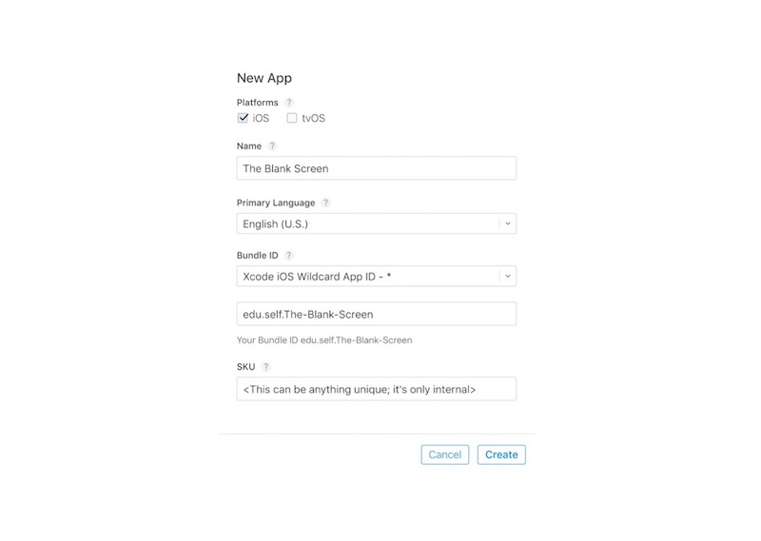

### Step 2: Price and Availability

In the next step, you specify your application's price and availability. Apple works with price tiers so that you don't have to specify a price for each country that Apple operates in. You can also specify in which stores your application should—or shouldn't—be available.

The information that you enter in this step can be modified once your application is live in the App Store. In other words, you can change the price and availability of an application without having to submit an update. You can easily do this by selecting the **Pricing and Availability**tab on the left of your app's iTunes Connect page.

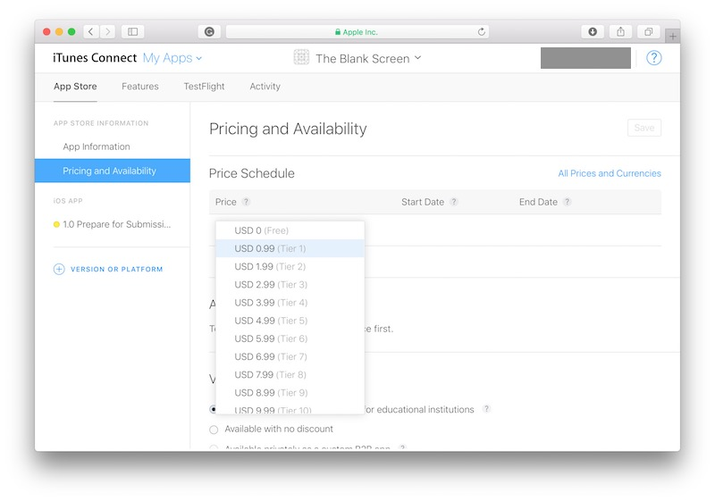

### Step 3: Metadata

We've already covered the application's metadata. The only aspect that I haven't talked about yet is your application's rating. Based on your application's content and functionality, it is given a rating. This rating is not only useful for telling users about your application's content and features, but is also used by the operating system for the parental controls features.

It is strongly recommended that you don't try to outsmart the rating system. Apple is well aware of this strategy and will reject your application if it doesn't agree with the rating that you have set. There are many other things here that you may need to adjust based on your app, but we won't go over them since they are pretty self-explanatory. To do this, go to the **App Information**tab in the left pane.

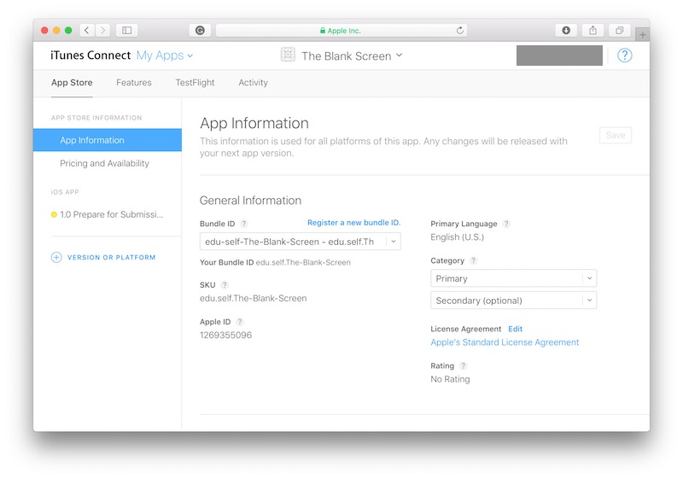

**5. Uploading the App Binary**

To submit your app, you need to create an **archive**. You can only create an archive by building your application on a **generic device**. If you select the iOS Simulator in the active scheme, you will notice that the **Archive** option in Xcode's **Product** menu is grayed out. Connect an iOS device to your Mac, select it in the active scheme, and select **Archive** from Xcode's **Product** menu.

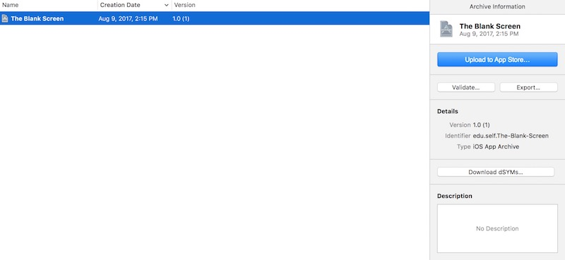

If all went well, you should now have an archive, and Xcode's Organizer should automatically open and show you the archive you just created. Select the archive from the list and click the **Upload to App Store...** button on the right. The application binary is then uploaded to Apple's servers.

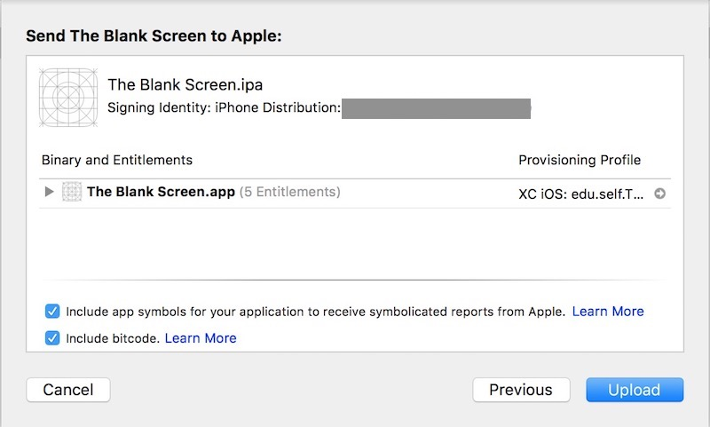

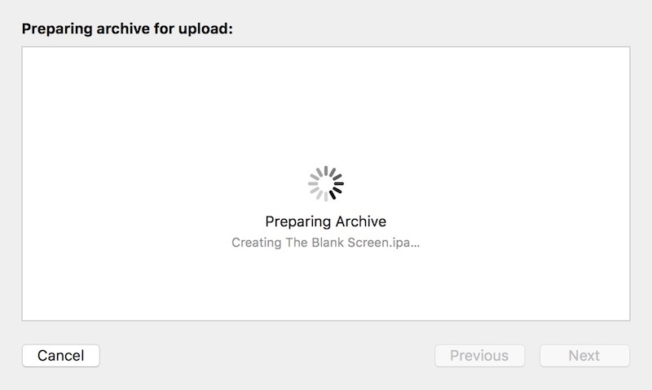

Advertisement

## 6. Waiting

If the submission process went without problems, your application's status will change to **Waiting for Review**. It takes several days for Apple to review your app, and the time it takes tends to fluctuate over time.

**b)on Play store**

### 1. Create Your Android App



* First thing for uploading your App on Play Store is to Develop your App and make it Store-Ready.
* Use Proper theme, colors, graphics, strings and icons.

### 2. Make its Signed Apk(Using Release Keystore)

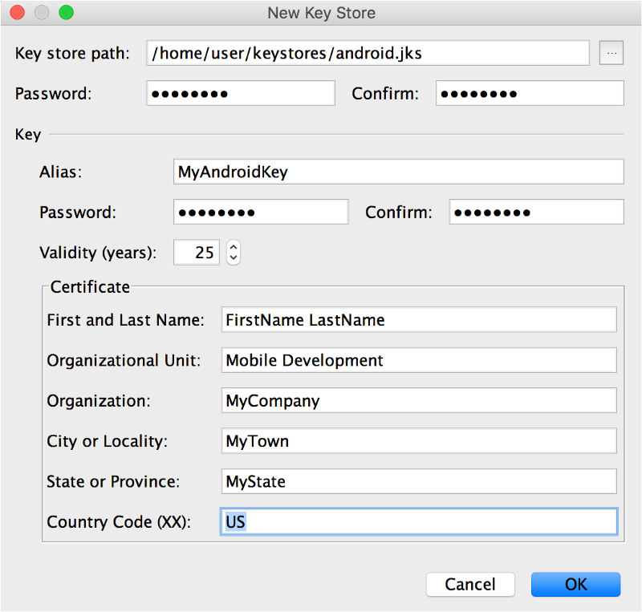

This is a graphical way to generate a release keystore

To generate keystores for signing Android apps at the command line, use:

$ keytool -genkey -v -keystore my-key.keystore -alias alias_name -keyalg RSA -keysize 2048 -validity 10000

A debug keystore which is used to sign an Android app during development needs a specific alias and password combination as dictated by Google. To create a debug keystore, use:

$ keytool -genkey -v -keystore debug.keystore -storepass android -alias androiddebugkey -keypass android -keyalg RSA -keysize 2048 -validity 10000

Keystore name: “debug.keystore”  
Keystore password: “android”  
Key alias: “androiddebugkey”  
Key password: “android”

**3. Login to your Gmail Account and visit this link :**[**https://play.google.com/apps/publish/**](https://play.google.com/apps/publish/)

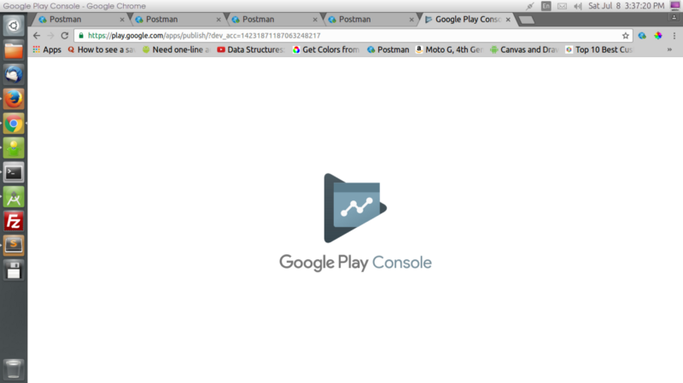

And Go to this Link — <https://play.google.com/apps/publish/>

### 4. Create a Merchant Account

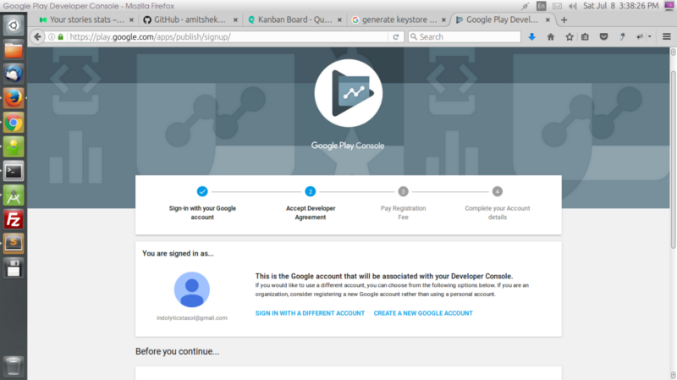

### 5. Mandatory Fields needed in App Listing:

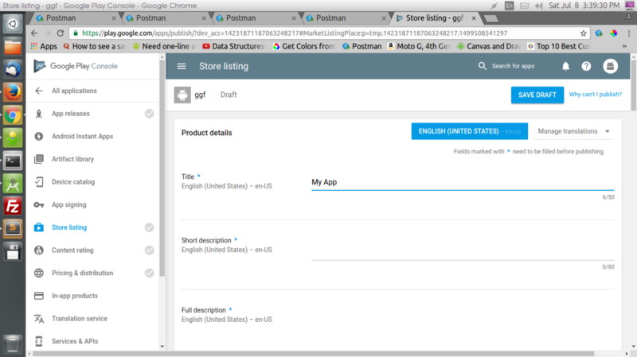

— Title  
 — Short Desc  
 — Full Desc  
 — App Screenshots(JPEG or 24-bit PNG (no alpha))(Min-2,Max-8)(Min-320px,Max-3840px)  
 — Hi-res icon(512 x 512)(32-bit PNG (with alpha))  
 — Feature Graphic(1024 w x 500 h)(JPG or 24-bit PNG (no alpha))  
 — App Type  
 — Category  
 — Content Rating  
 — Developer/Company Email  
 — Privacy Policy Url  
 — And some other details